**KAZAL BROTHERS LTD.**

D-Logic Sales Force Application   
(Including Sales & Distribution)  
(Android & Desktop Version)

Table of Contents

**Introduction** 4

**1.** **Application Name:** 4

**3.** **Company Name & Logo:** 4

**4.** **Search option for any Column data** 4

**5.** **Transaction form sample design** 4

**Basic Setup** 5

**6.** **Financial Year** 5

**7.** **Designation** 5

**8.** **User/Employee Registration** 6

**9.** **Region Type** 6

**10.** **Region/Area** 7

**11.** **Institution Type** 8

**12.** **Institution** 8

**13.** **Books Category** 10

**14.** **Books (Products)** 10

**15.** **TA/DA Allowance Type** 11

**16.** **Visit Purposes** 12

**17.** **Mapping Employee VS Region** 13

**18.** **Party Management** 13

**Transactions** 16

**19.** **Assign Visit Plans** 16

**20.** **Visit Approval Process** 17

**21.** **Visit Entry** 17

**22.** **Visit Approval** 18

**23.** **Production Order** 20

**24.** **Product Receipt** 21

**25.** **Sales Orders** 22

**26.** **Money Receipt** 23

**27.** **Sales Return** 24

**28.** **Damage Products/Books** 24

**29.** **Inventory Transfer** 25

**30.** **Sales Orders Approval Process** 26

**31.** **Delivery Challan** 27

**32.** **Invoice/Bill** 28

**33.** **Specimen Requisition** 29

**34.** **Specimen Approval** 30

**35.** **Reporting System** 30

# **Introduction**

## **Application Name:**

D-Logic Sales Force Software   
(Including Sales & Distribution)

1. **Web Application & Mobile Apps**

For Web Application & Mobile Apps we use all the form, In the security system user role will define which form edit/update have the permission.

For **Mobile Apps** here only need to add dashboard for NSM, RSM, ZM & AM – Target VS Achievement and also message sending & notification system.

## **Company Name & Logo:**

**Company Name: Kazal Brothers Limited**



## **Search option for any Column data**

Every List of the data have the **Search option for any Column data** that I send you sample design:

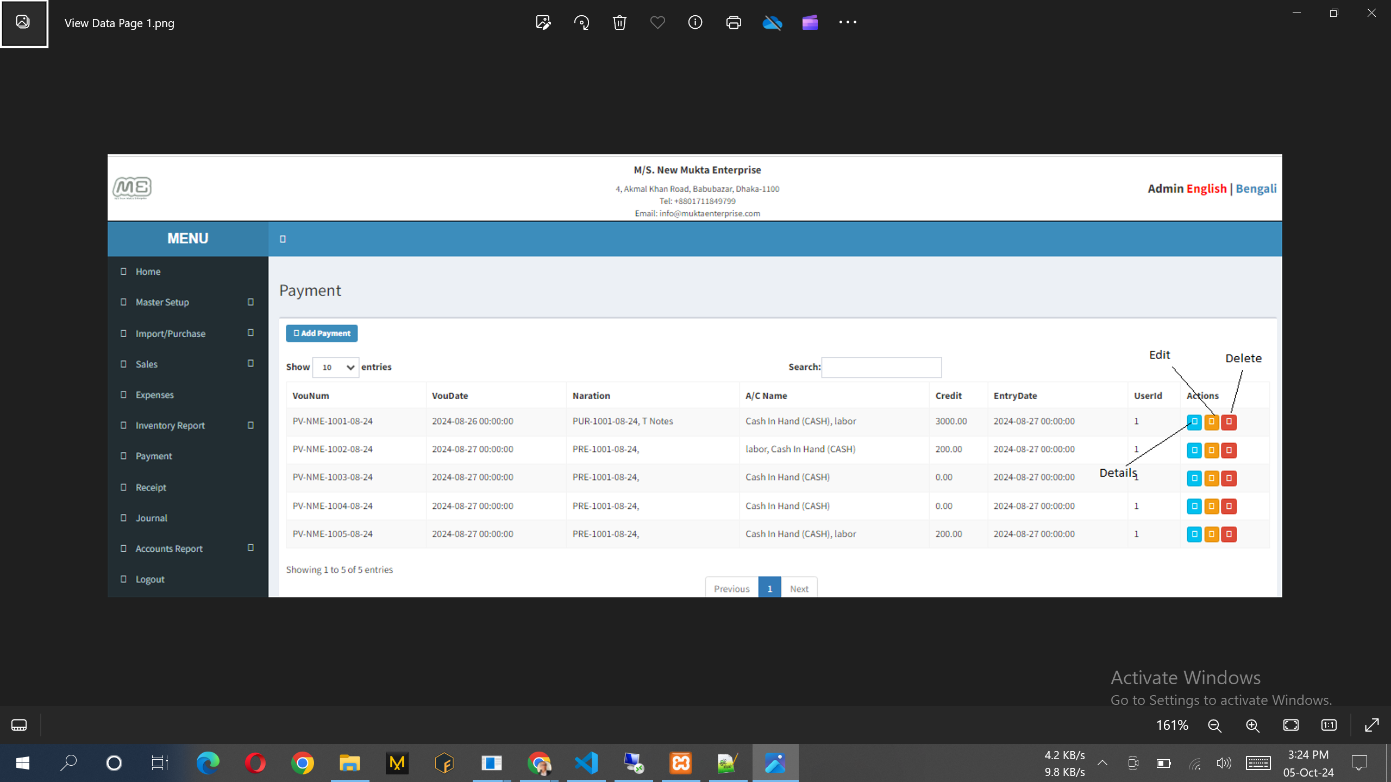

## **Transaction form sample design**

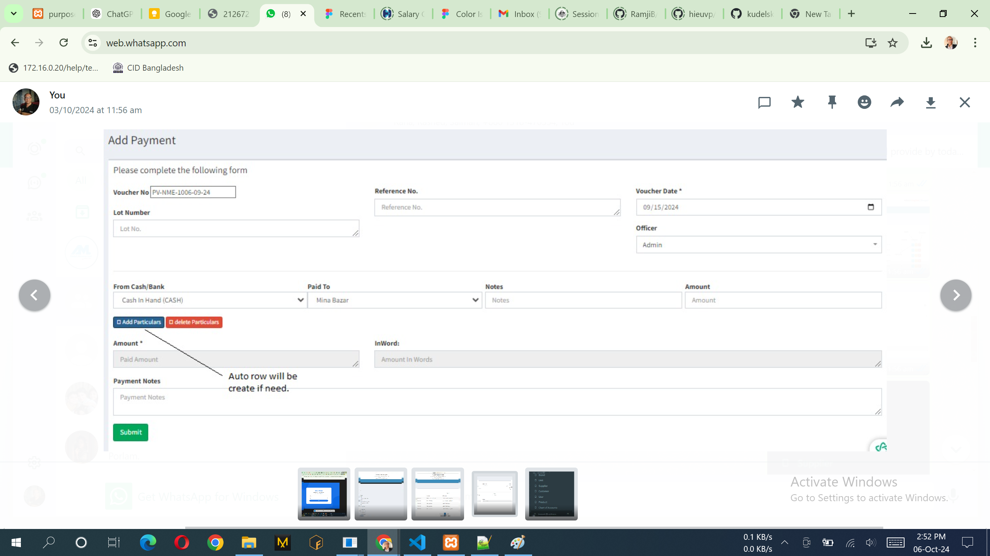

# **Basic Setup**

## **Financial Year**

Note:

1. Only show this data from database.

## **Designation**

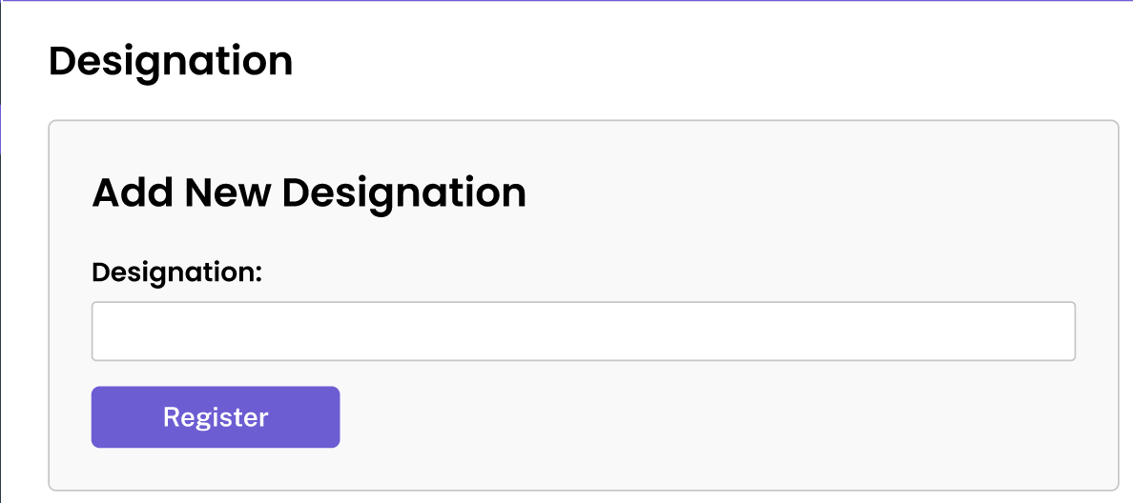

Notes:

1. Replace Button "Registration" to "Save Designation".

## **User/Employee Registration**

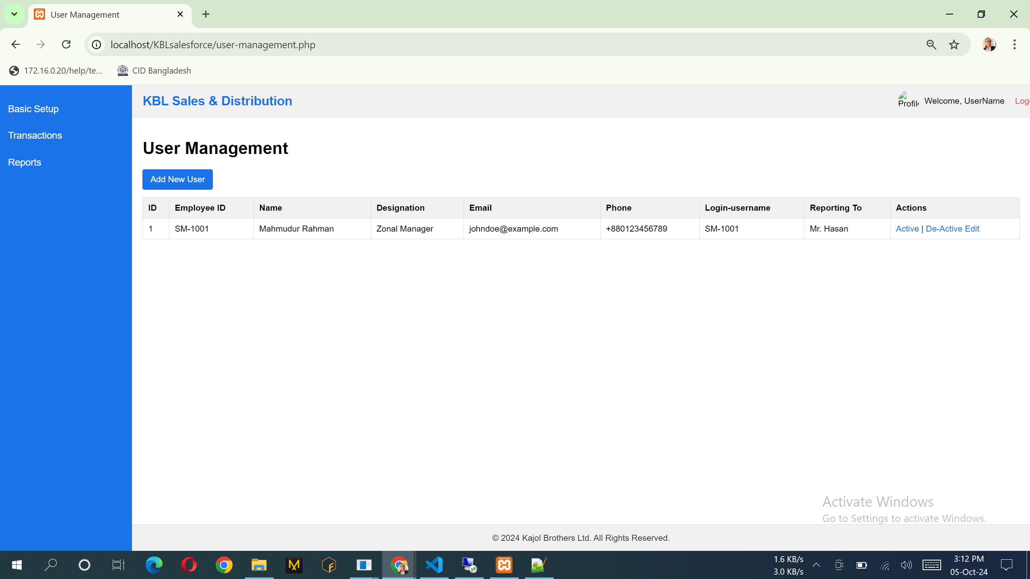

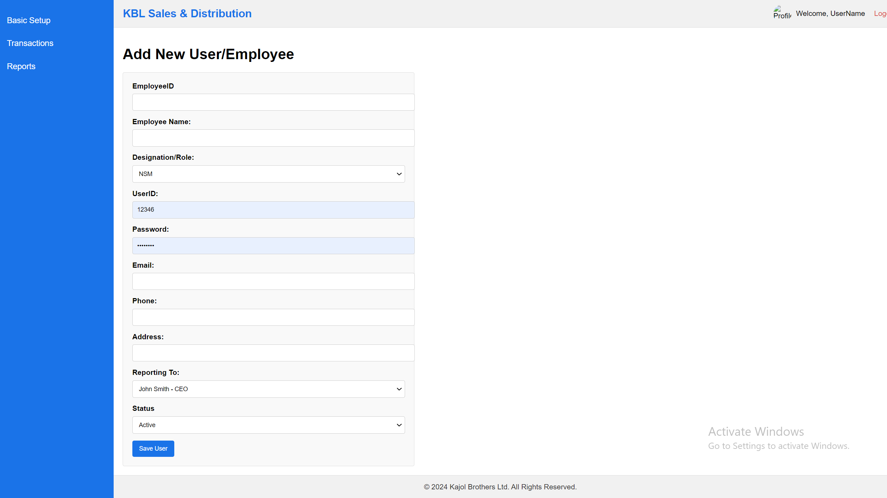

Note:

1. Reporting To: Load all of the employee including their designation.
2. Data can be add, edit & view. No delete option over here. Only can active/de-active option.

## **Region Type**

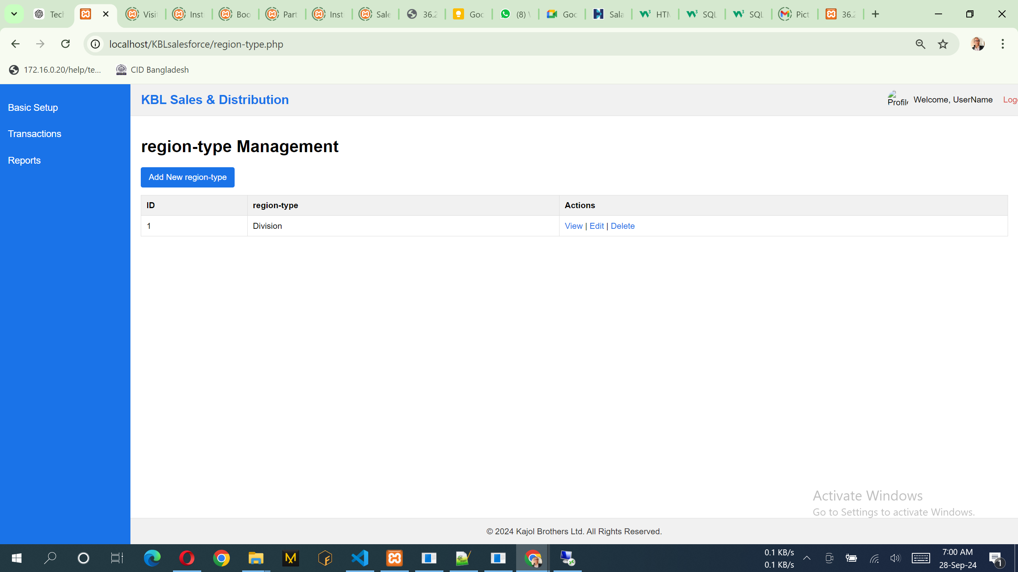

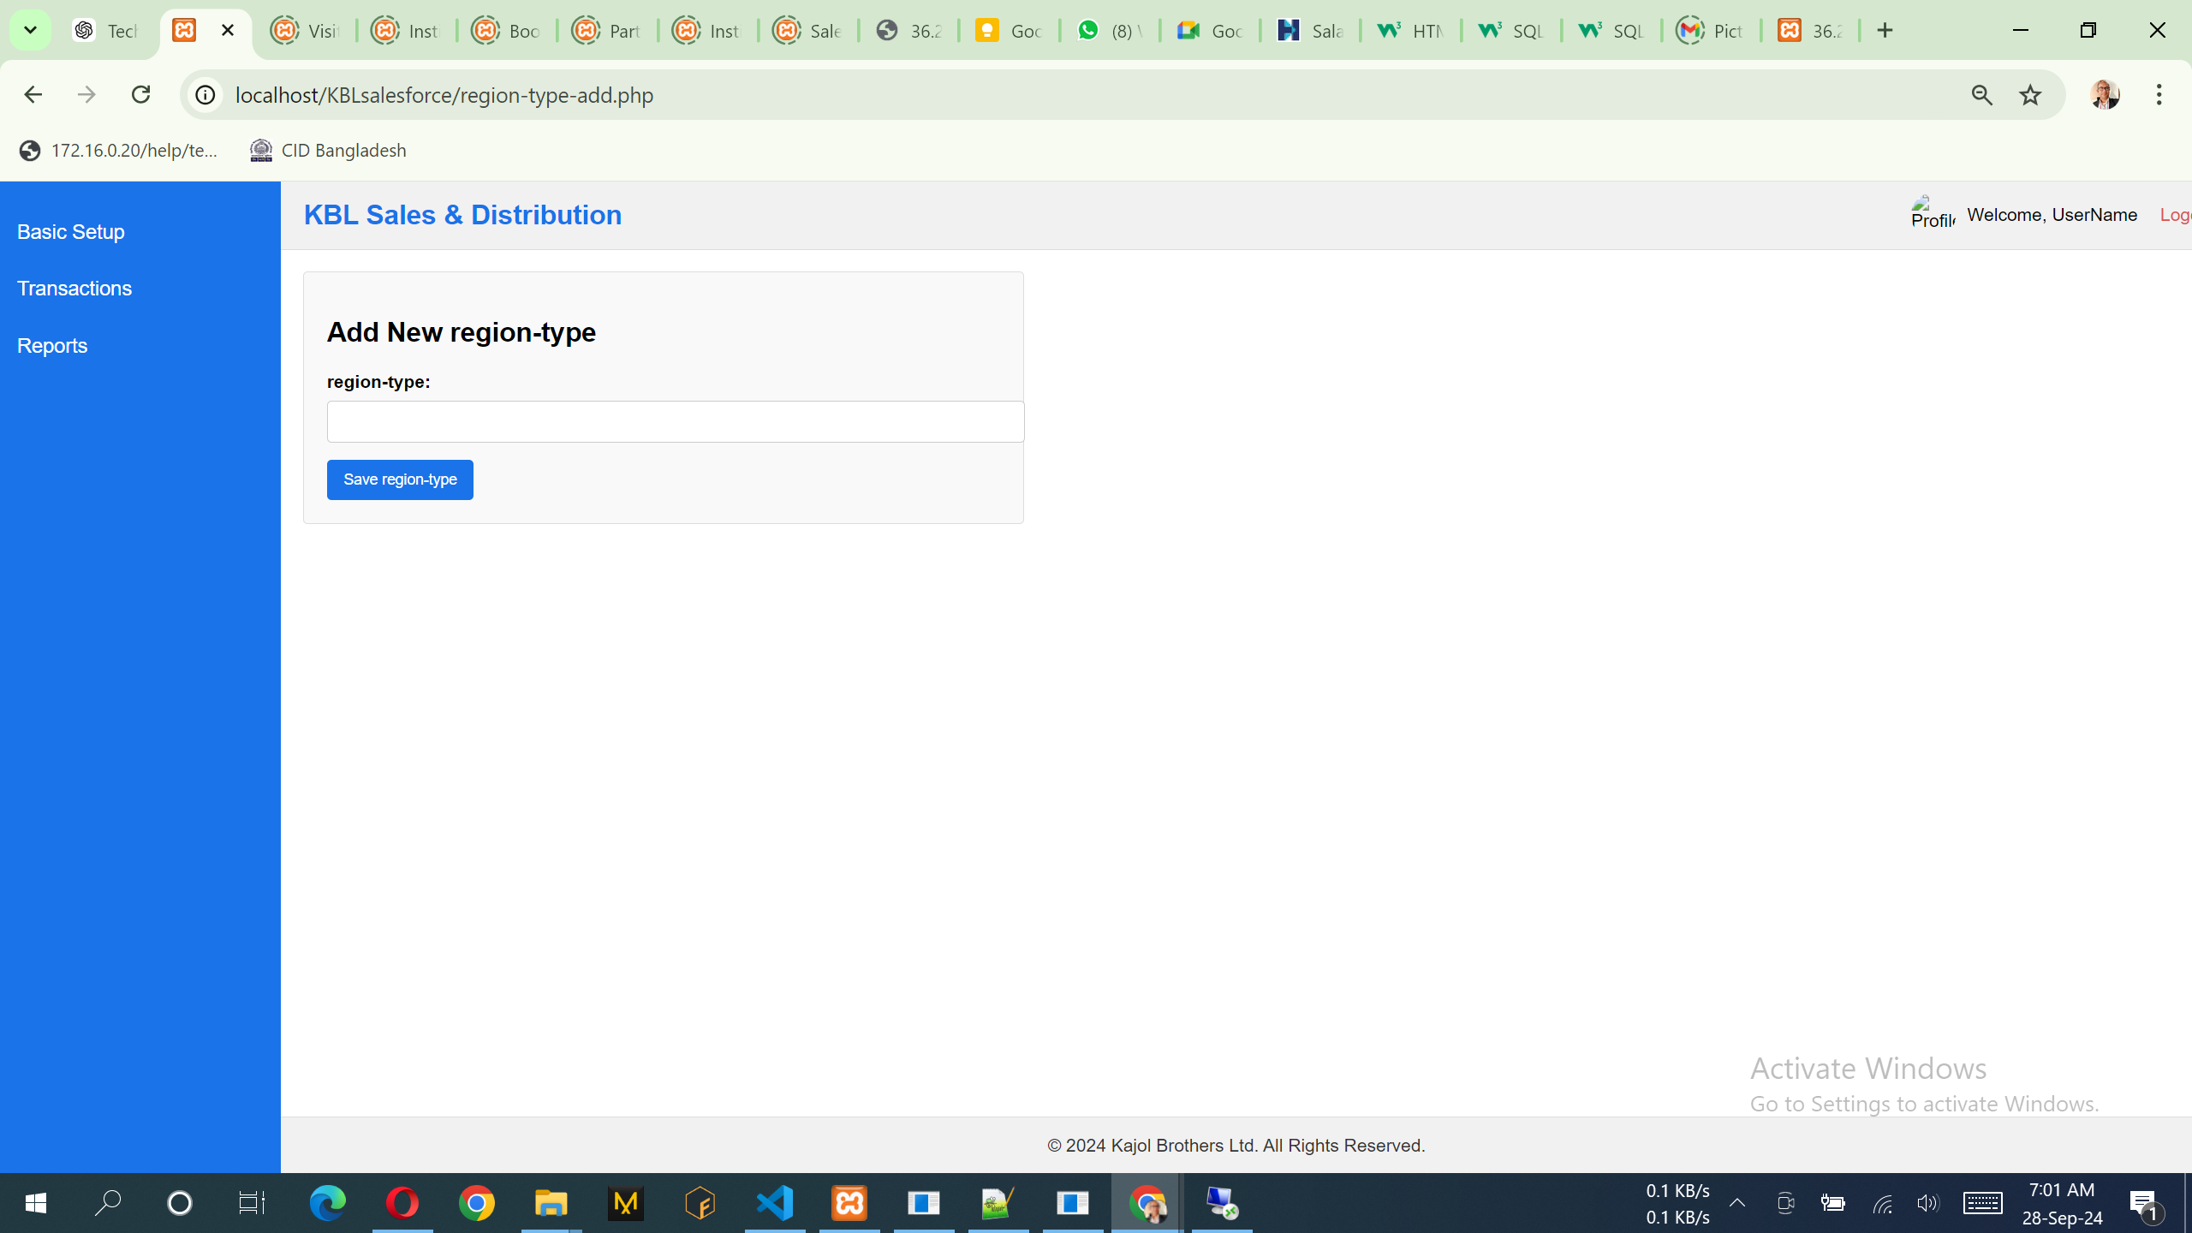

Notes:

1. List of the data can add, view & edit. No delete option.

## **Region/Area**

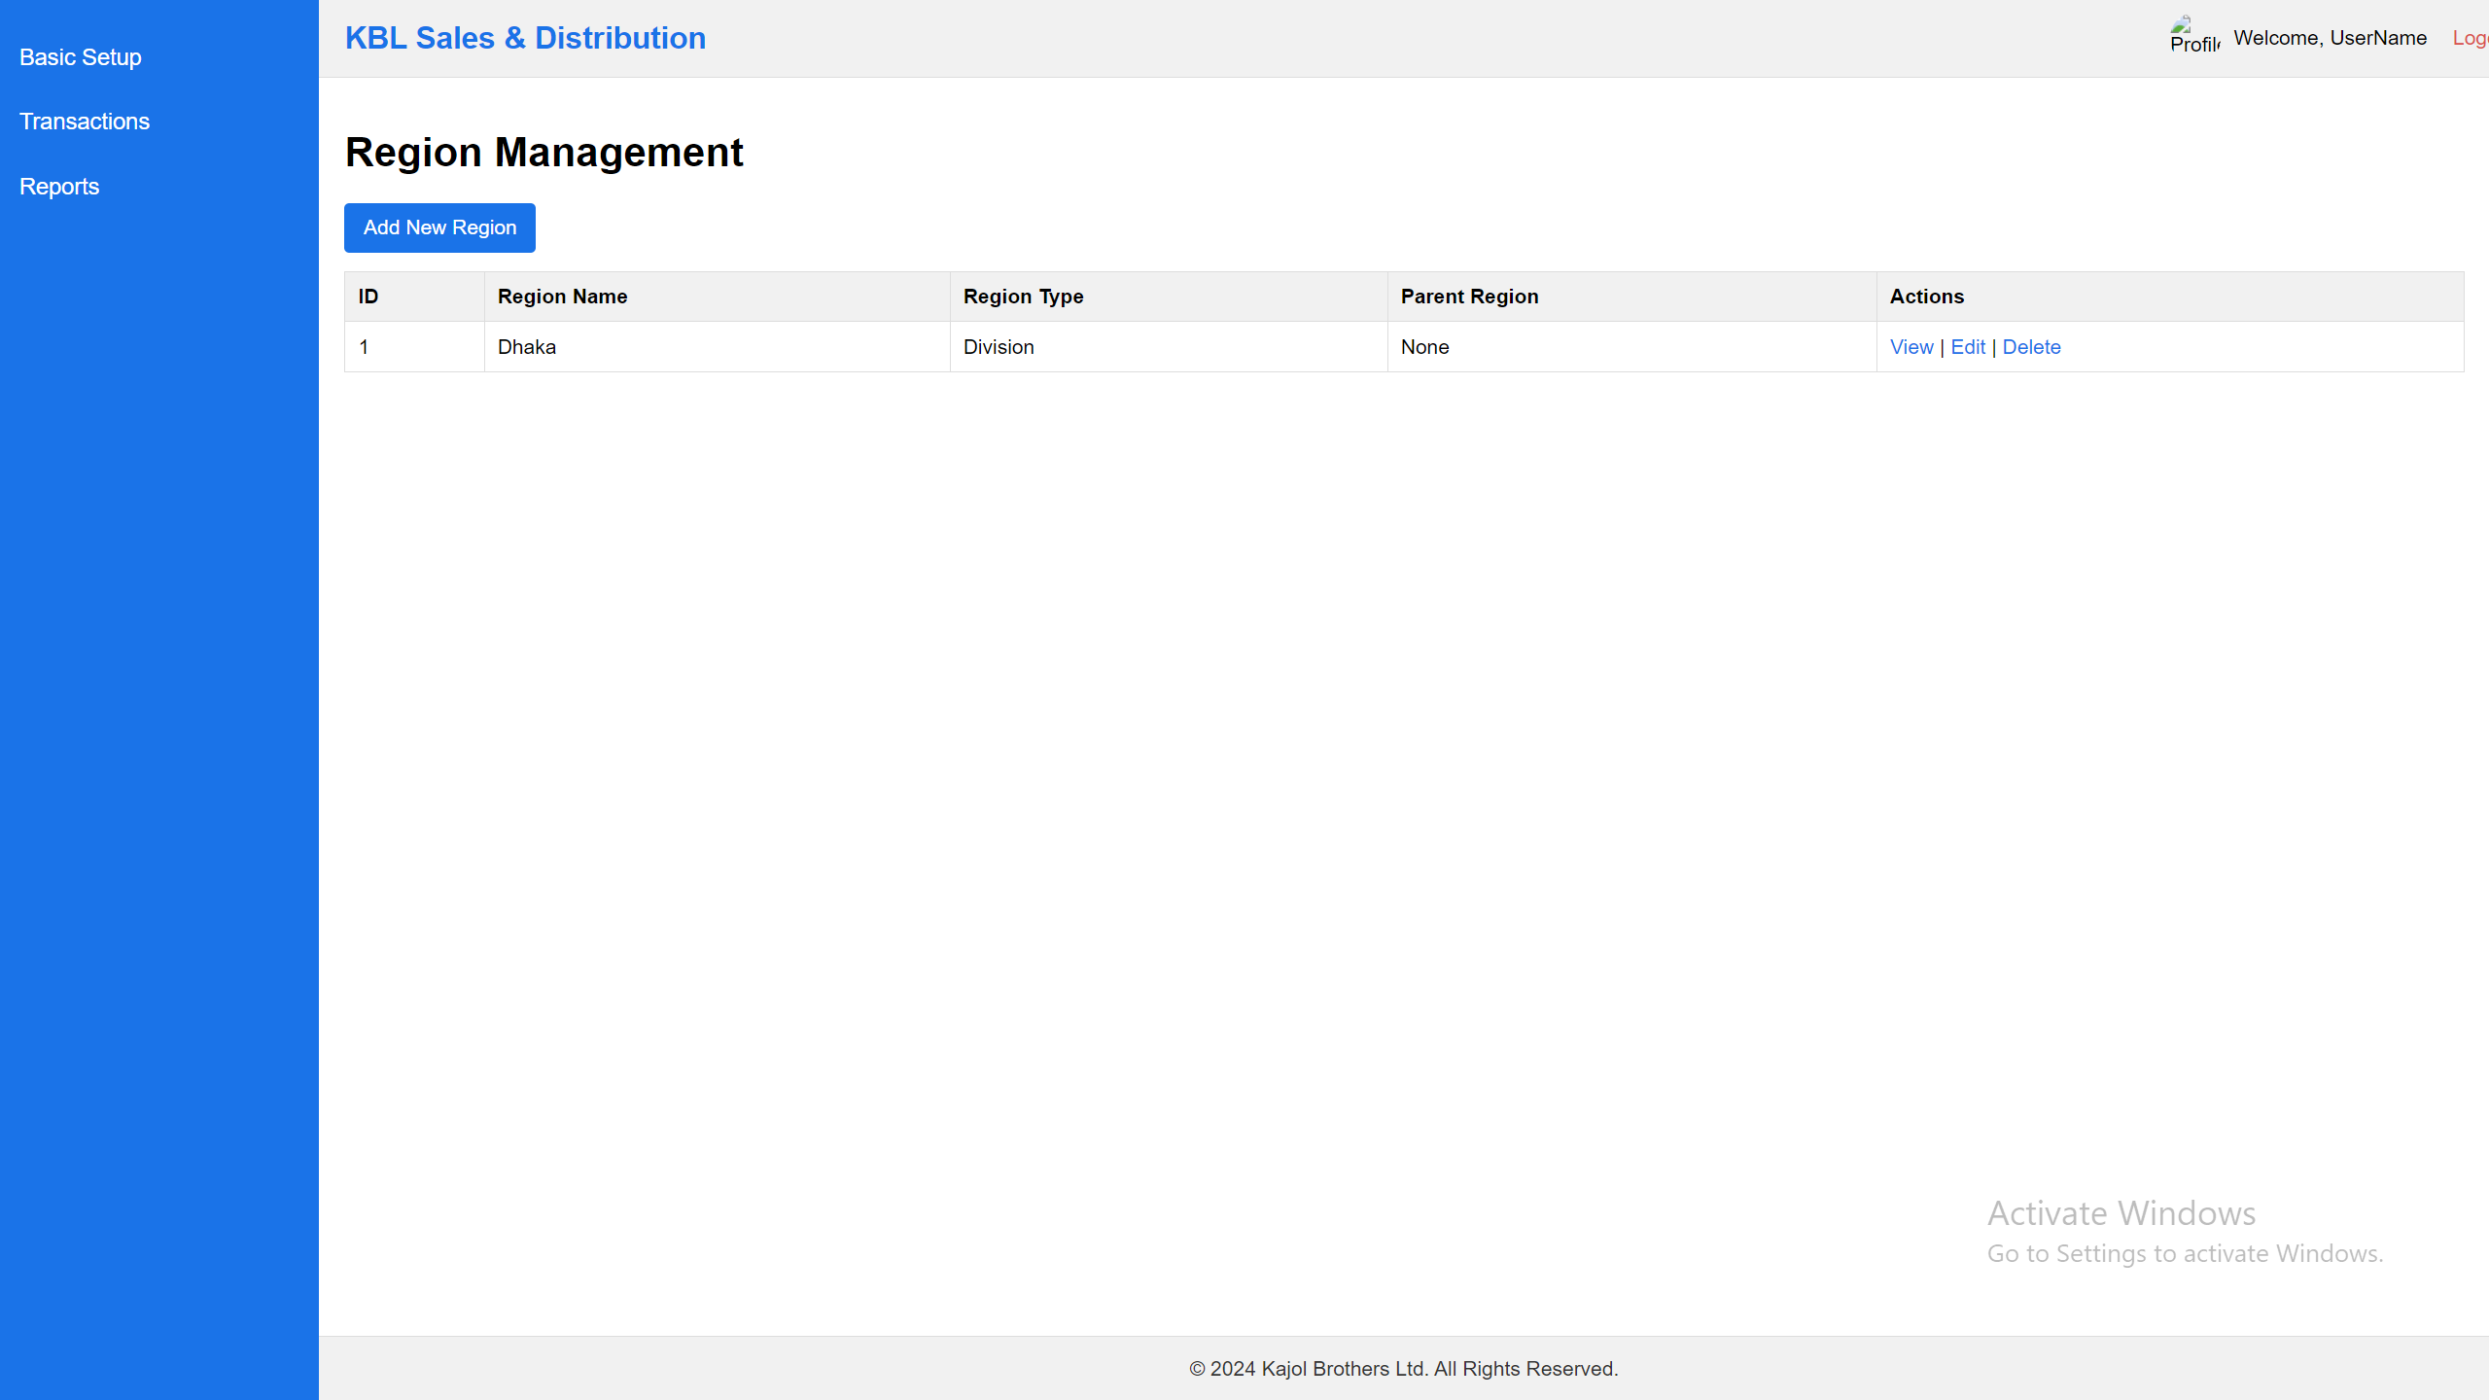

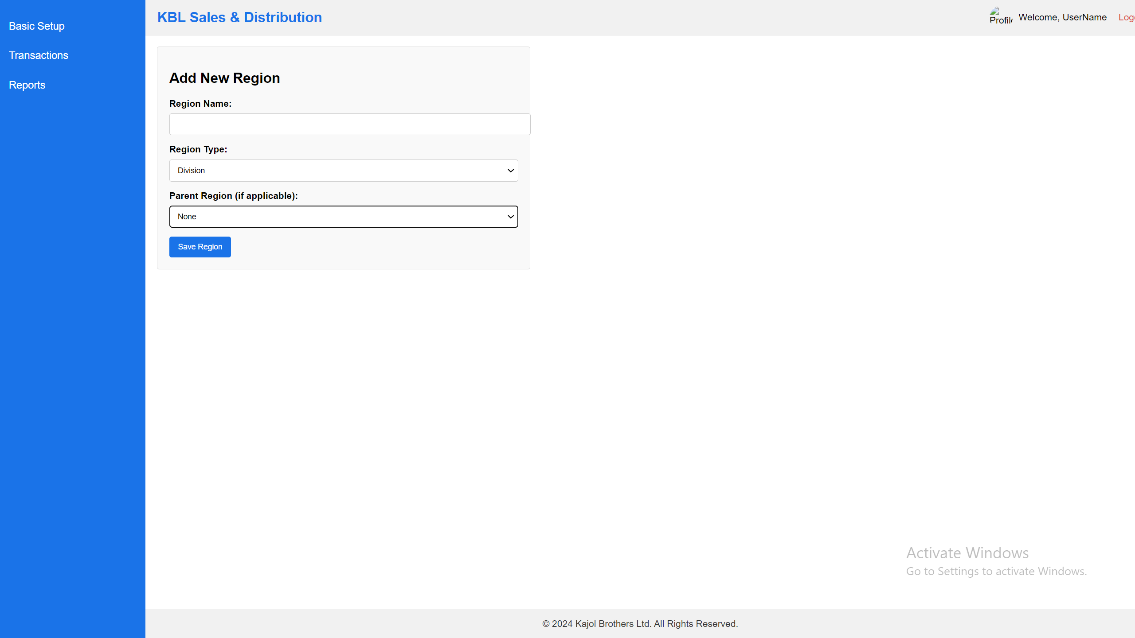

Notes:

1. Region Type: Division, District, Thana, Area [Load those data]
2. Parent Region: Only Top Head like not need to select Parent, but all the other like Division, District, Thana, Area name must be need to select parent Region like:
3. Bangladesh -> Dhaka Division, Dhaka District -> Mohammadpur Thana -> Katashur Area.
4. List of the data can add view & edit. No delete option.

## **Institution Type**

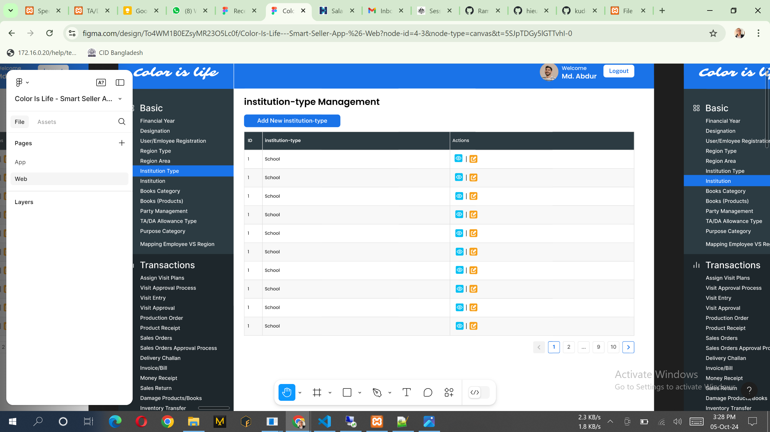

Need to change Capital Letter of all the word 1st letter same changes needed Add new institution.

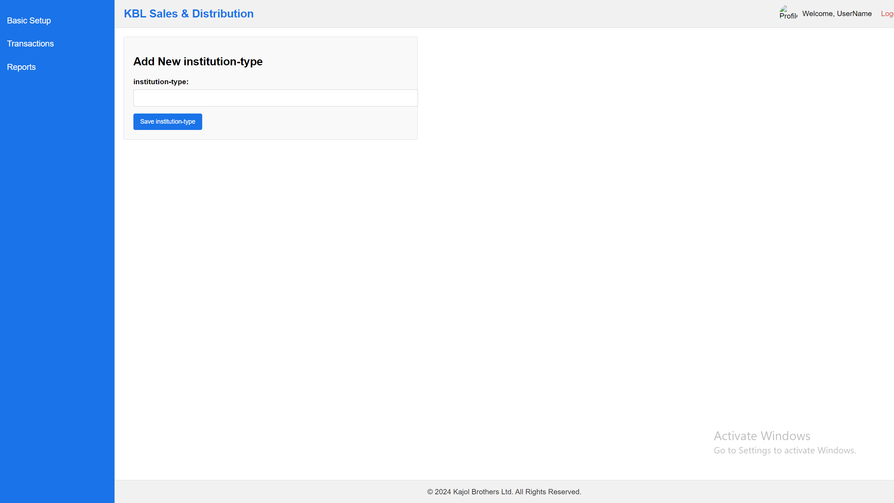

Notes:

1. List of the data can add, view & edit. No delete option.

## **Class Info**

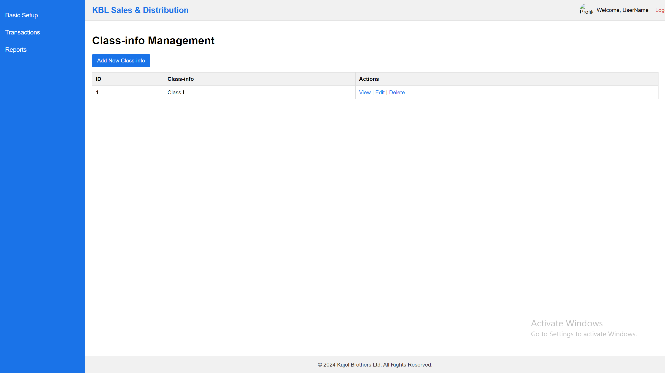

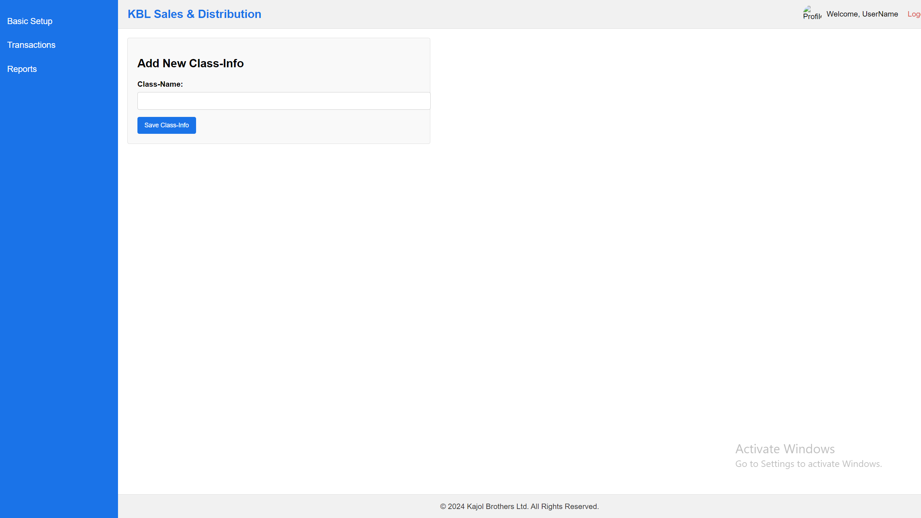

Notes:

1. List of the data can add, view & edit. No delete option.

## **Subject Info**

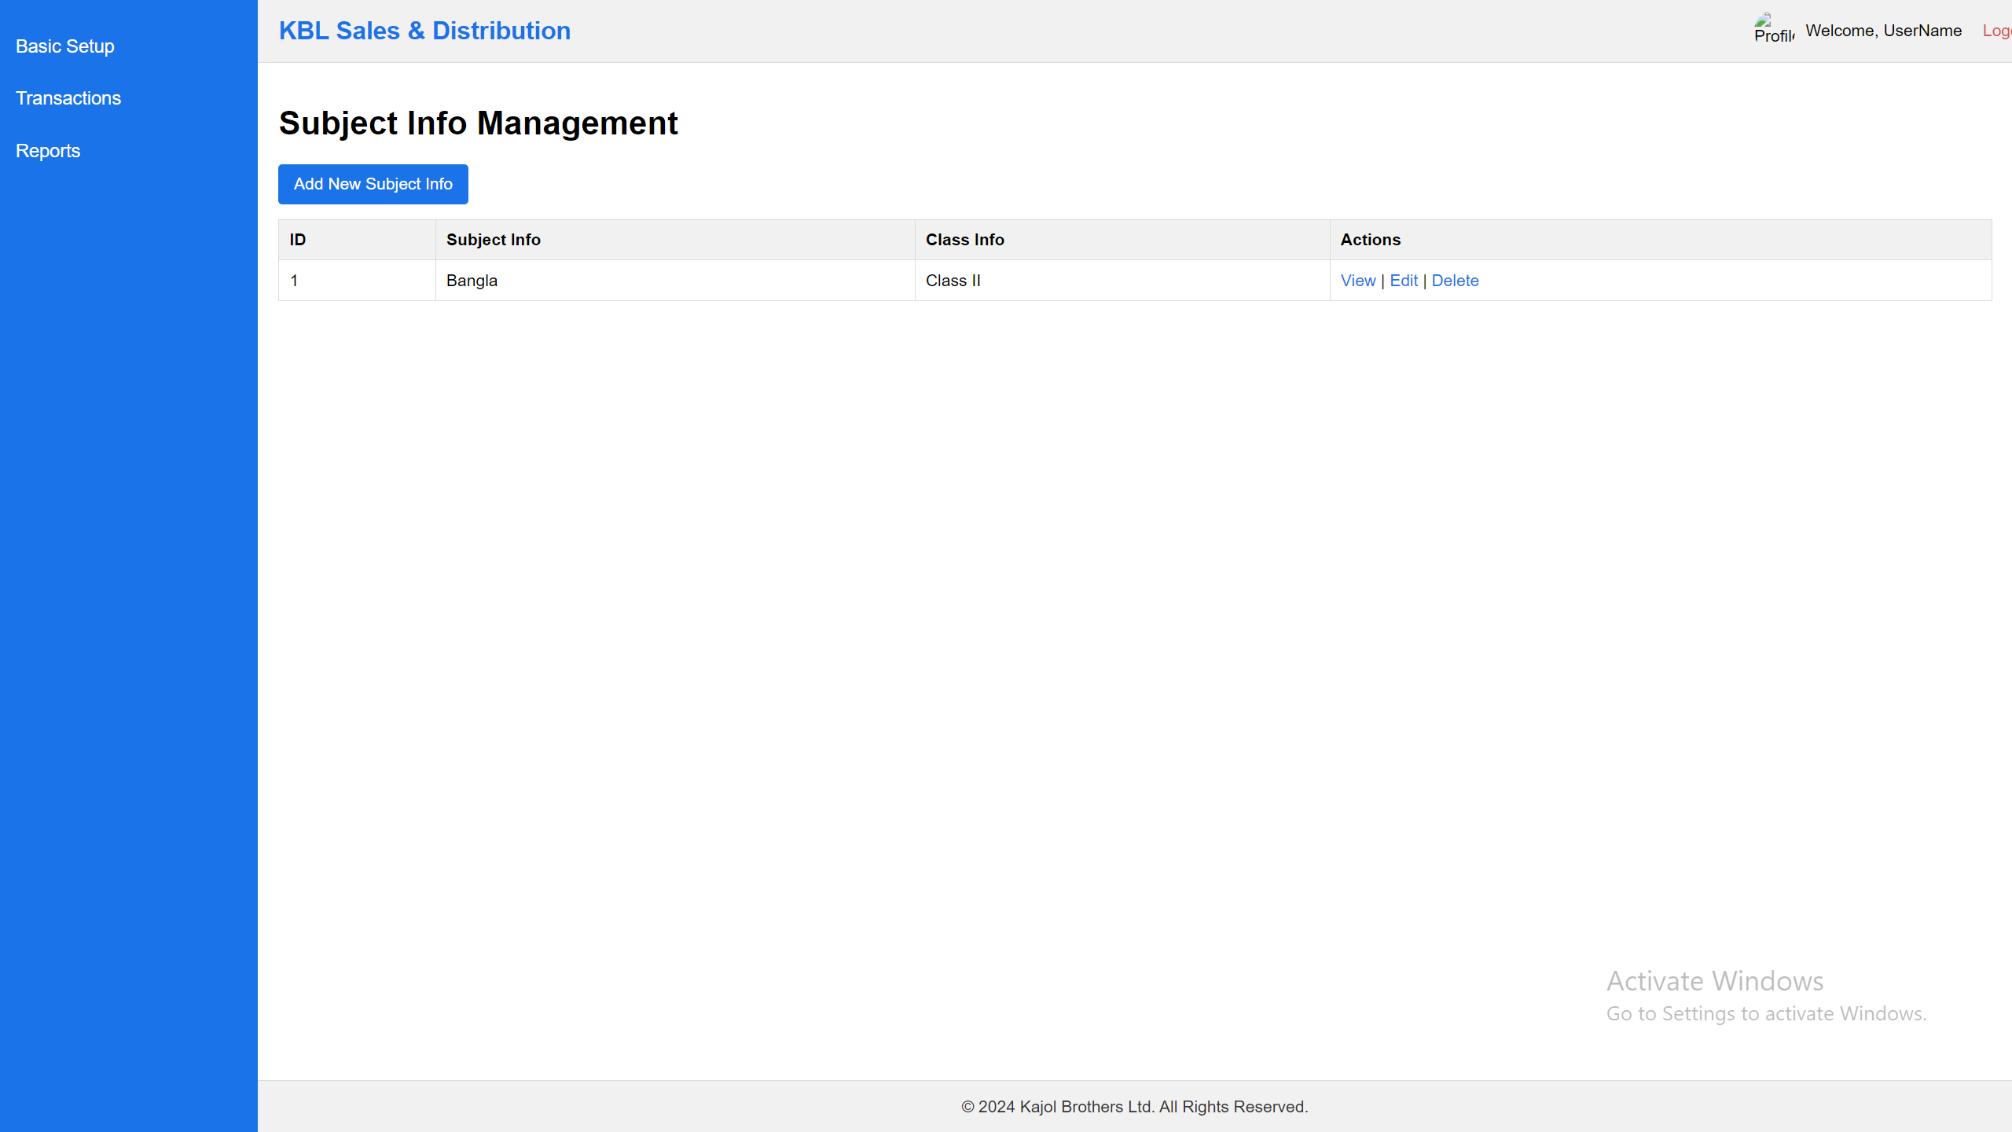

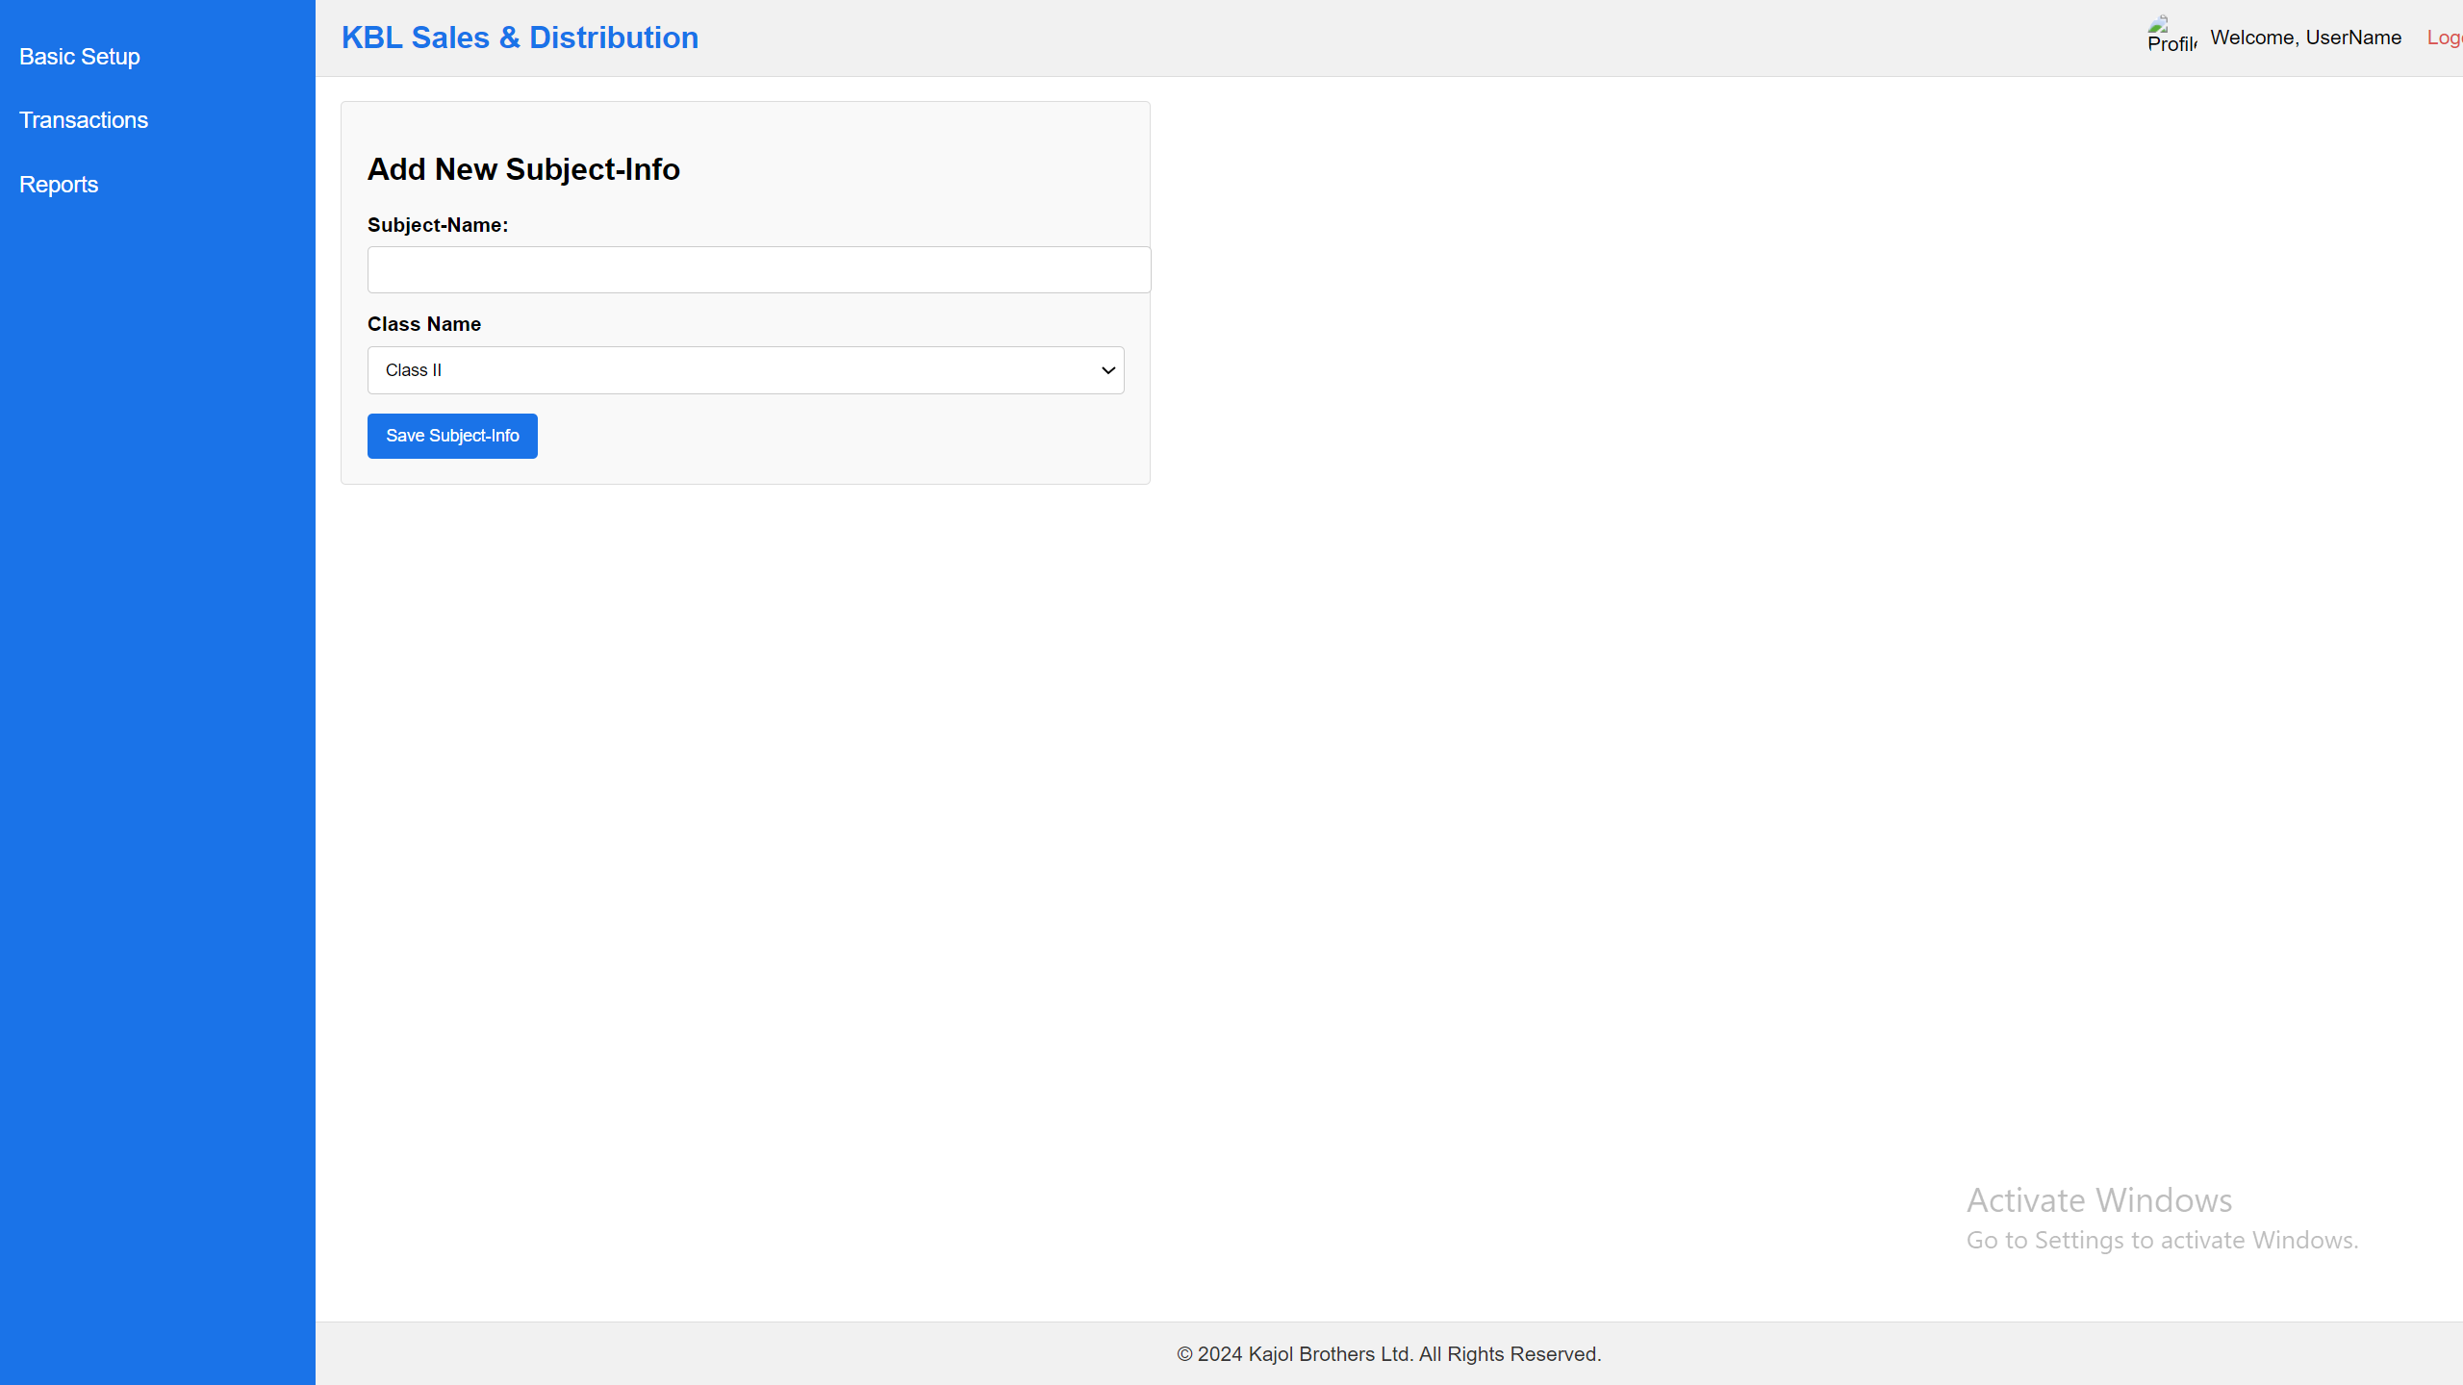

Notes:

1. List of the data can add, view & edit. No delete option.

## **Institution**

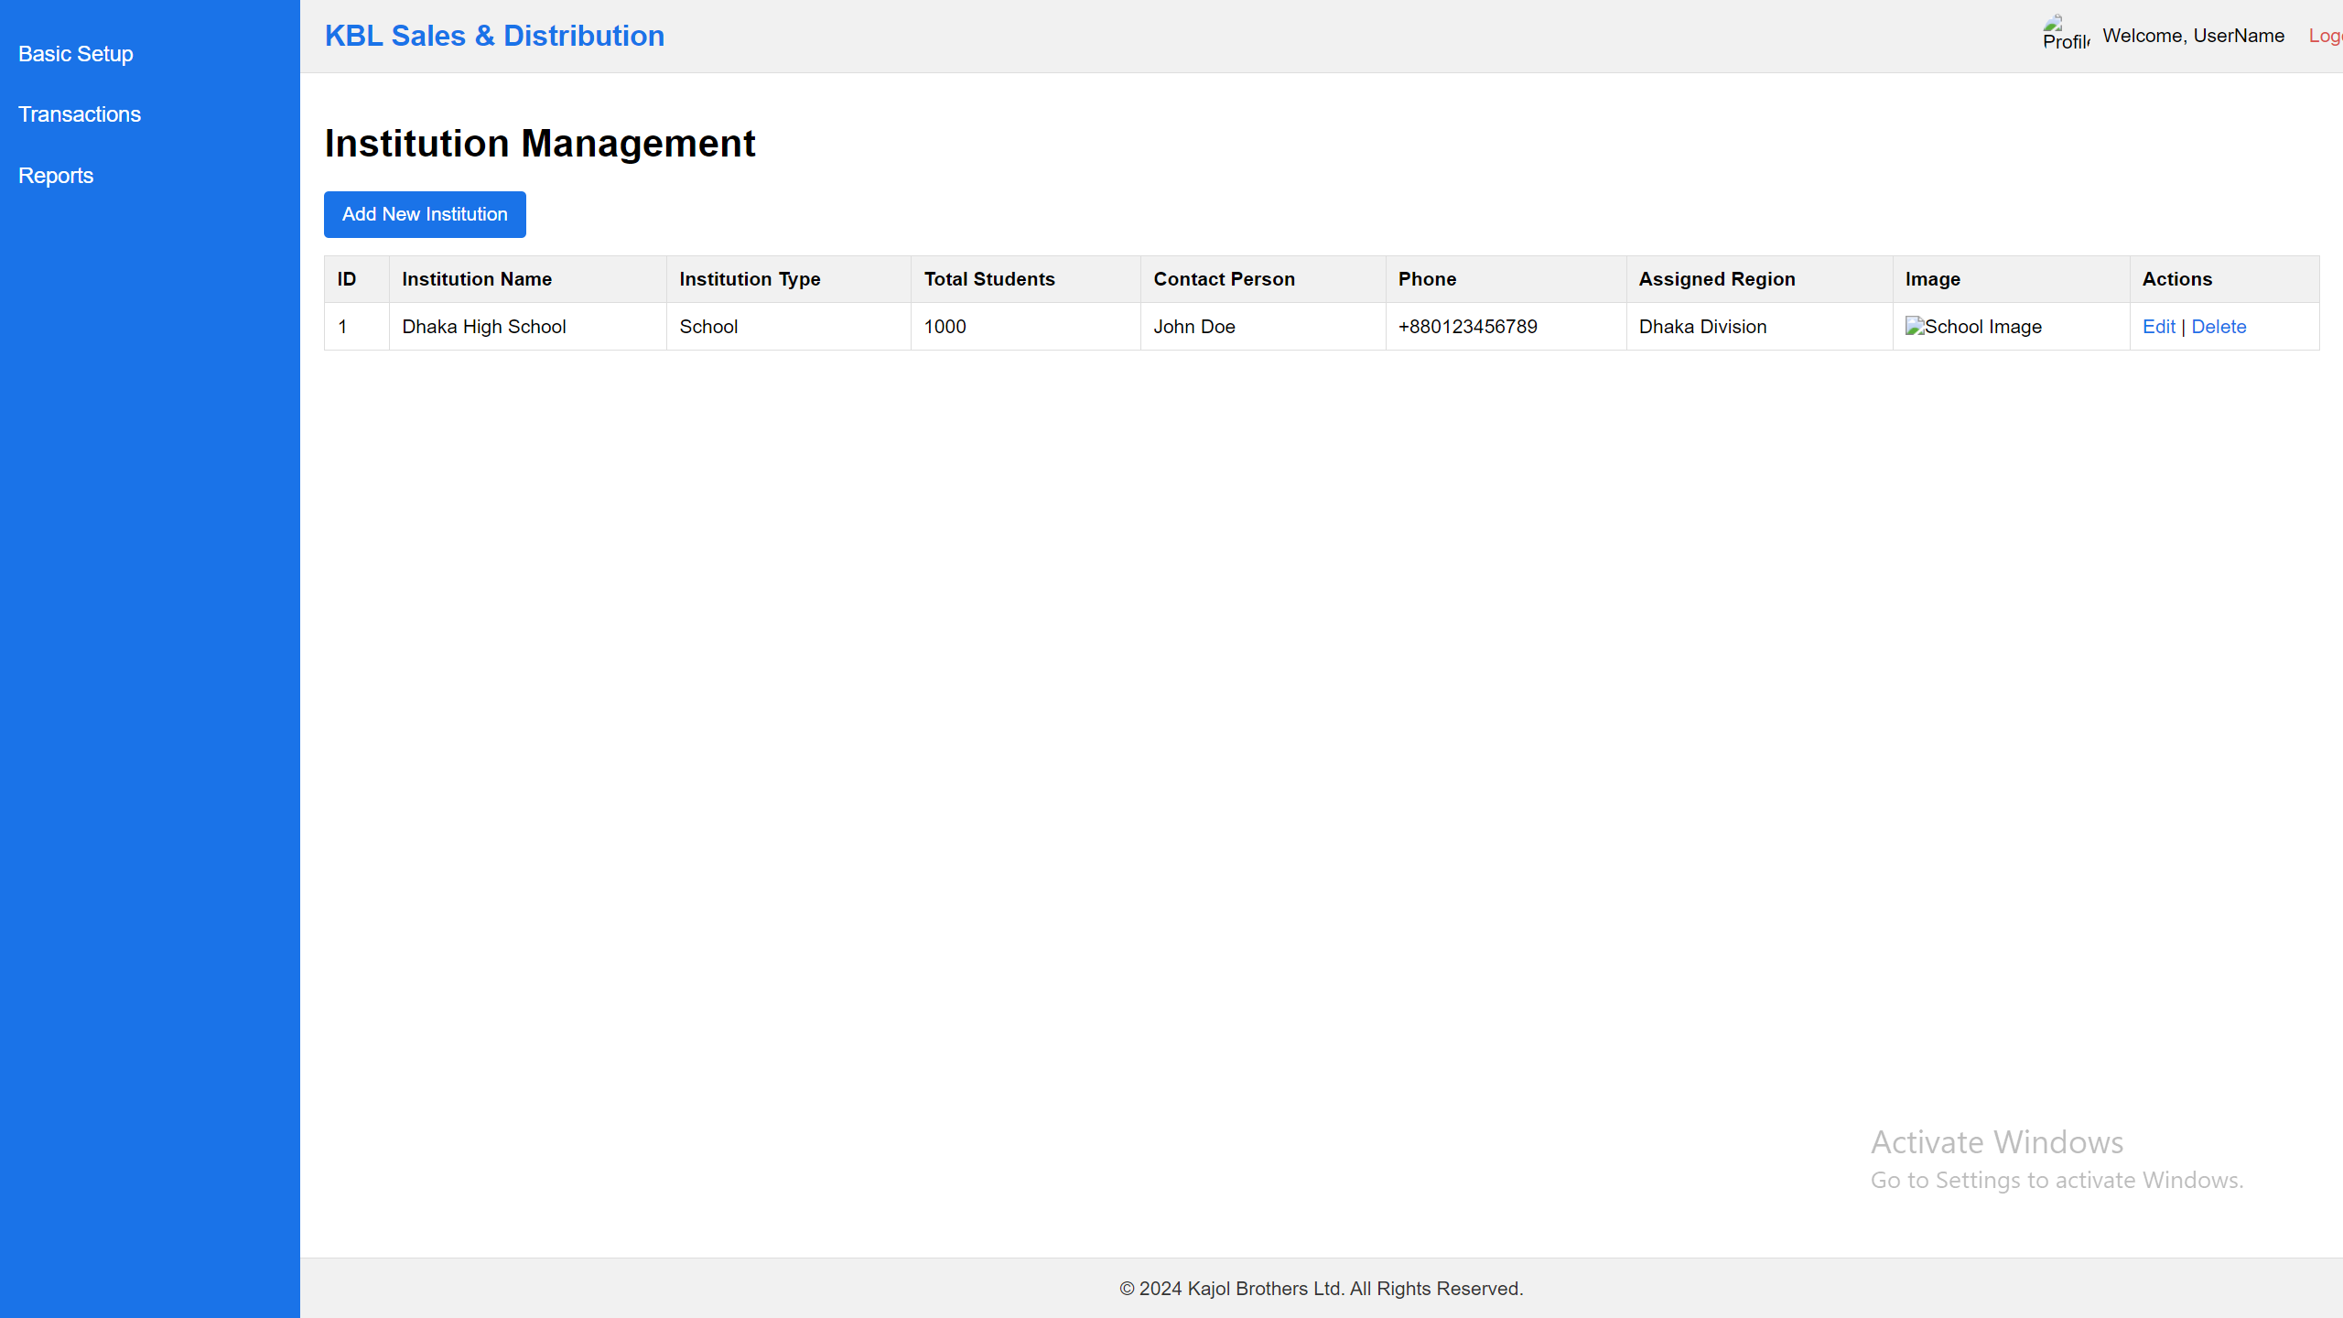

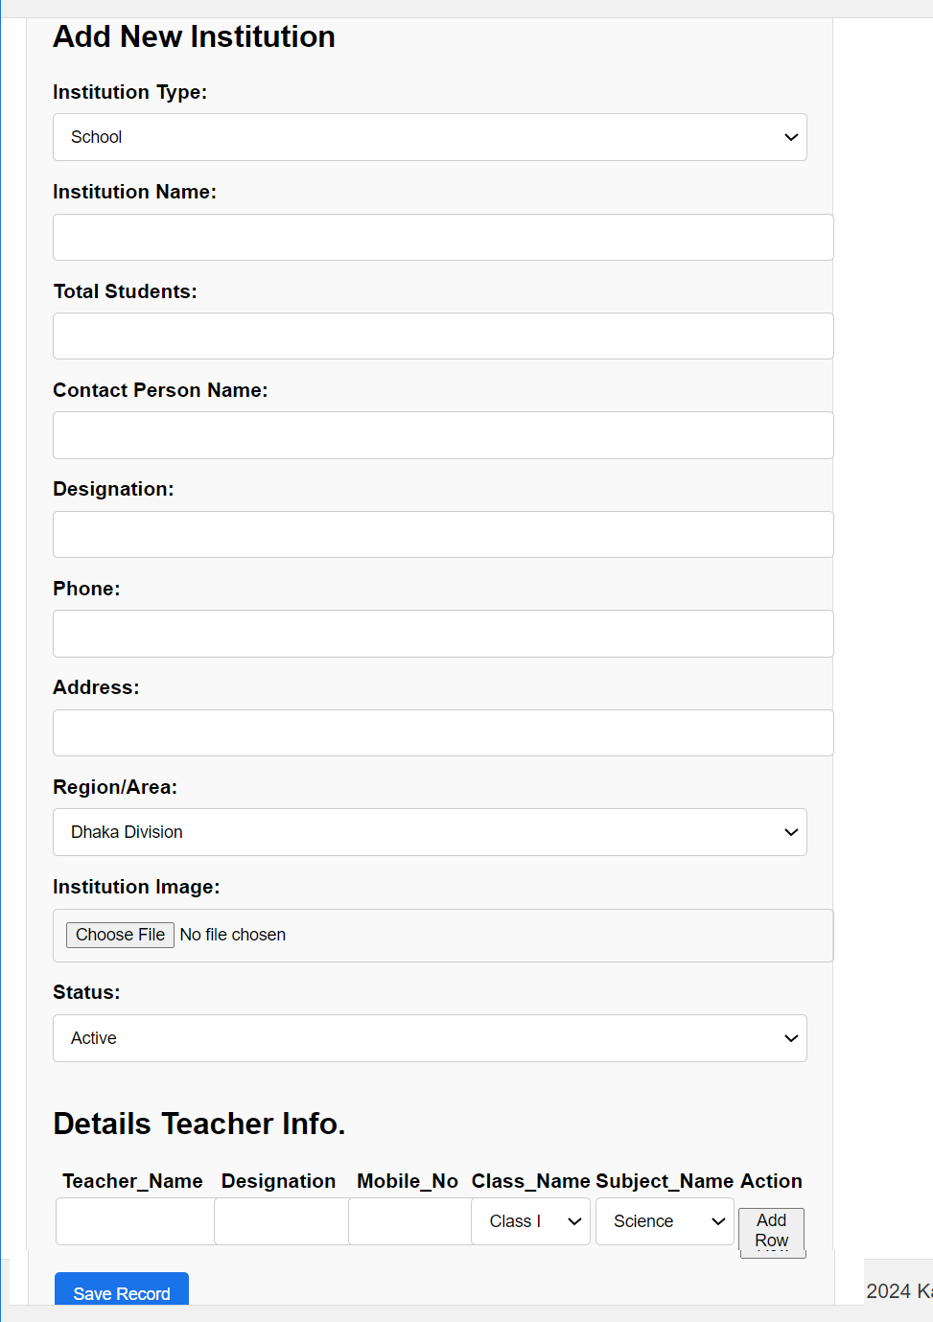

Notes:

1. Region/Area: Load all the region Area
2. Details Teacher Info: Here one teacher may can take multiple classes and also can add multiple teacher here.
3. List of the data can add, view & edit. No delete option.

Notes:

1. List of the data can add, view & edit. No delete option.

## **Books Category**

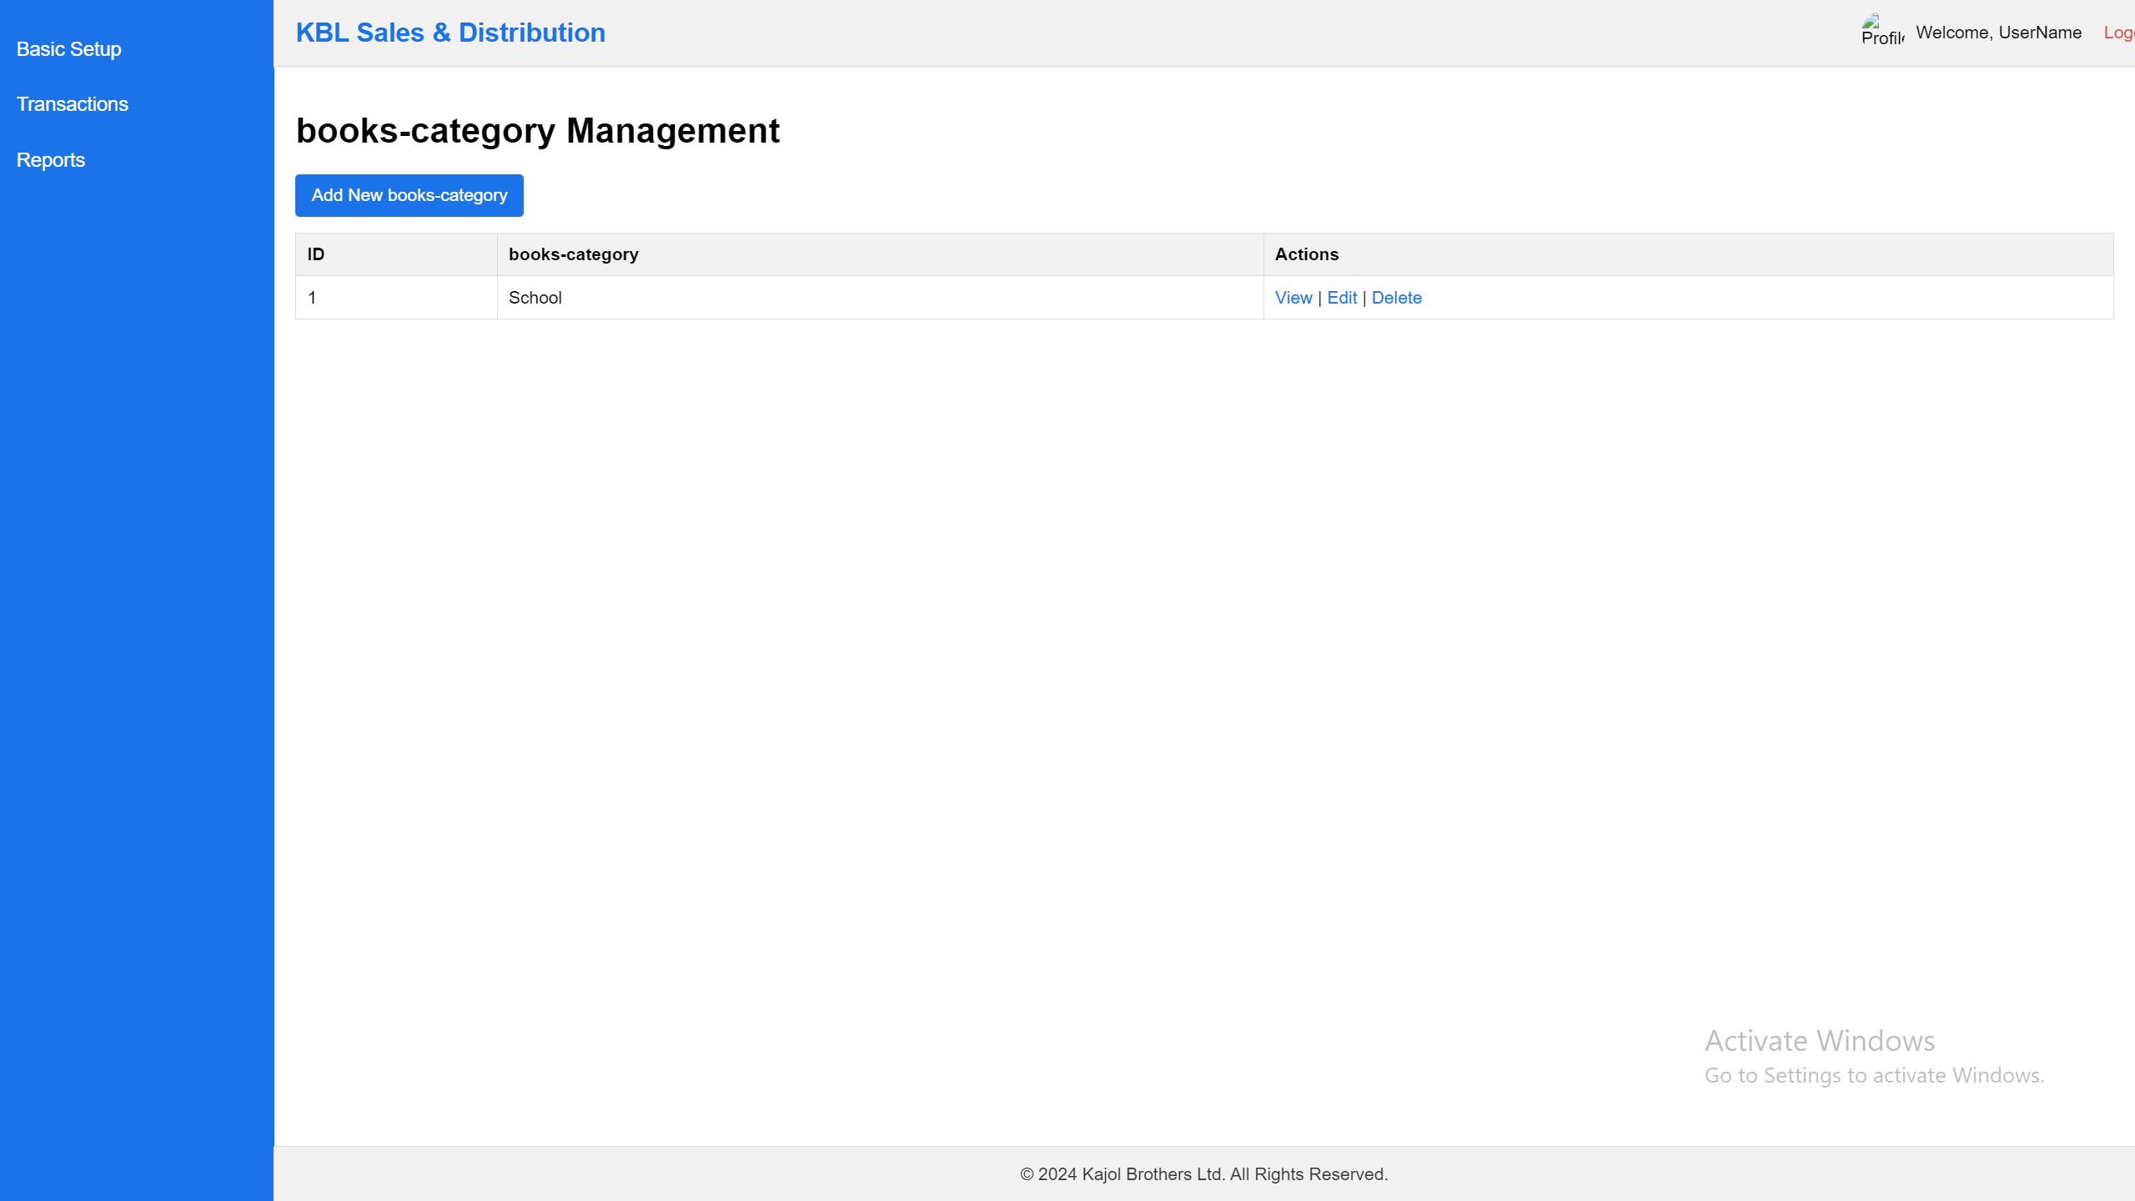

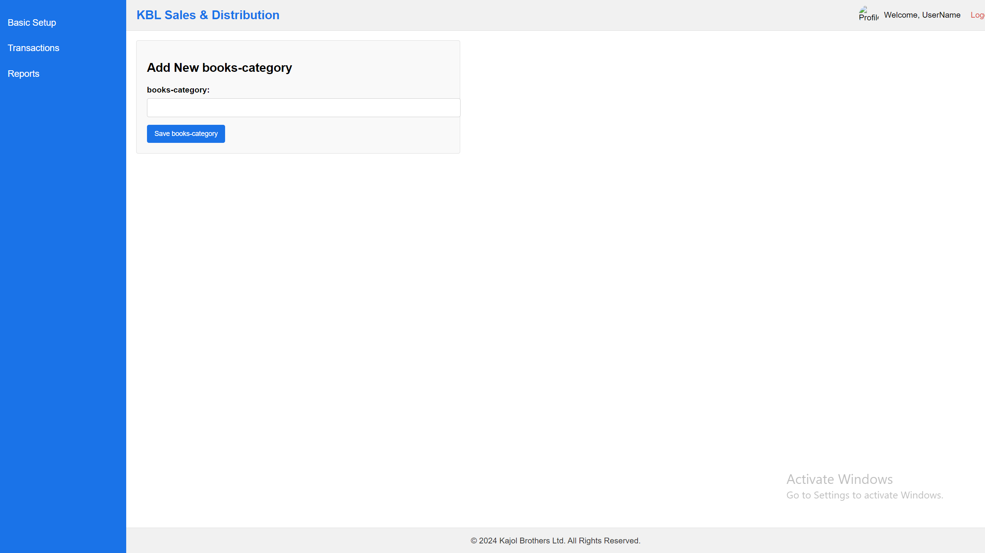

Notes:

1. List of the data can add, view & edit. No delete option.

## **Books (Products)**

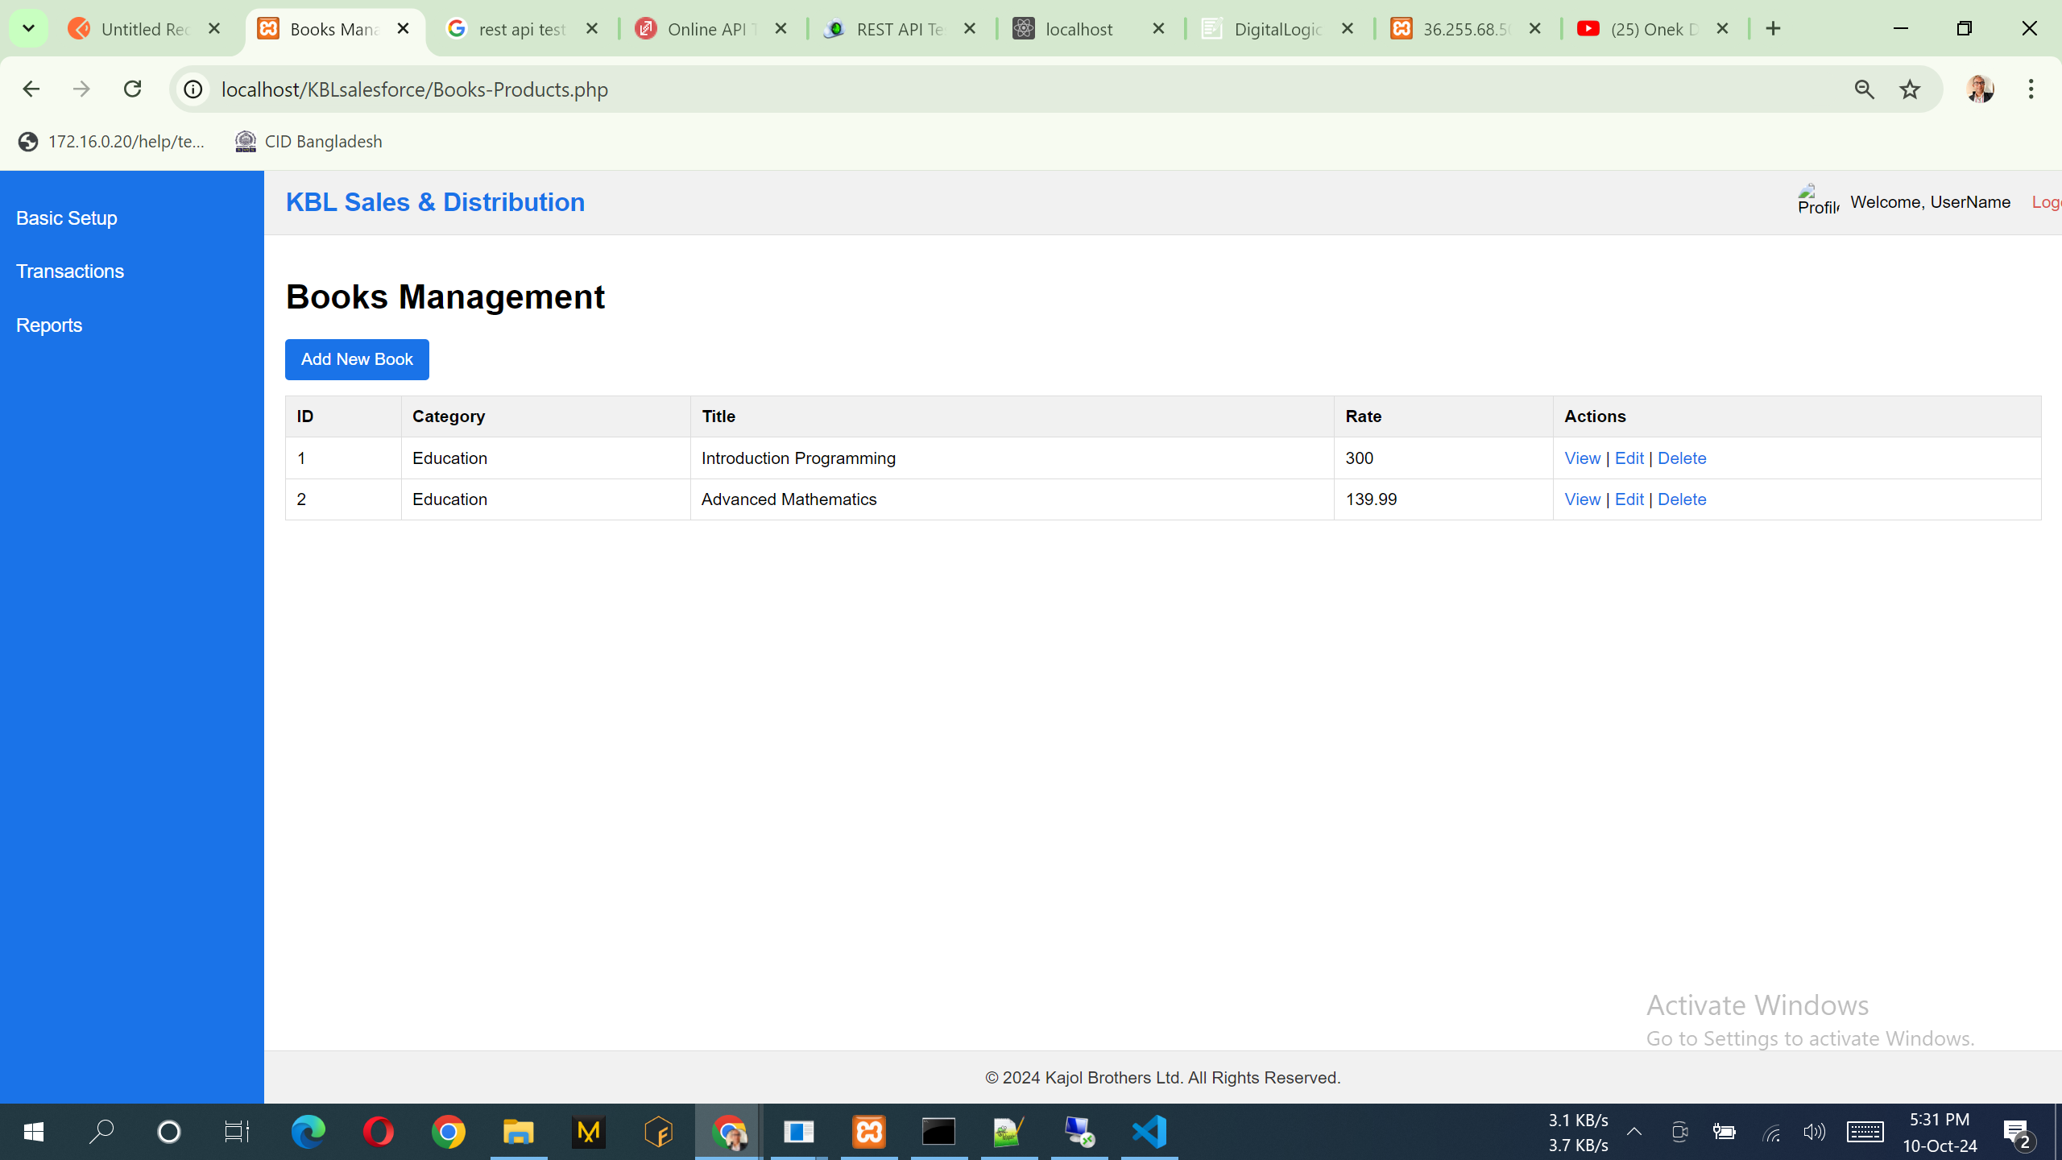

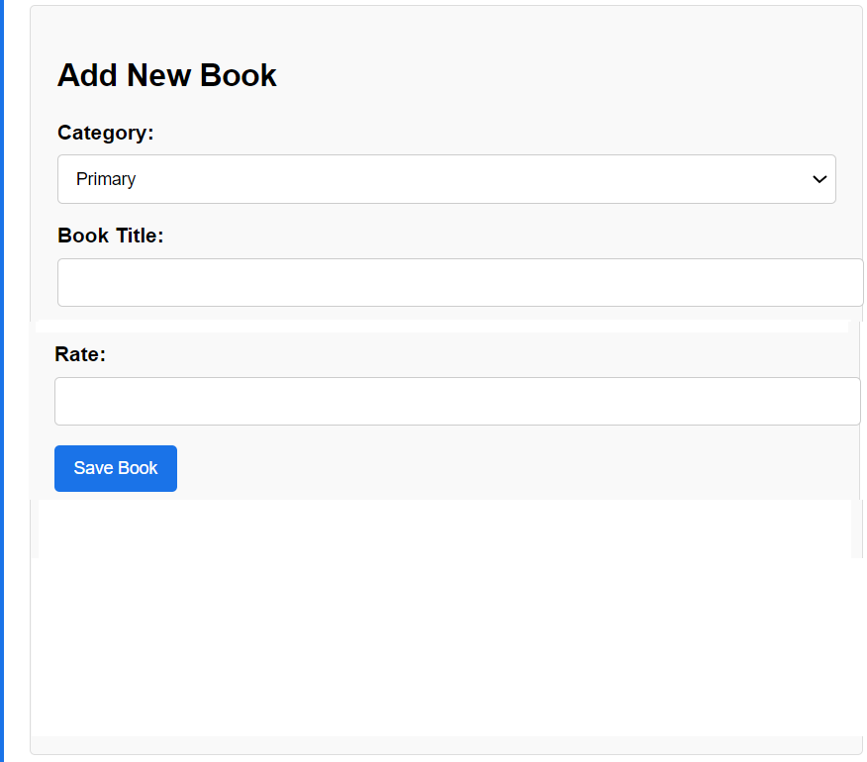

Notes:

1. List of the data can add, view & edit. No delete option.
2. Category: Data will come from the Books Category.
3. One Book can serve multiple classes and that time you can select more than one classes.
4. If select HSC then HSC Subject can be select any one from the combo box.

## **TA/DA Allowance Type**

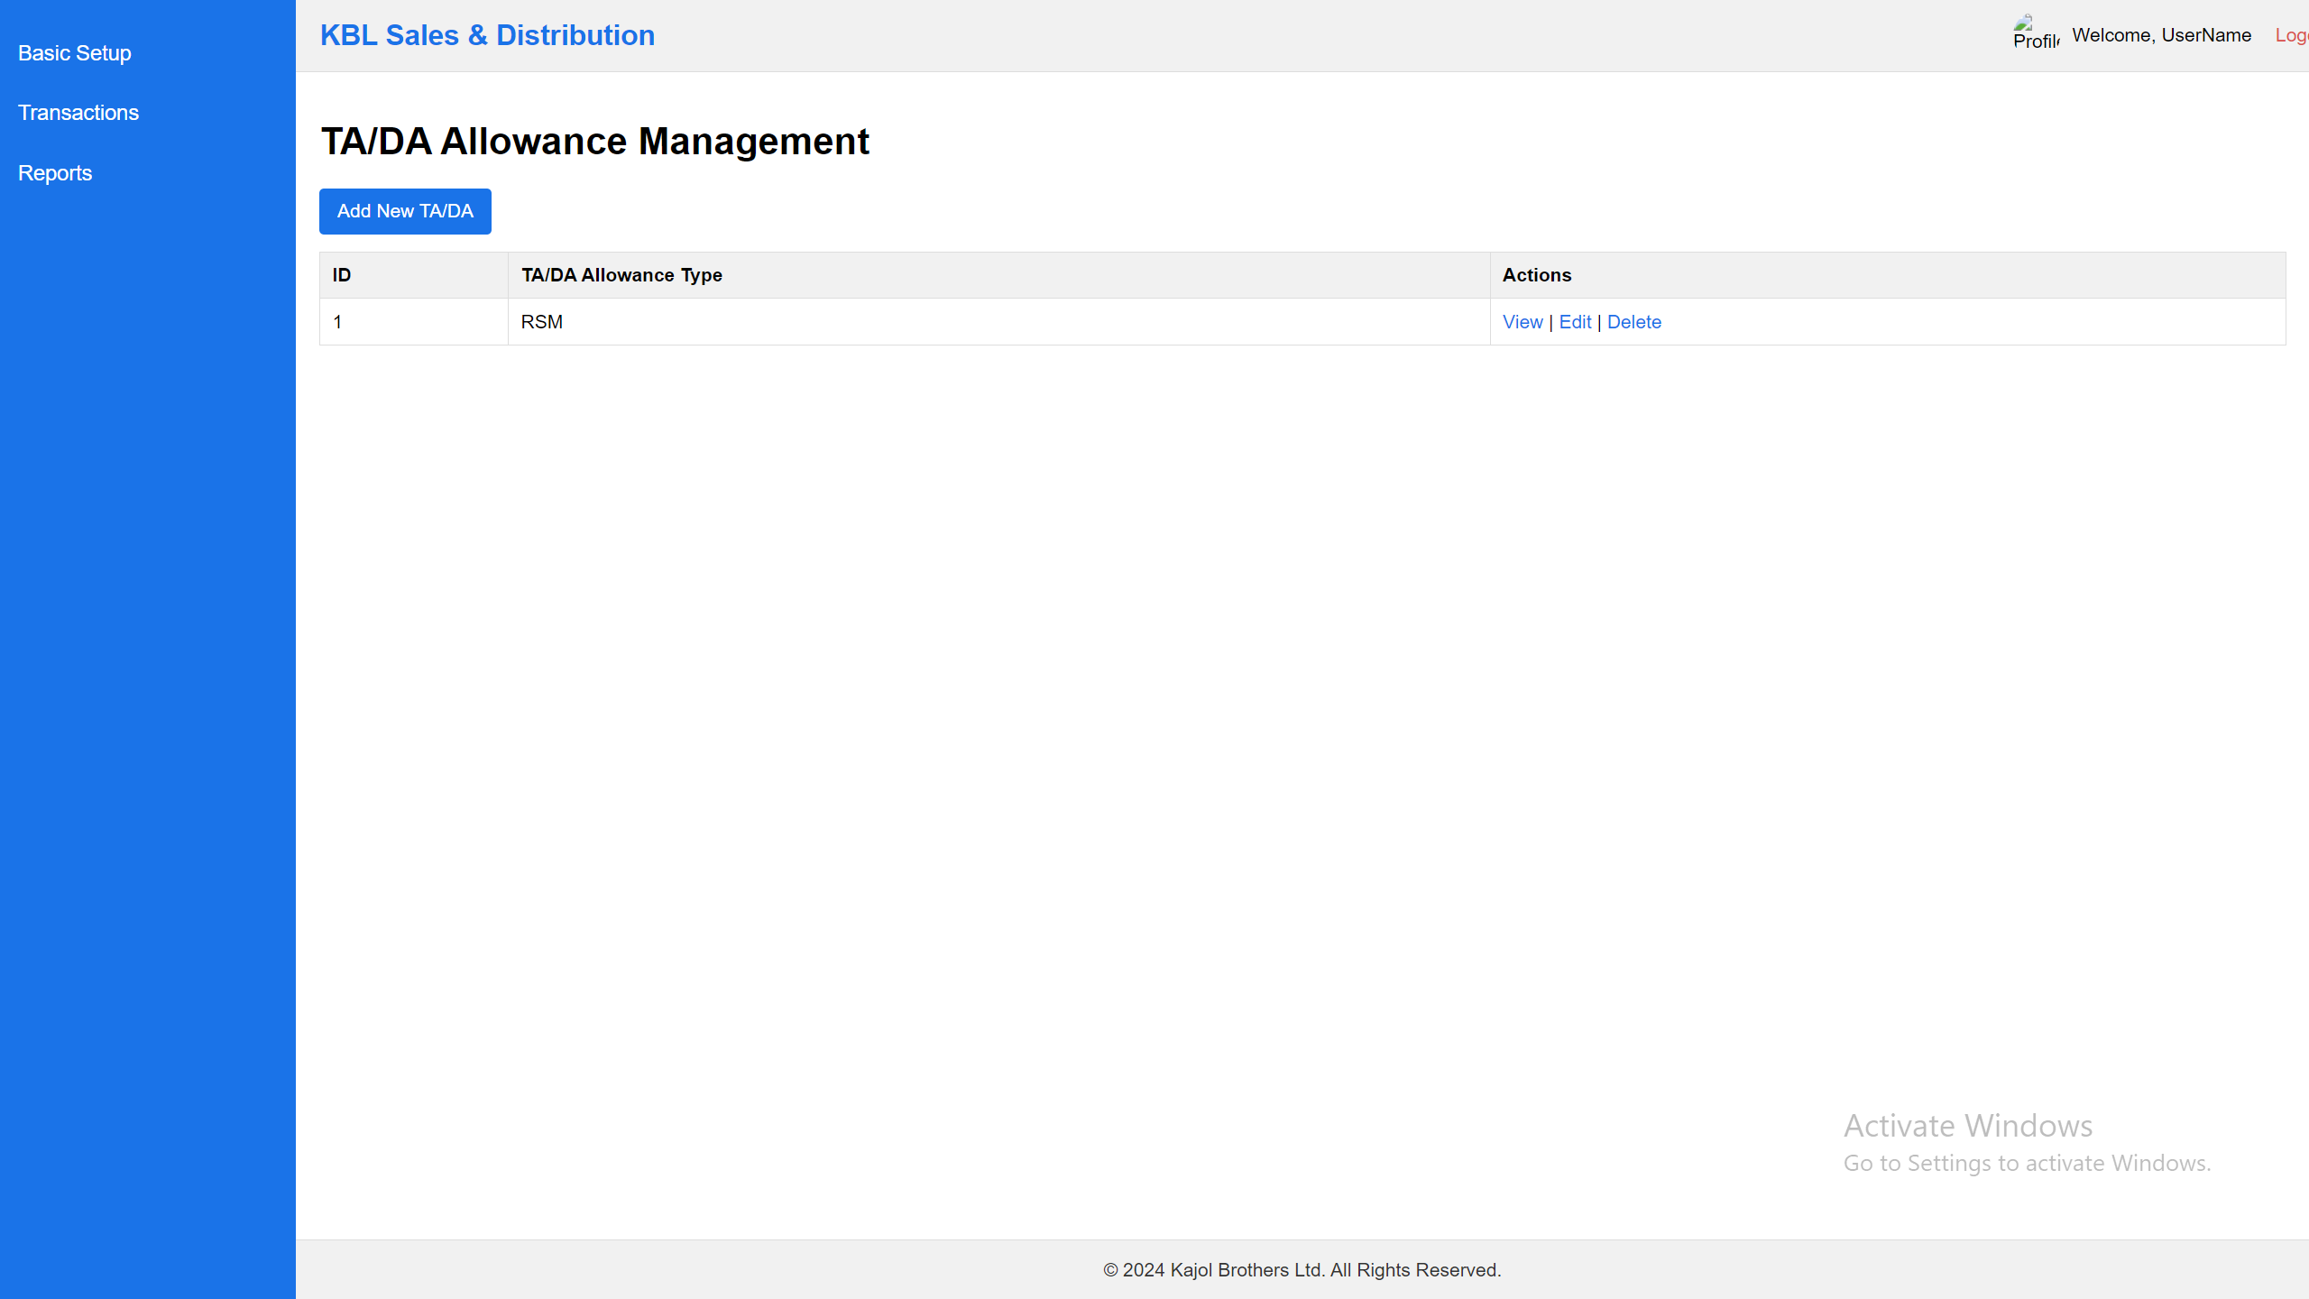

Here Name will be change “TA/DA & Others Allowance Management”

Also TA/DA add form:  
Add New TA/DA & Others Allowance.

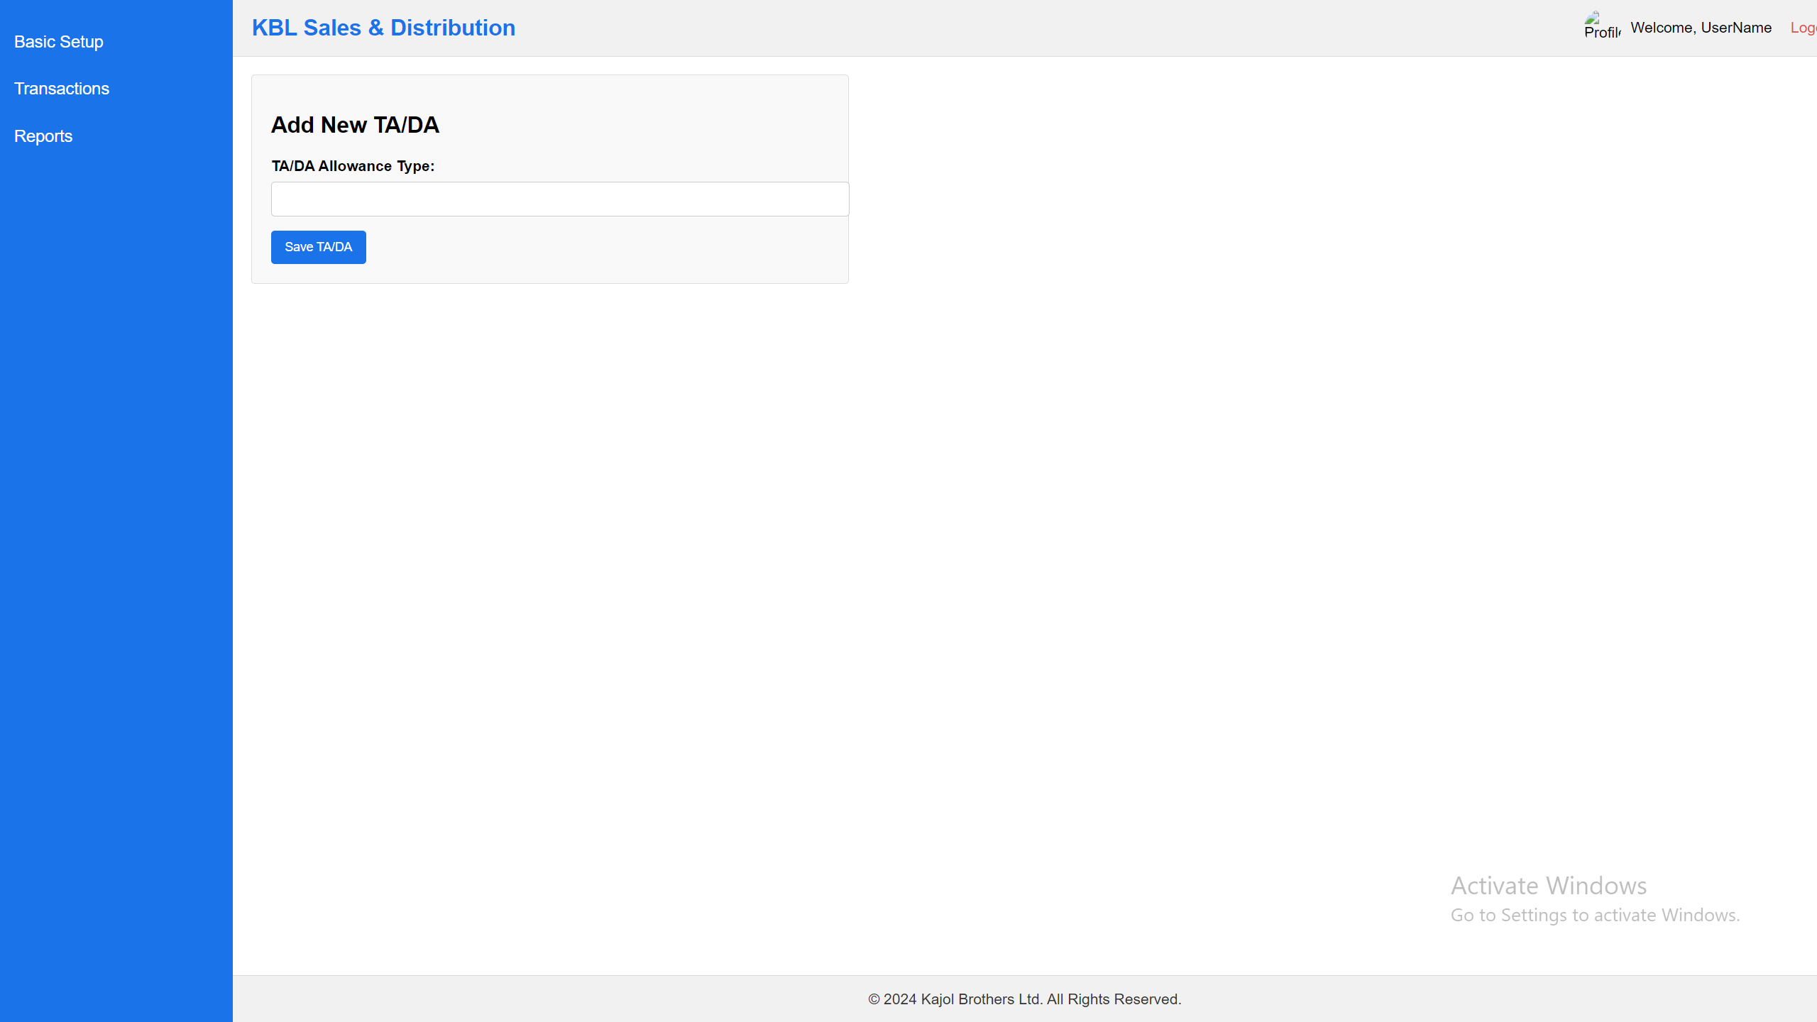

Notes:

1. List of the data can add, view & edit. No delete option.

## **Visit Purposes**

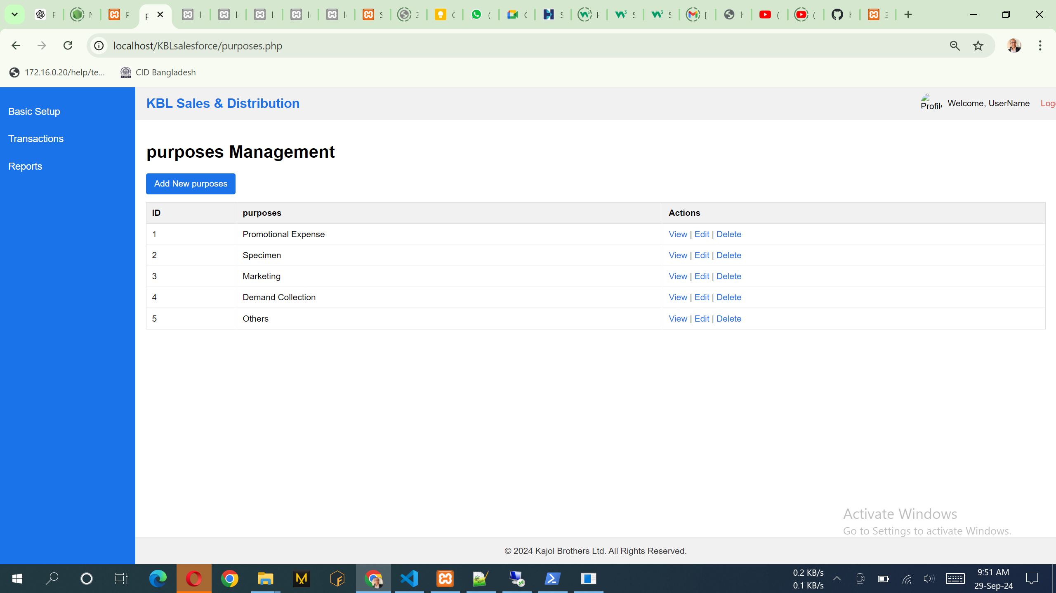

Notes:

1. List of the data can add, view & edit. No delete option.

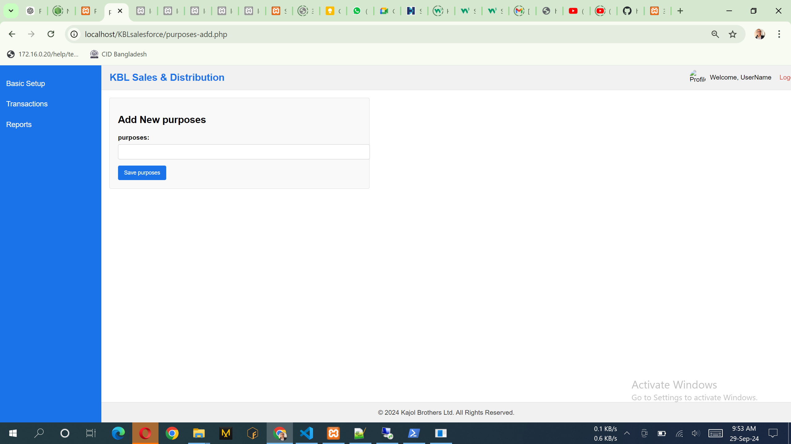

Notes:

1. Purpose can add in this form

## **Mapping Employee VS Region**

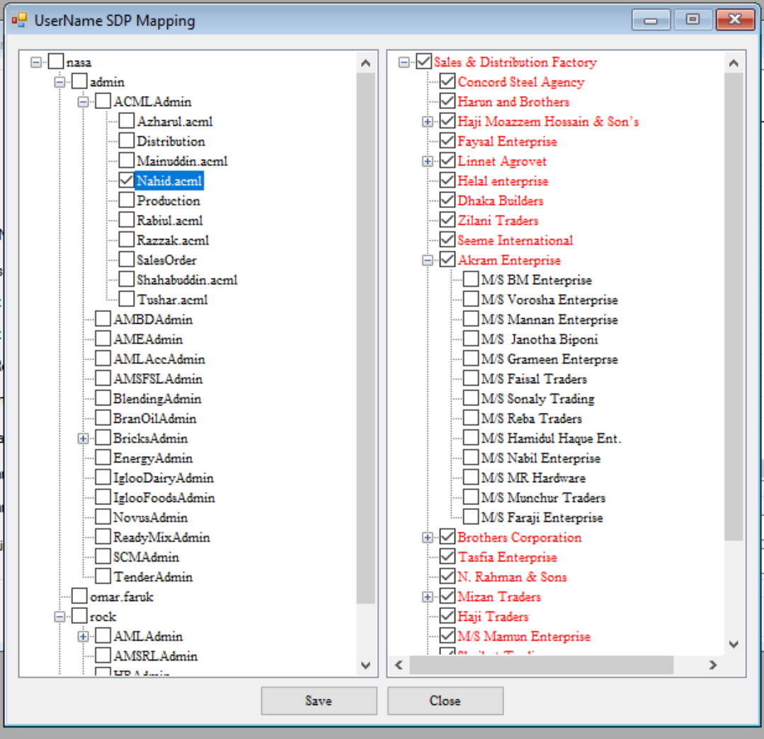

Note:

1. Load all the employee left site with radio button and loan all the Region like Tree with Check box
2. Here we will select one-to-many system.

The data can save & edit. No delete option.

## **Party Management**

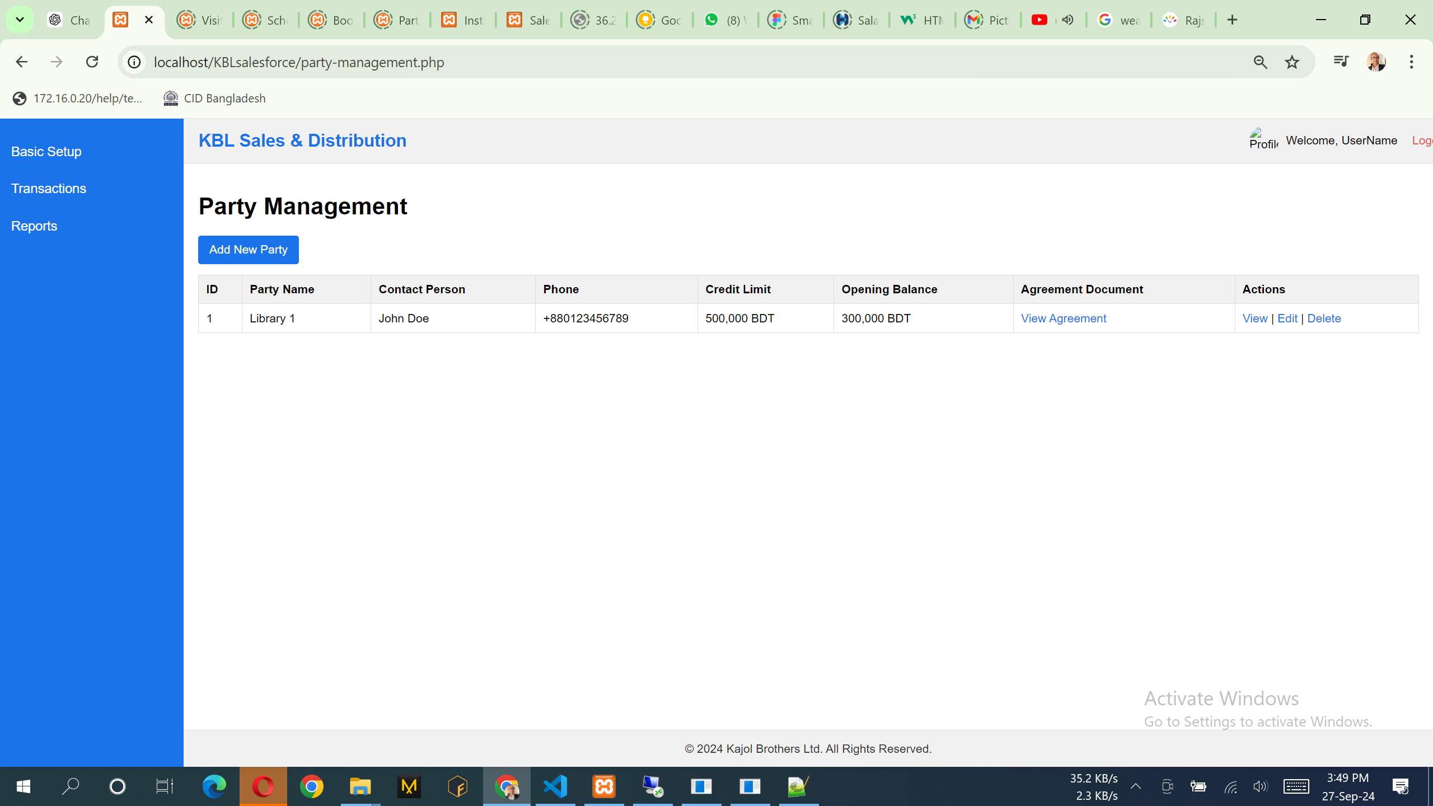

|  |  |
| --- | --- |
|  |  |
|  |  |
|  |  |

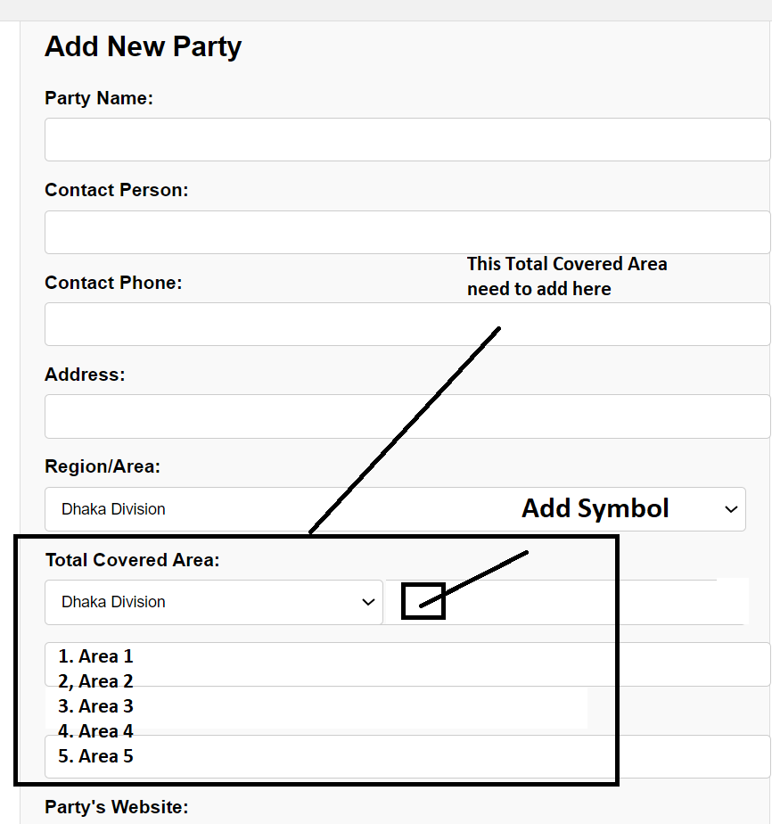

Notes:

1. Also in this design there should be two column system.
2. List of the data can add, view & edit. No delete option.
3. Region/Area: Data will come from the Region form of all area.
4. All the attached image or pdf is mandatory except TIN number. Attached document must have download option when client need. List of the data have a view option that can see the report with all the attached document in a single report and report can print.
5. Also in this design there should be two column system.

# **Transactions**

## **Assign Visit Plans**

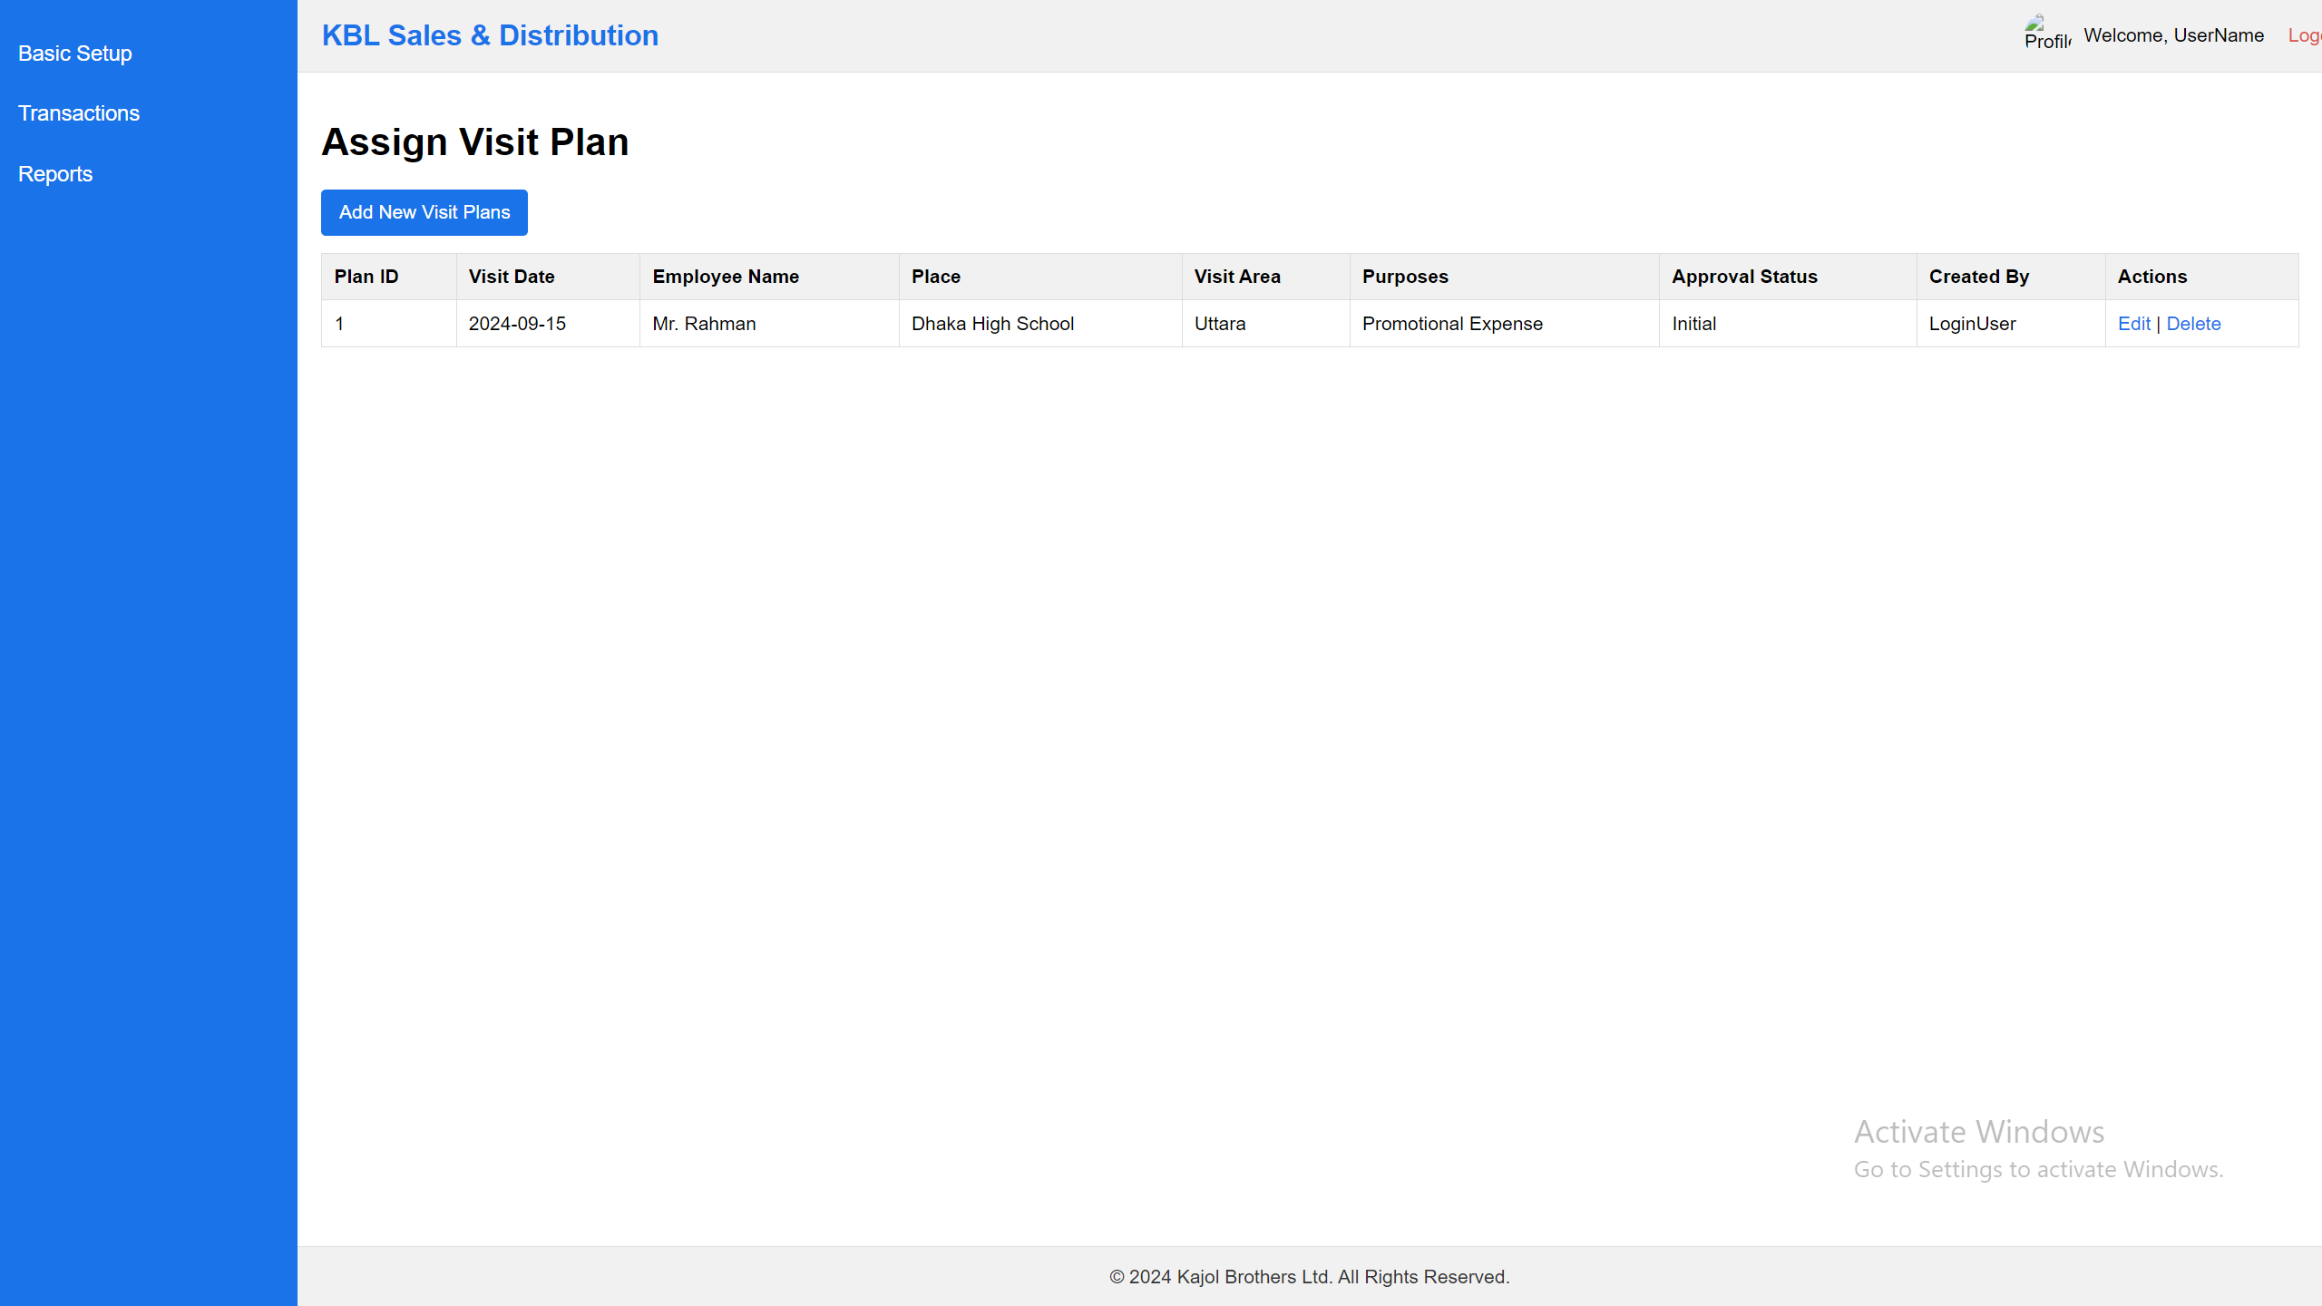

Notes:

1. List of the data can add, view & edit. No delete option.

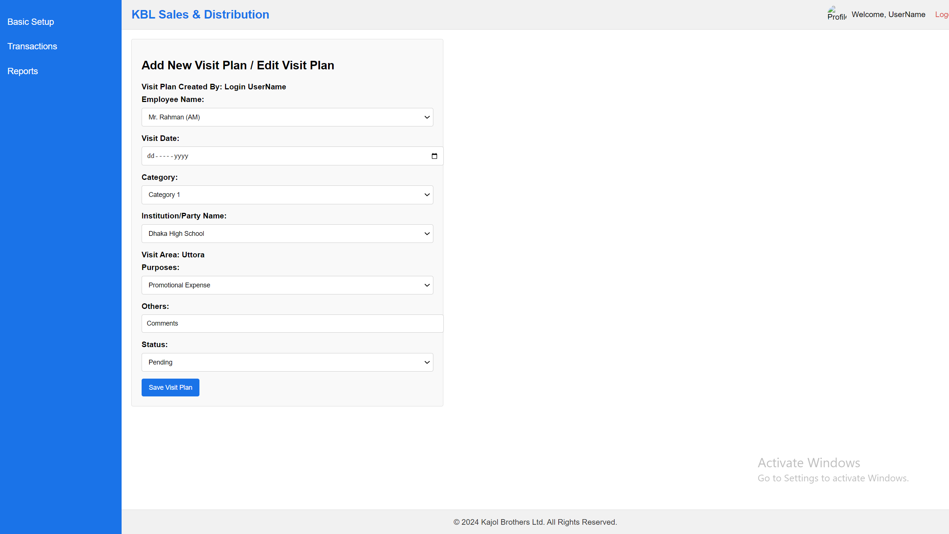

Notes:

1. Visit Plan can only create ZM/AM person who have the permission and one ZM/AM can’t see or load others ZM/AM person’s visit plan. It always depends on login user and login user data will load here.
2. List of the data can add, view & edit. No delete option.
3. Visit Area: Data will come from the party entry form previously set the area.
4. Purpose: Data will load Promotional Expense, Specimen, Marketing, Demand Collection, Others
5. Here when select purpose “Others” then Others next text box will come otherwise Others text box will not showing here.
6. Status will load two data pending & complete.
7. Initially ApprovalStatus = “pending”
8. Initially Status = “pending”

## **Visit Approval Process**

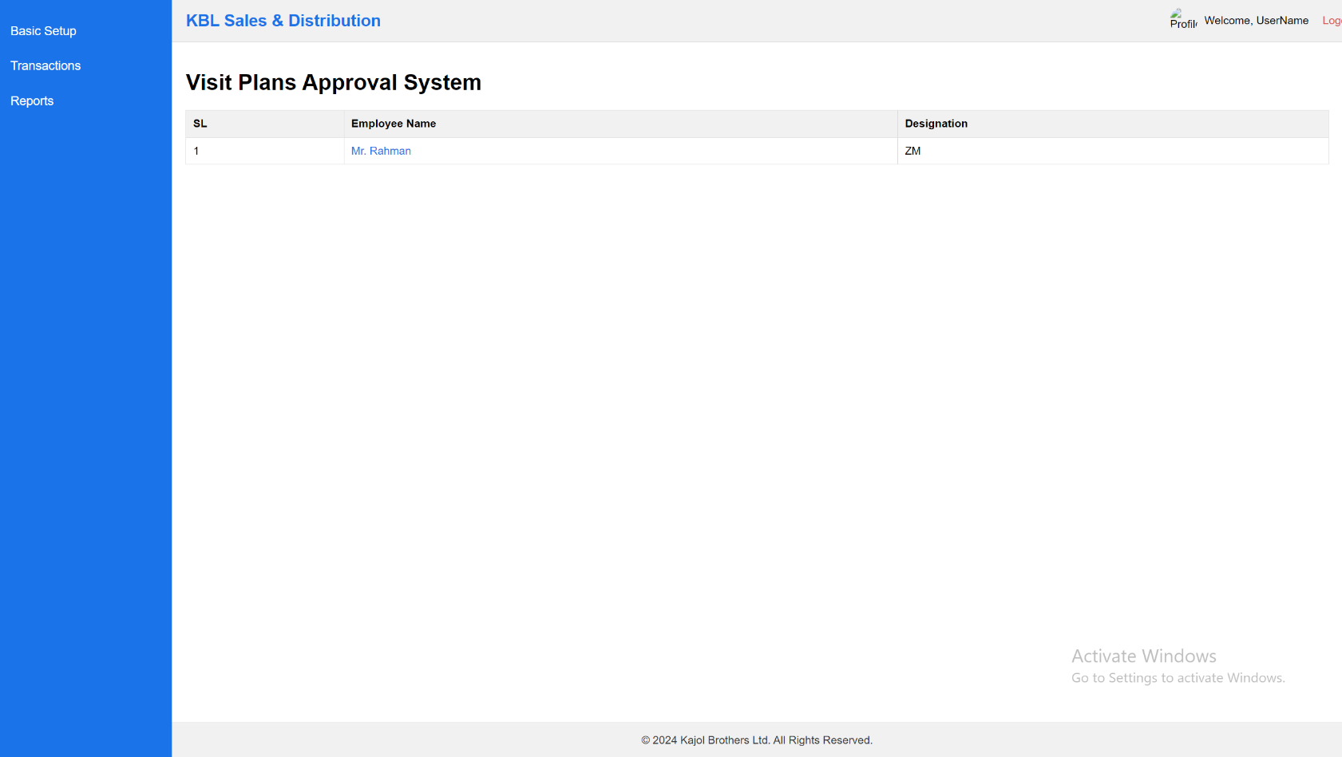  
Note:

1. Visit plan approval pending data only can show here and RSM can only approve the data as per his under AM/ZM created data and this reporting boss relation data will come from Employee Registration system.

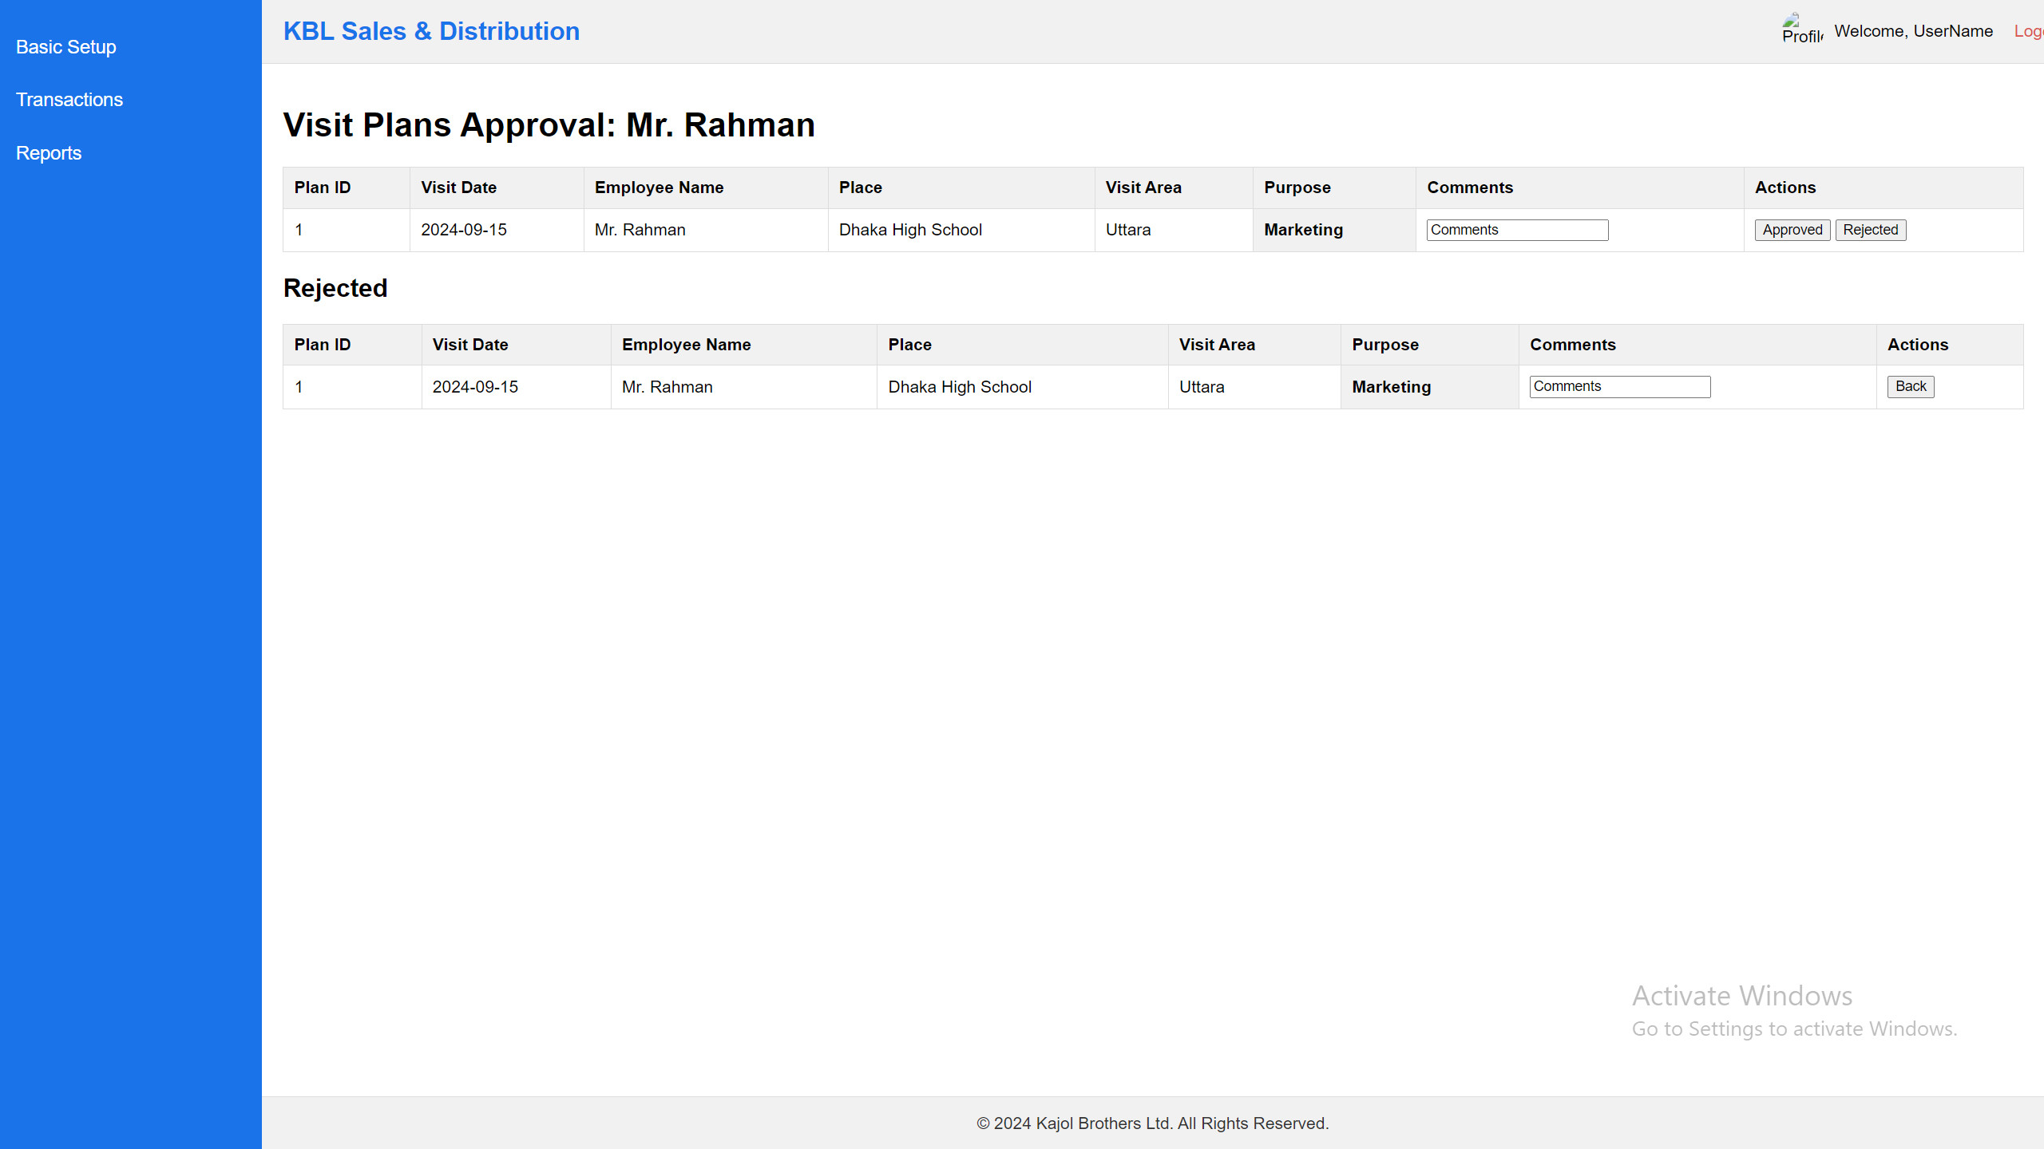

Note:

1. Visit Data when approved then data will automatically omit from here and also rejected data will auto goto Rejected list.
2. Initially ApprovalStatus = “Complete”
3. Initially Status = “pending”

## **Visit Entry**

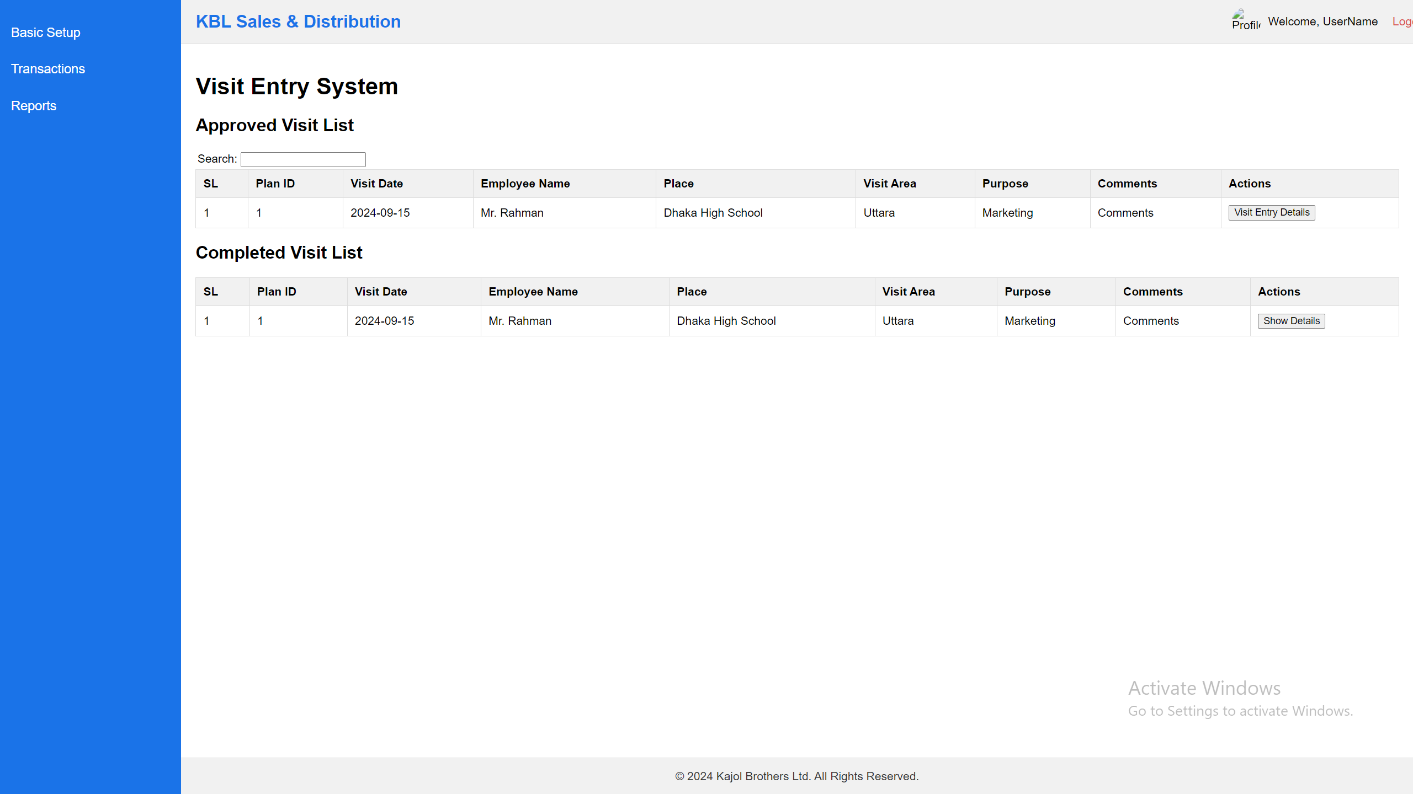

Note:

1. Visit Data Only can see those employee’s data who actually login here and he can enter Visit Entry Details.
2. “Show Details” button will show details report of the visit entry data.

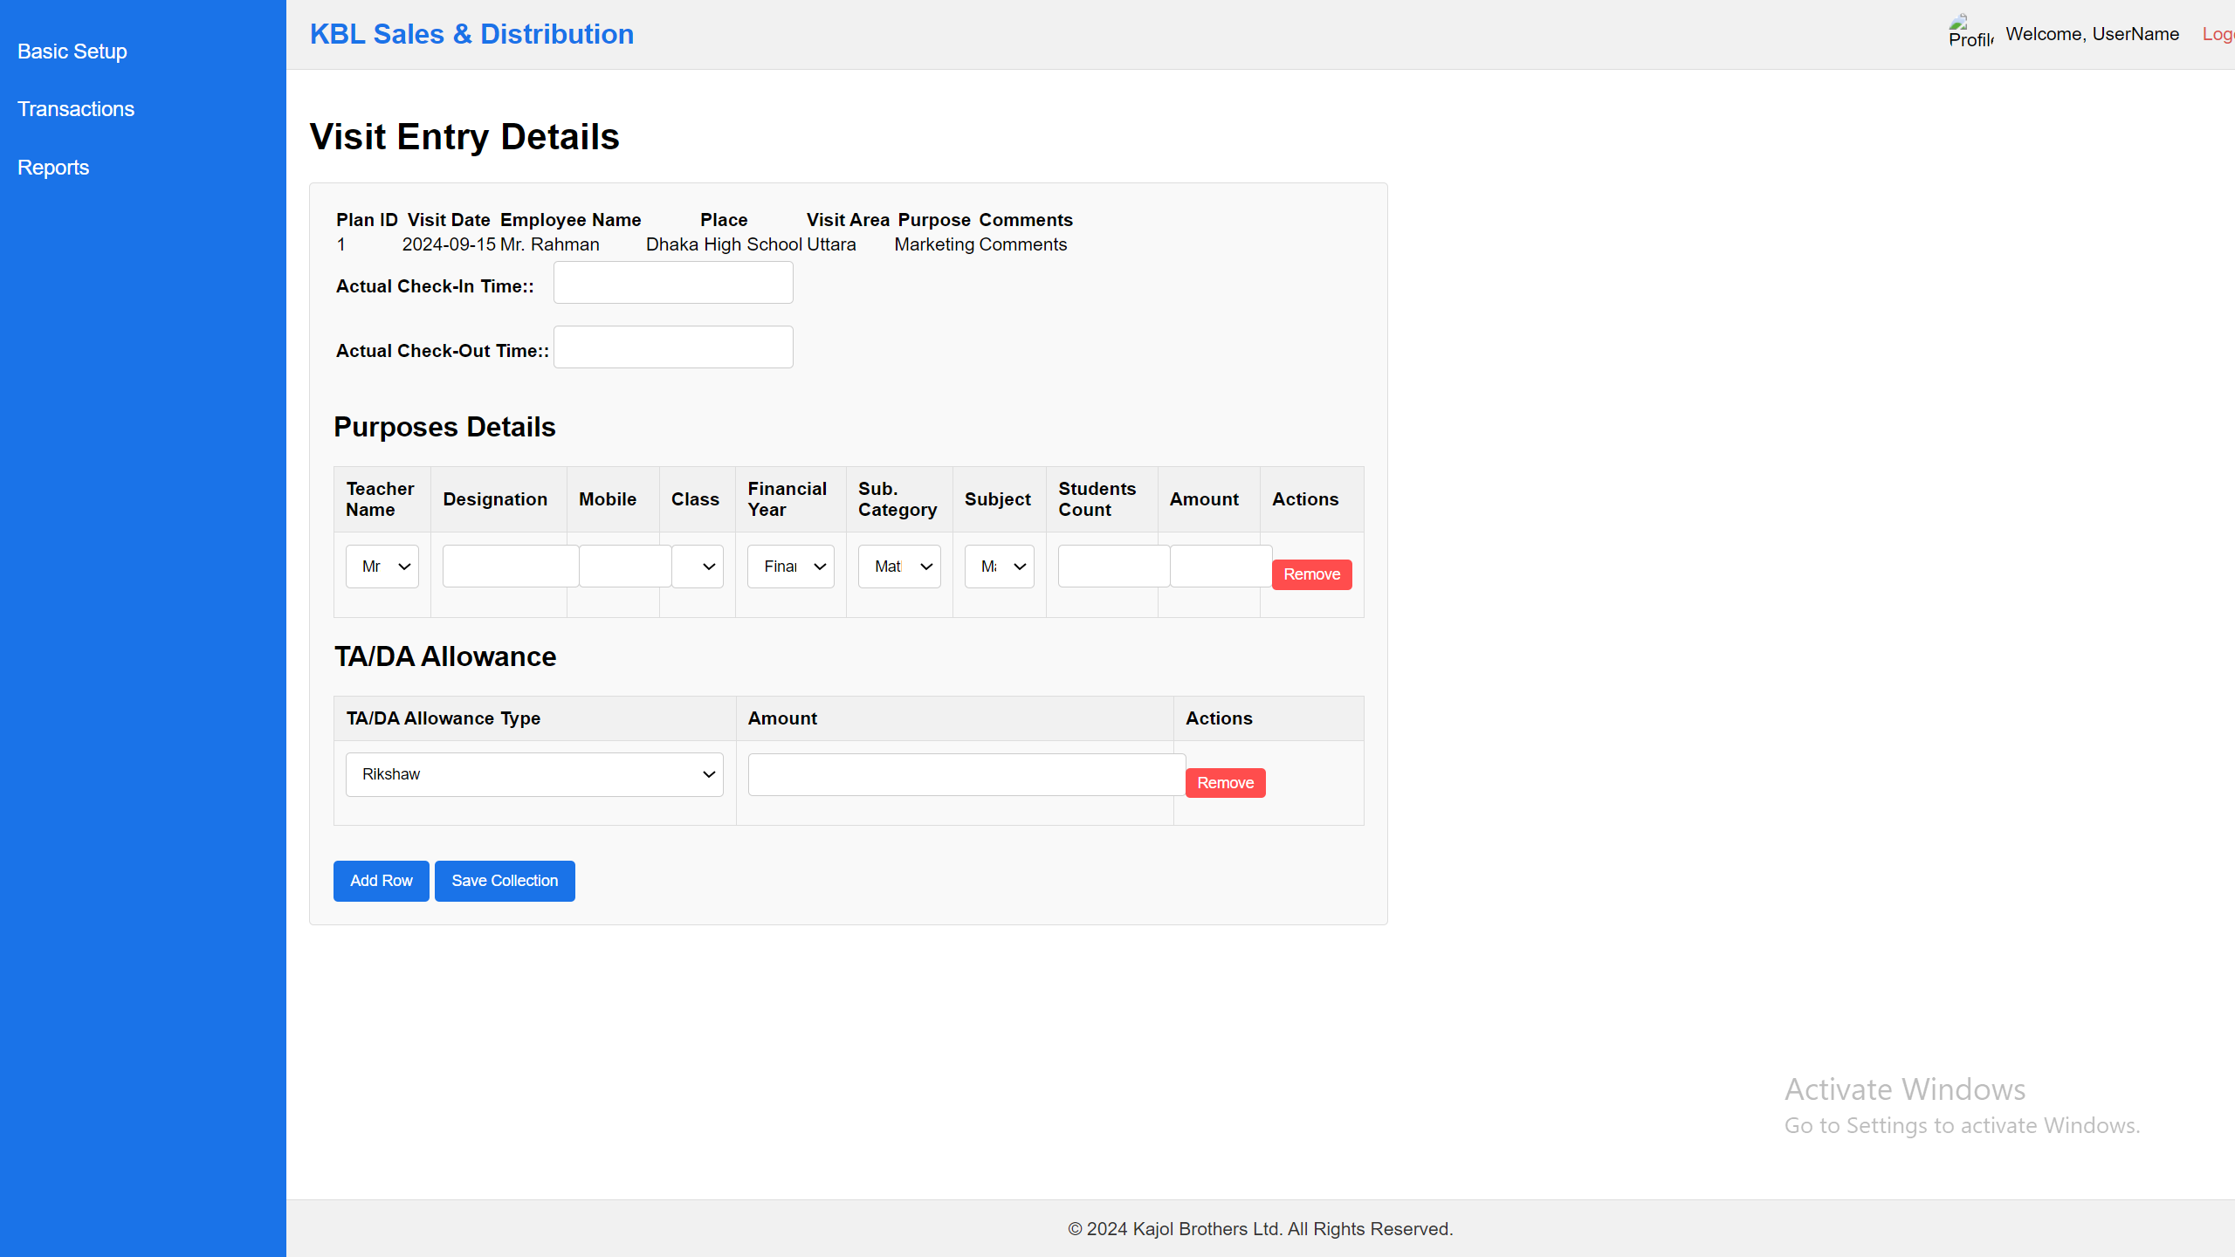

Note:

1. Visit Data must be enter from the visited location because geo-located data will auto save in the system and user enter check-in time and check-out time data.
2. Teacher combo data will load from the visit places school/college/coaching center entry form where initially enter all the teacher data.
3. Financial Year data will load from Financial Year Data.
4. Category data will load from product category data.
5. Subject will come from the product table all the data.
6. If the Purpose : Demand Collection then Student count & Amount will show here, but rest of the all purpose will not load this two column.
7. TA/DA Allowance data will load from the TA/DA Allowance type data.

## **Visit Approval**

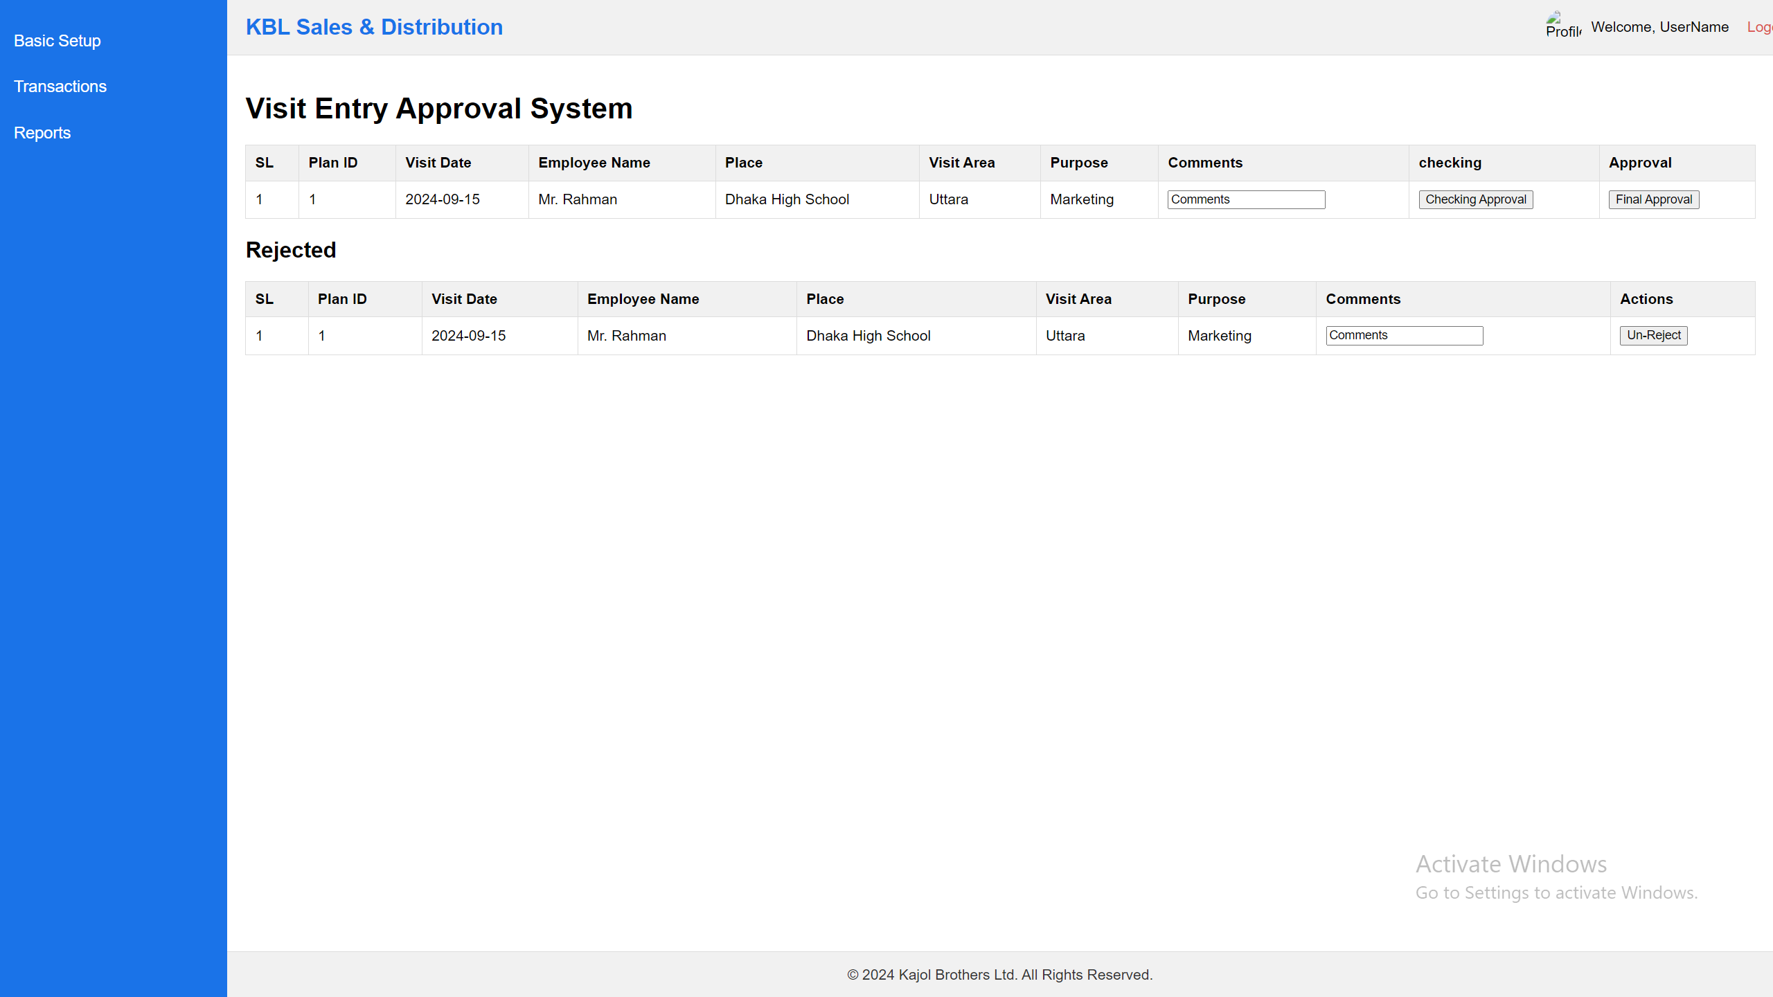

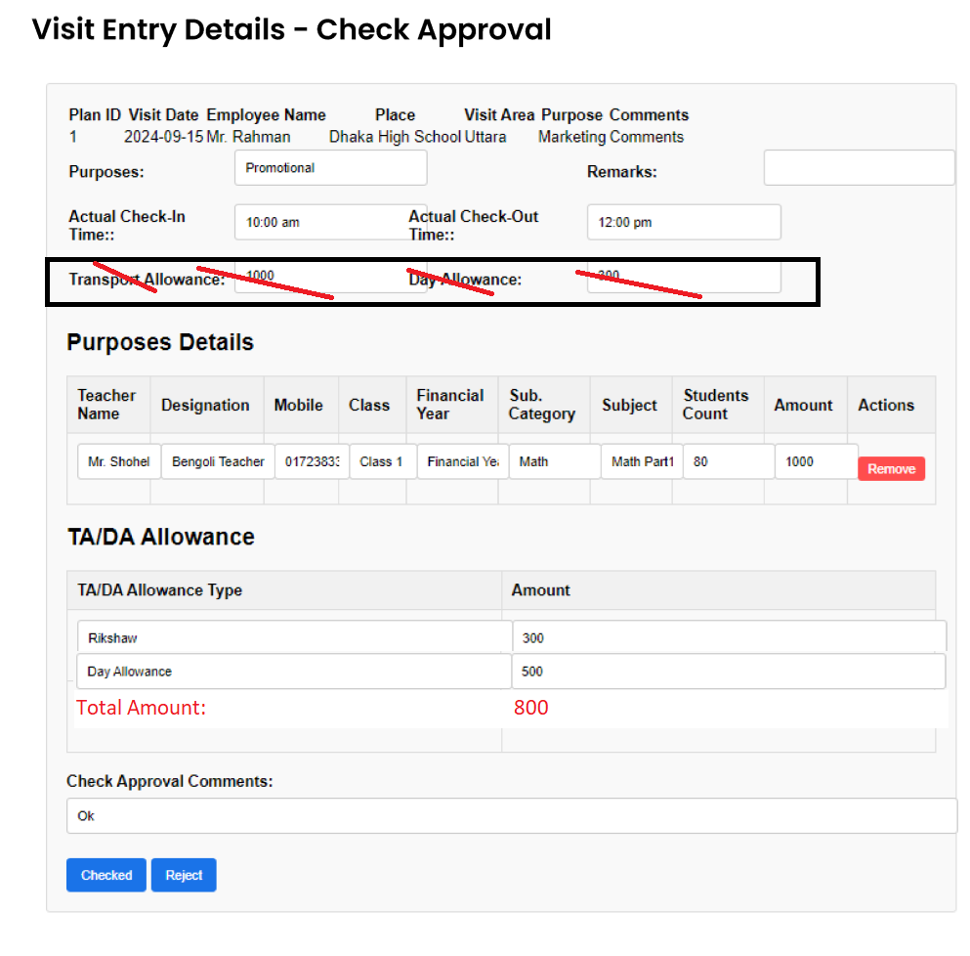

For Update visitplan master table

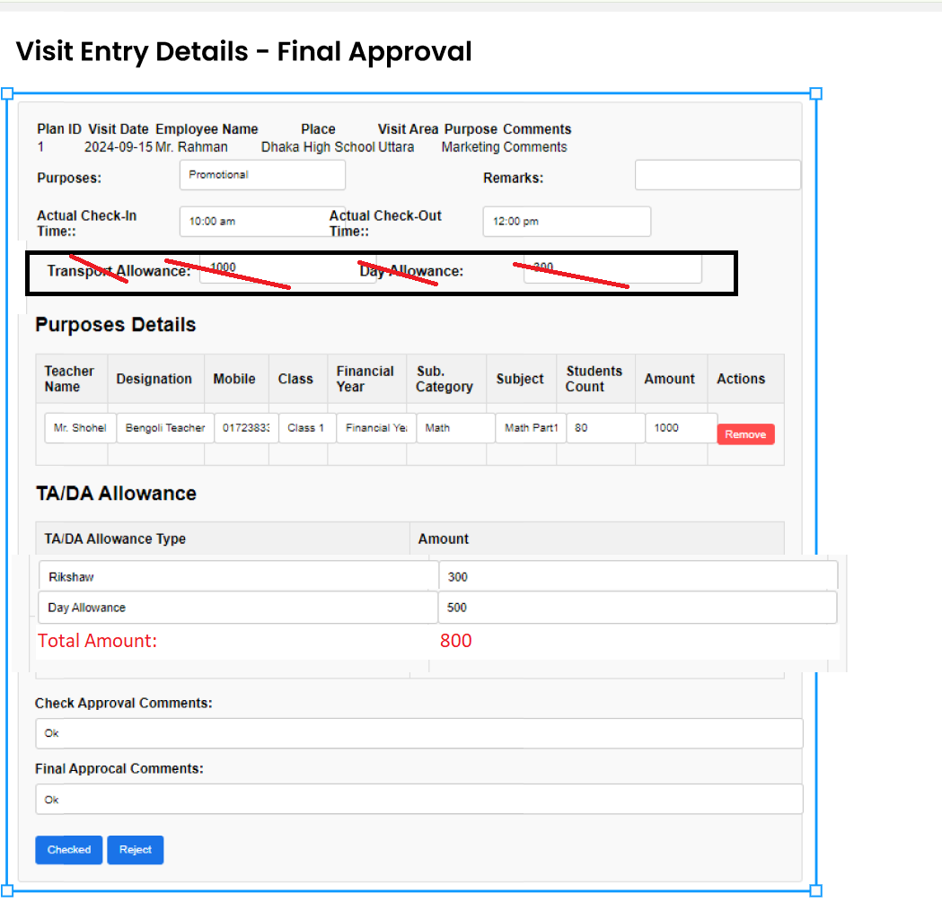

## **Production Order**

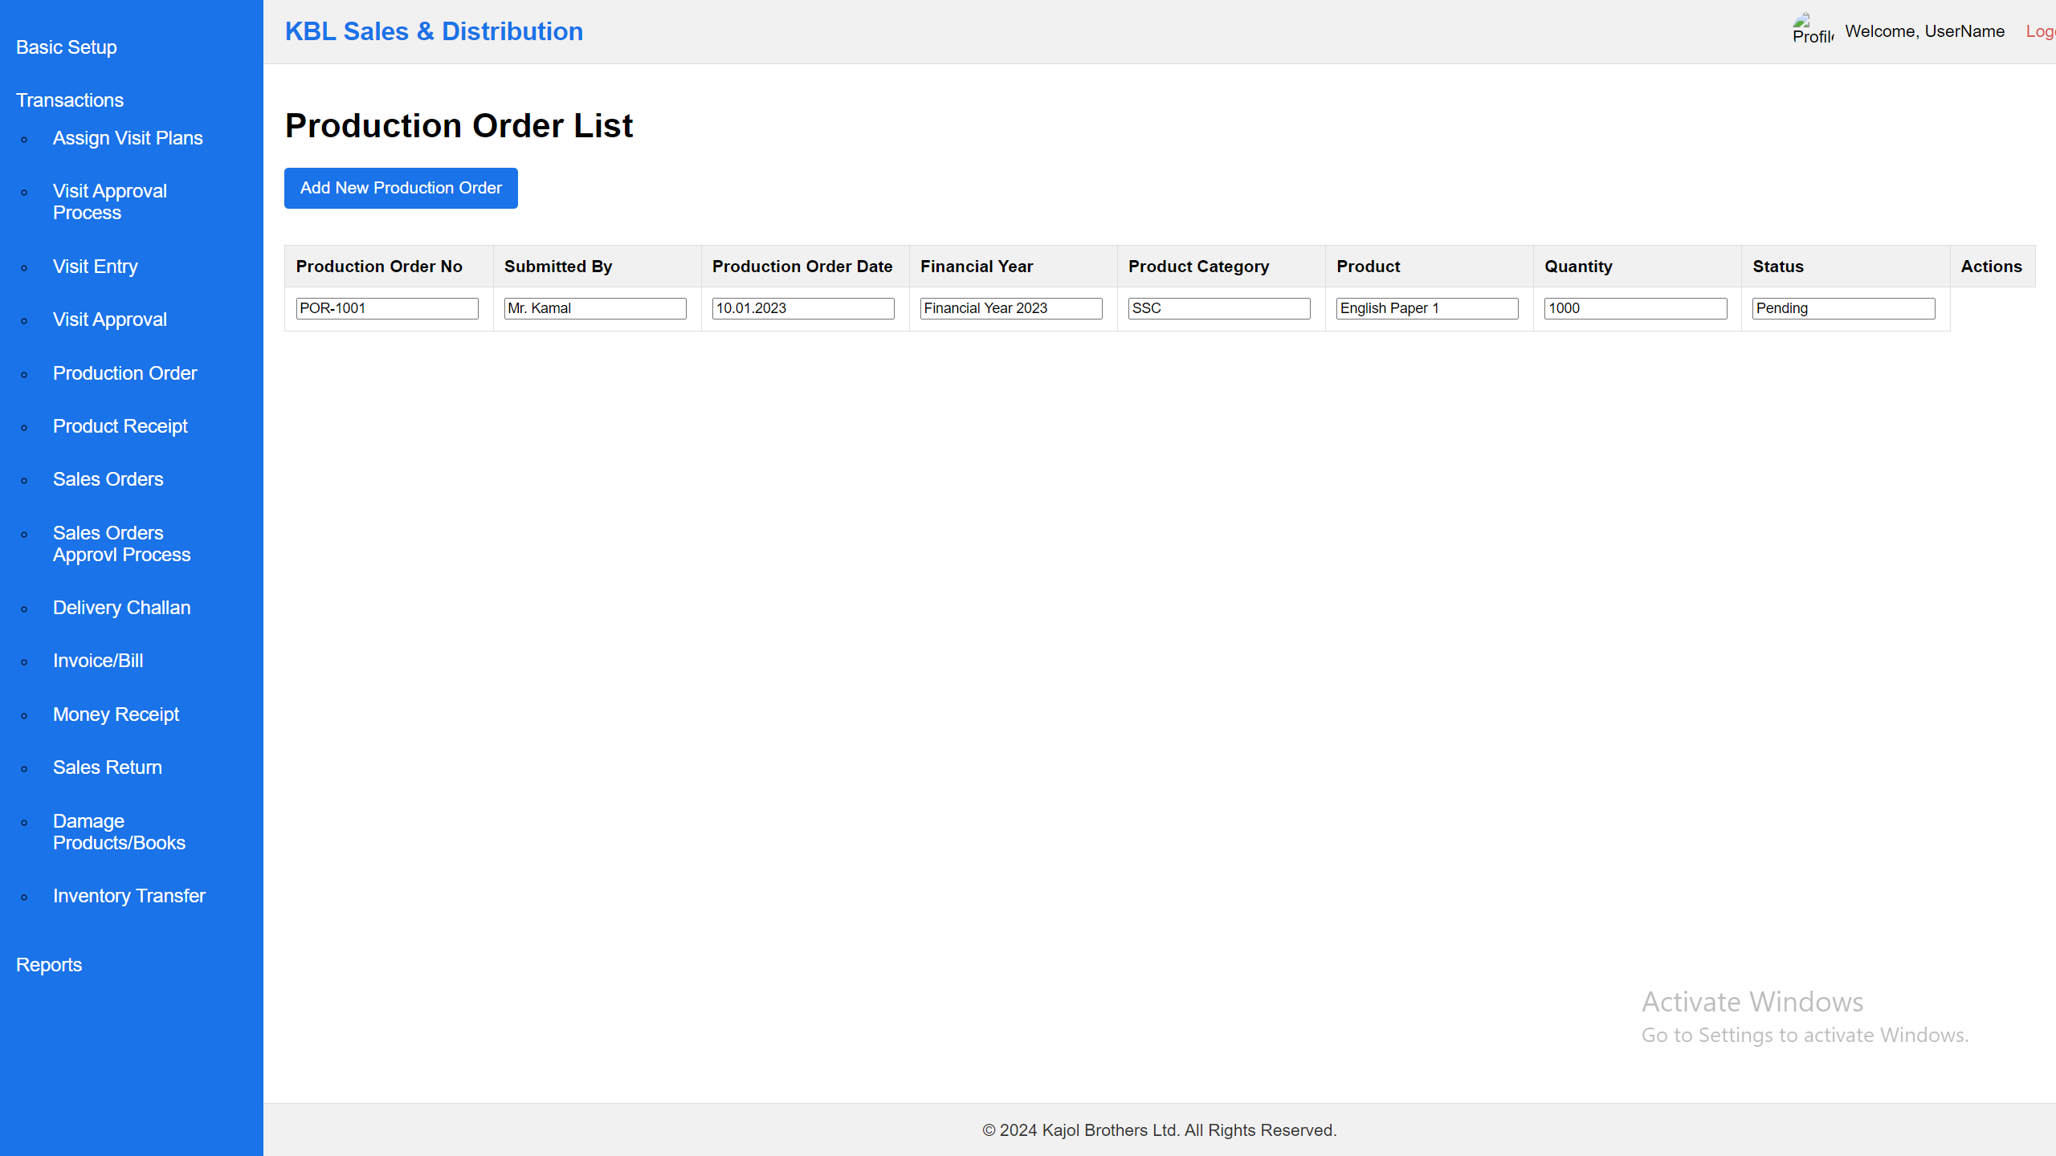

Notes:

1. List of the data can add, view & edit. No delete option.

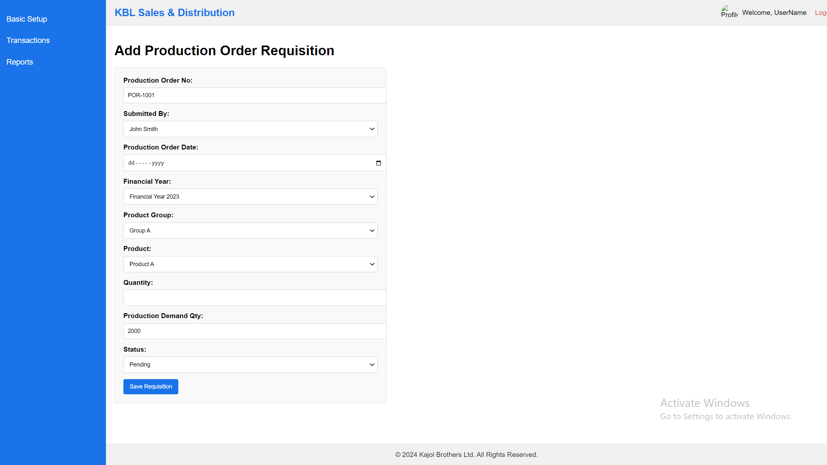

Notes:

1. ProductionOrderNo will auto generated
2. Production demand Qty will come from the previous demand collection.
3. Initially Status = “pending”, “On-progress”, “Complete”

## **Product Receipt**

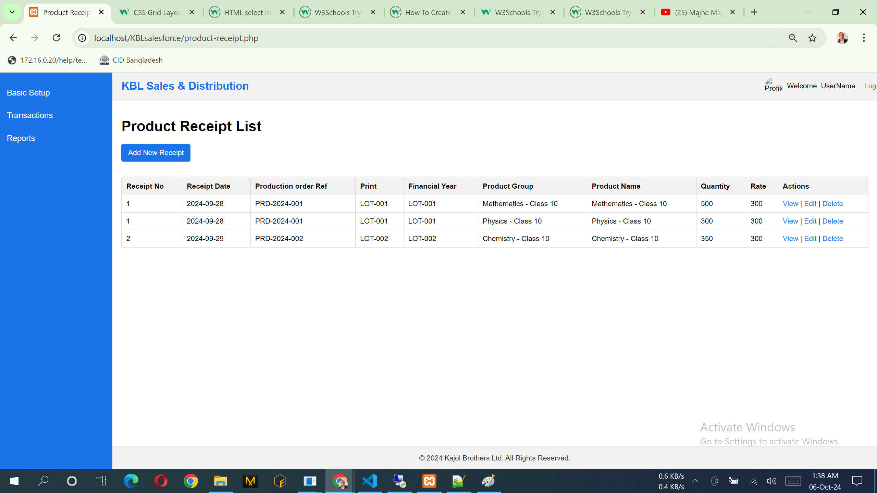

Notes:

1. List of the data can add, view & edit. No delete option.

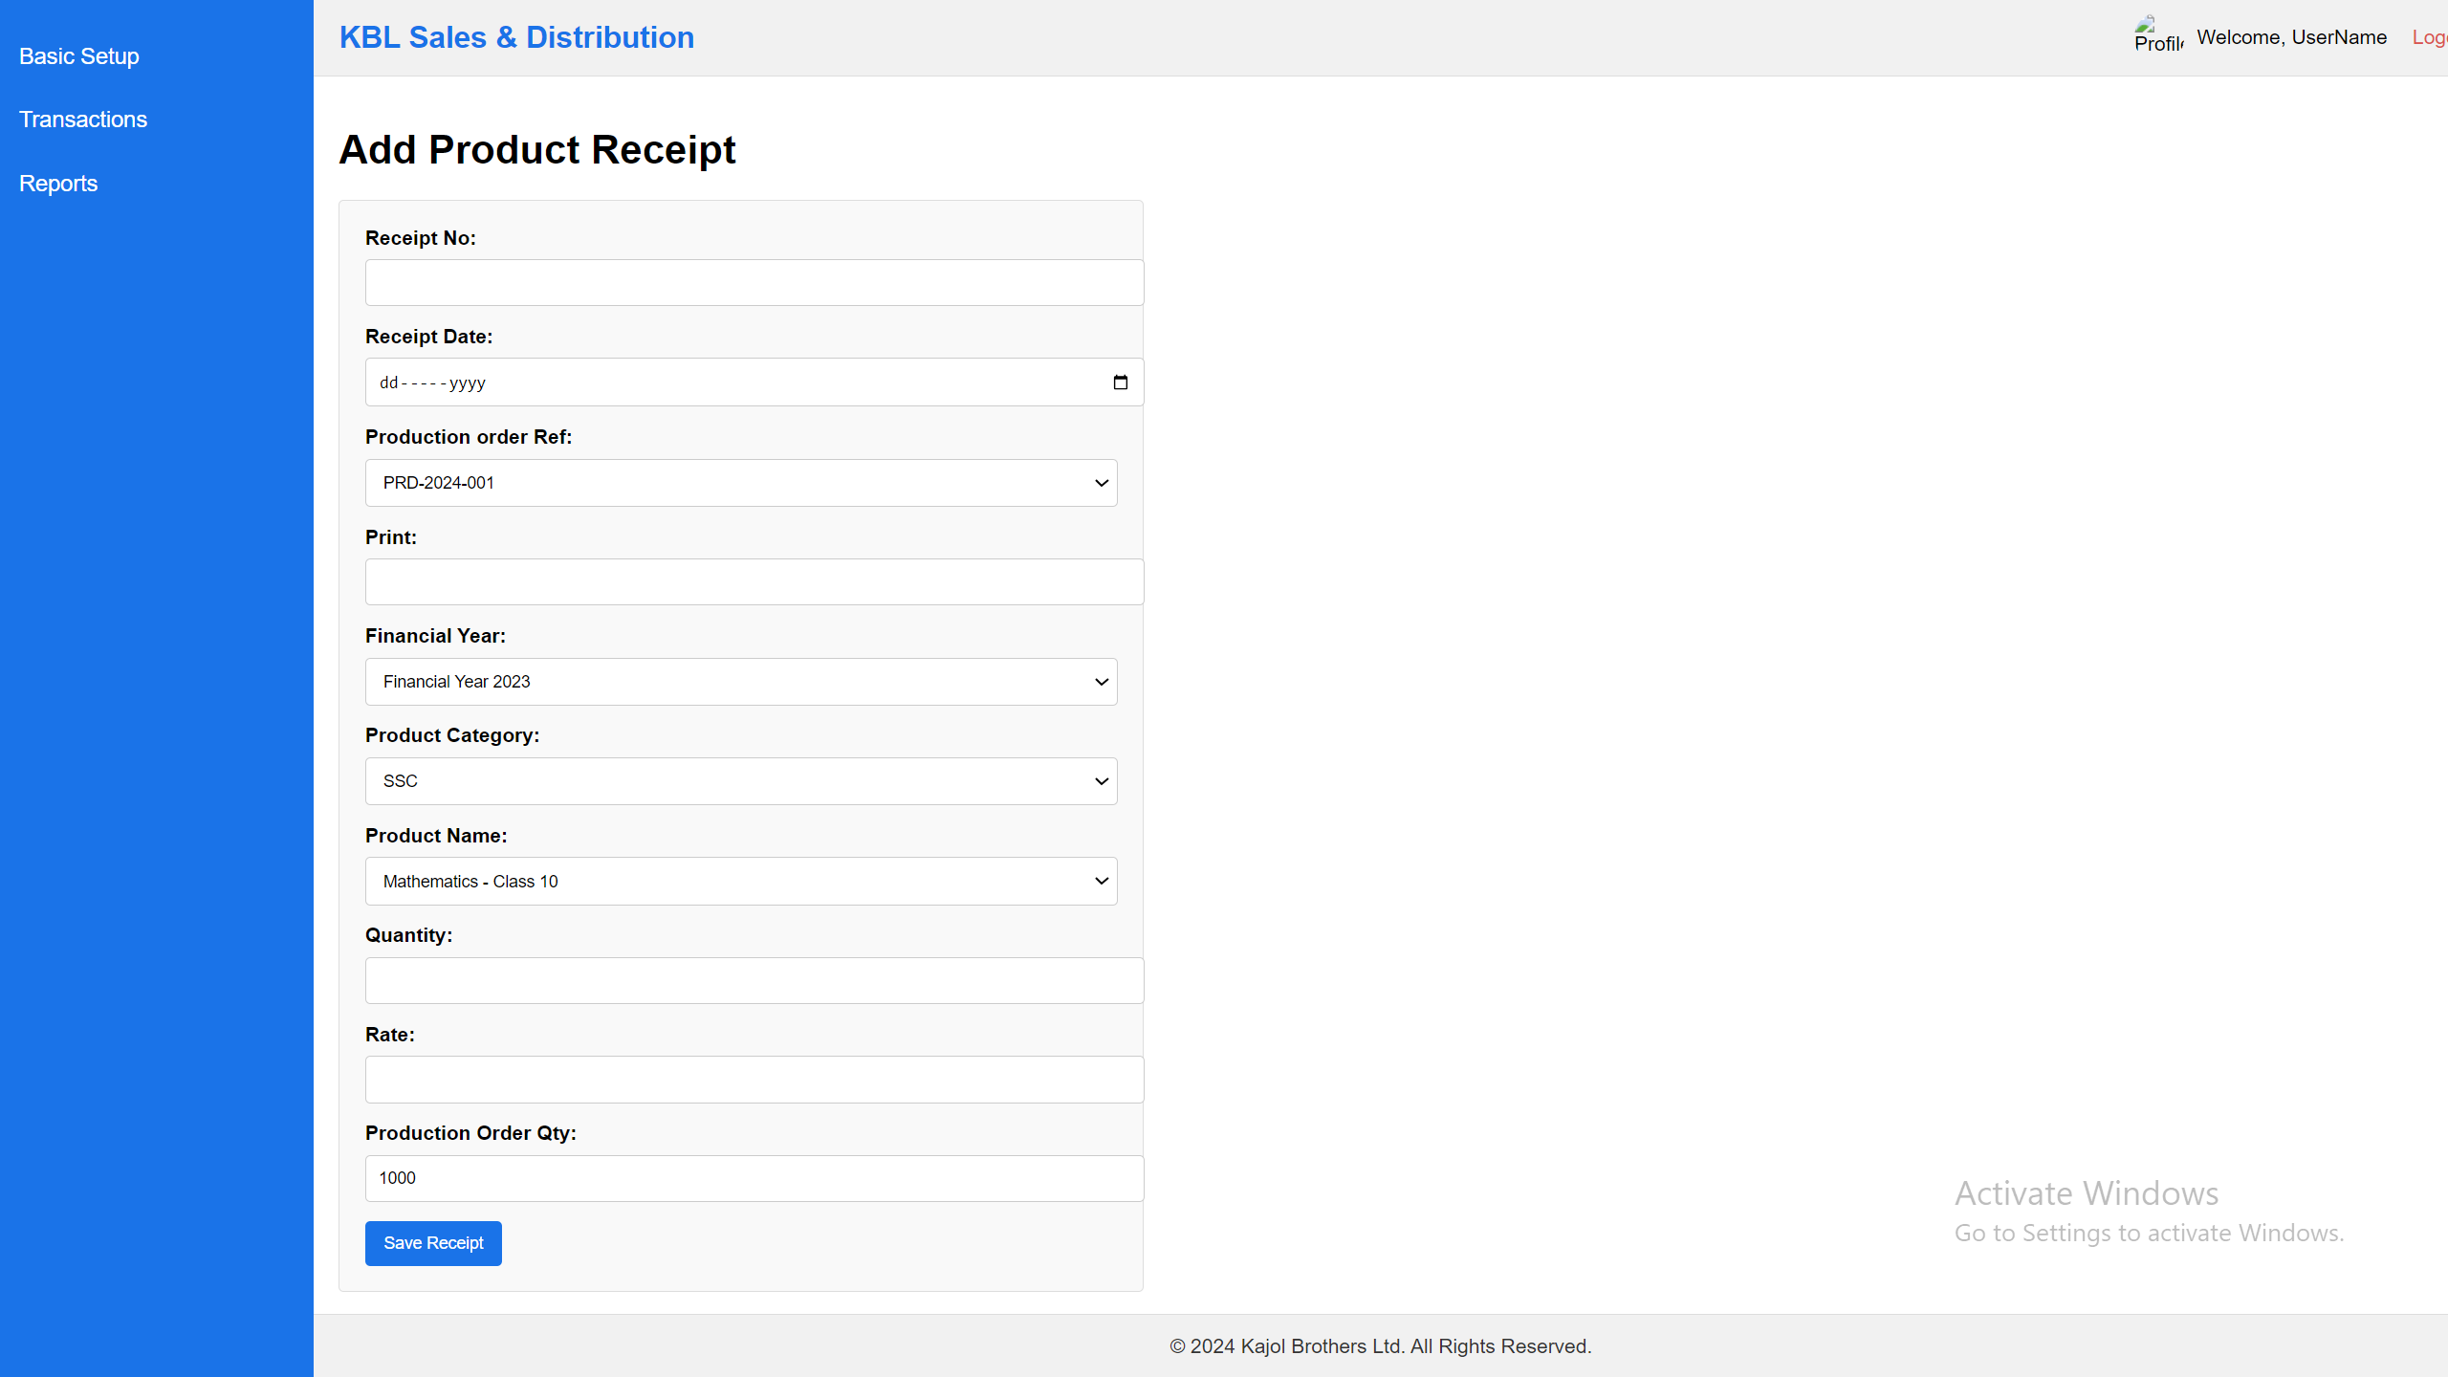

Notes:

1. Production Order Qty will auto come when select production order ref
2. production order ref combox data come from production order
3. Receipt Number will auto generate like PRT-1001

## **Sales Orders**

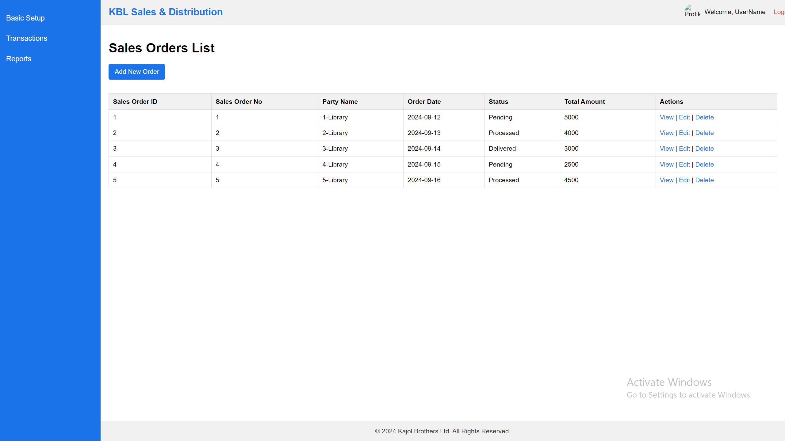

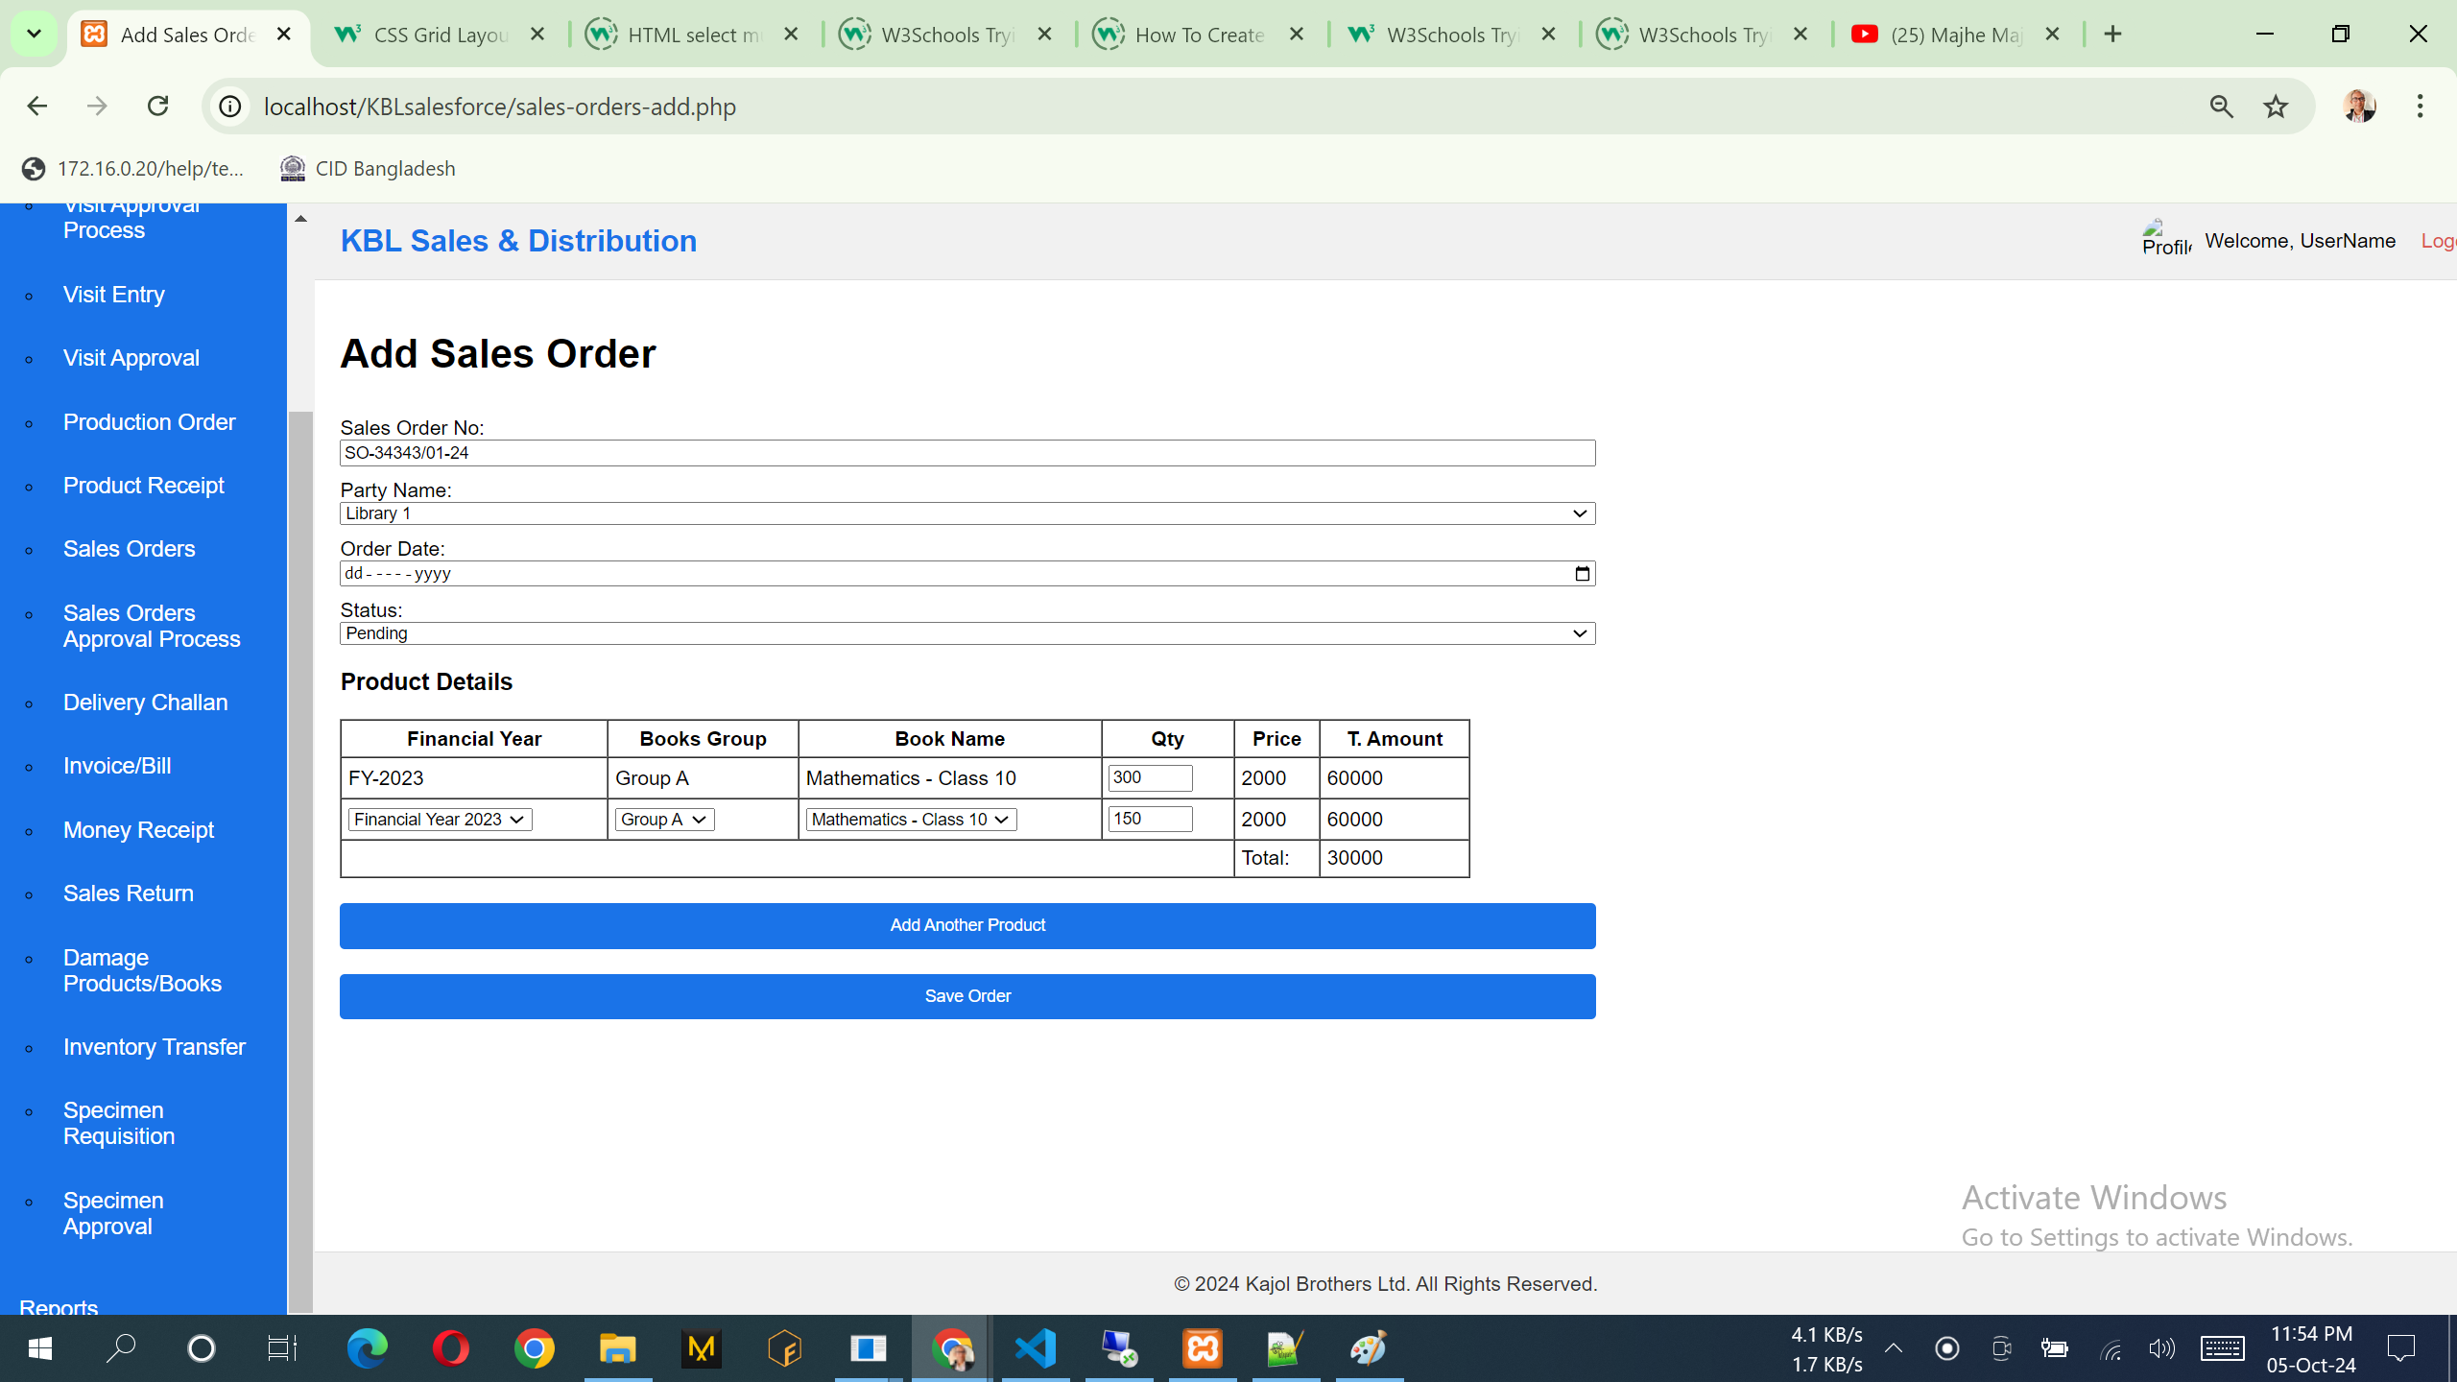

## **Money Receipt**

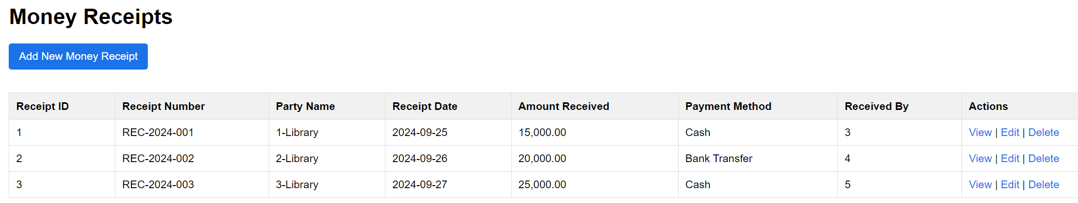

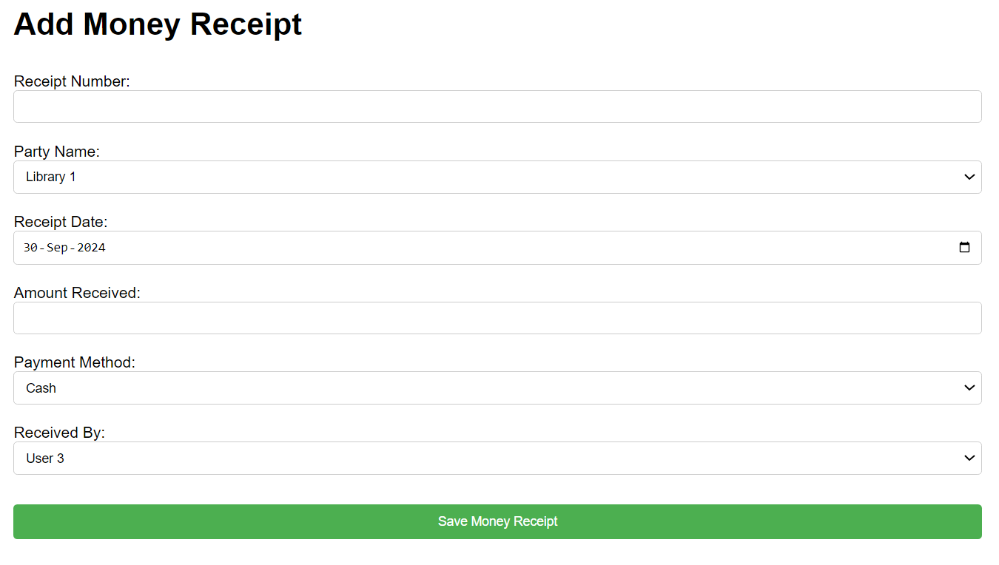

## **Sales Return**

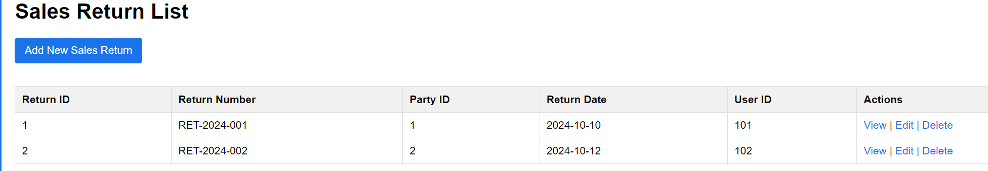

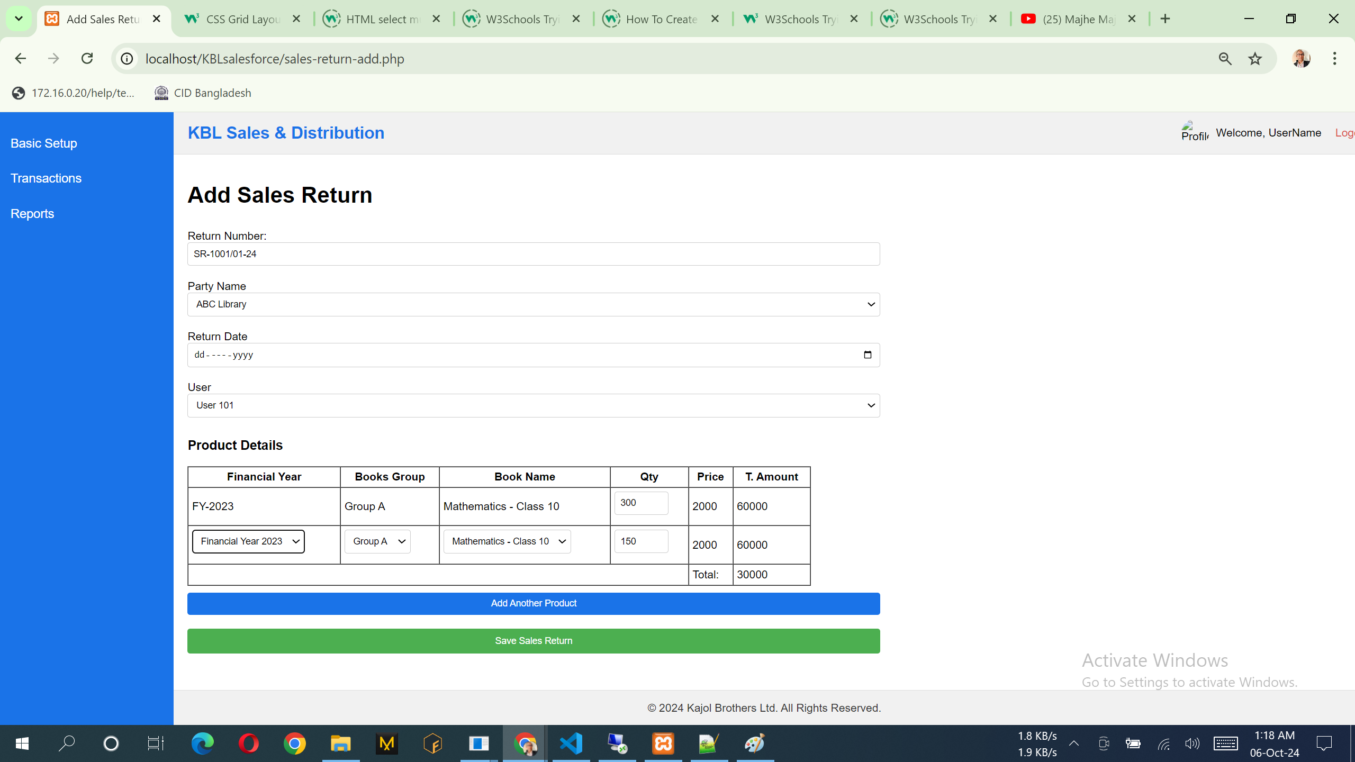

## **Damage Products/Books**

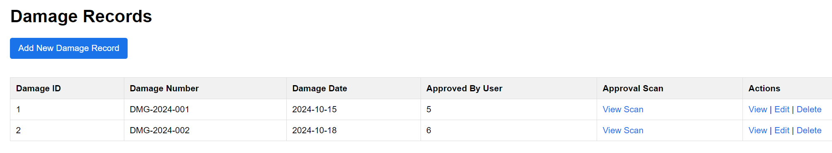

Notes:

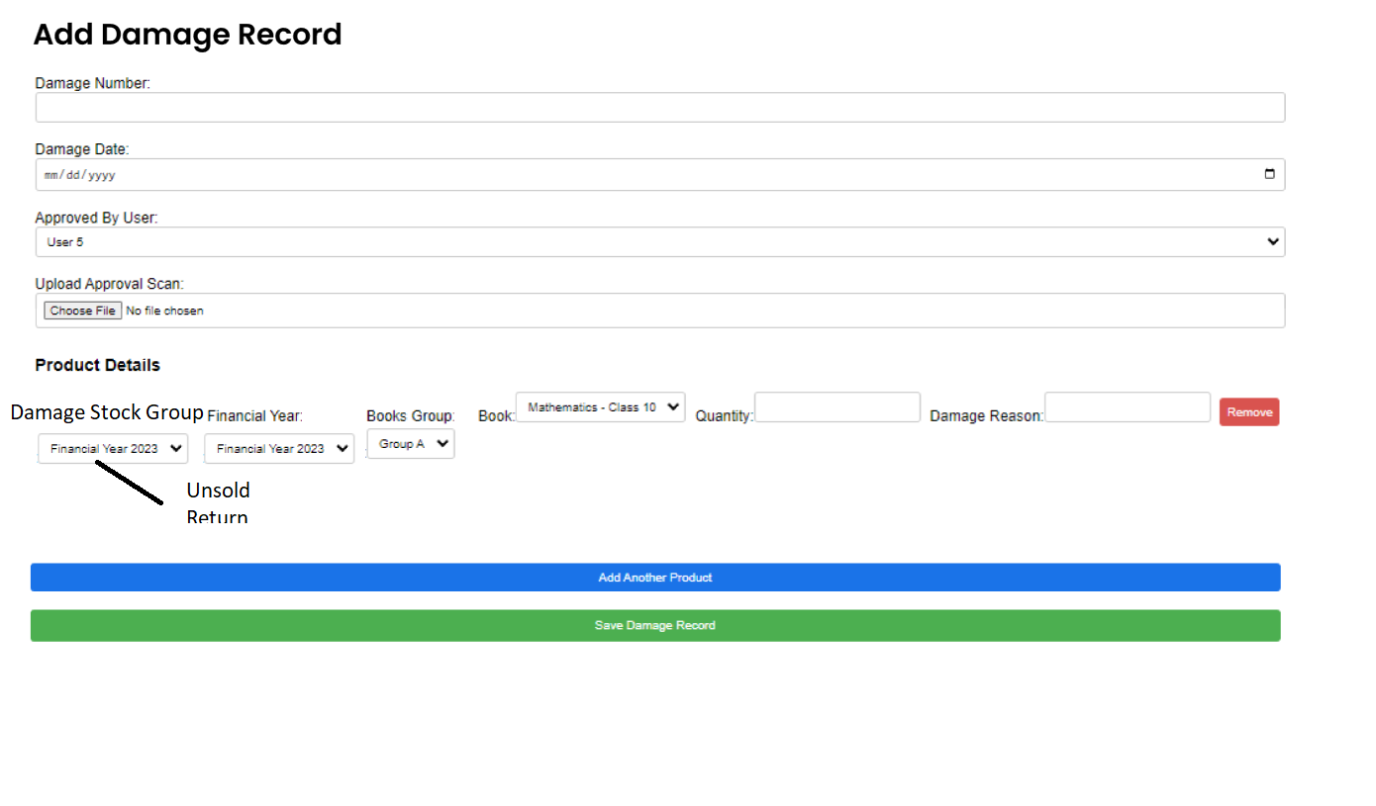

## **Inventory Transfer**

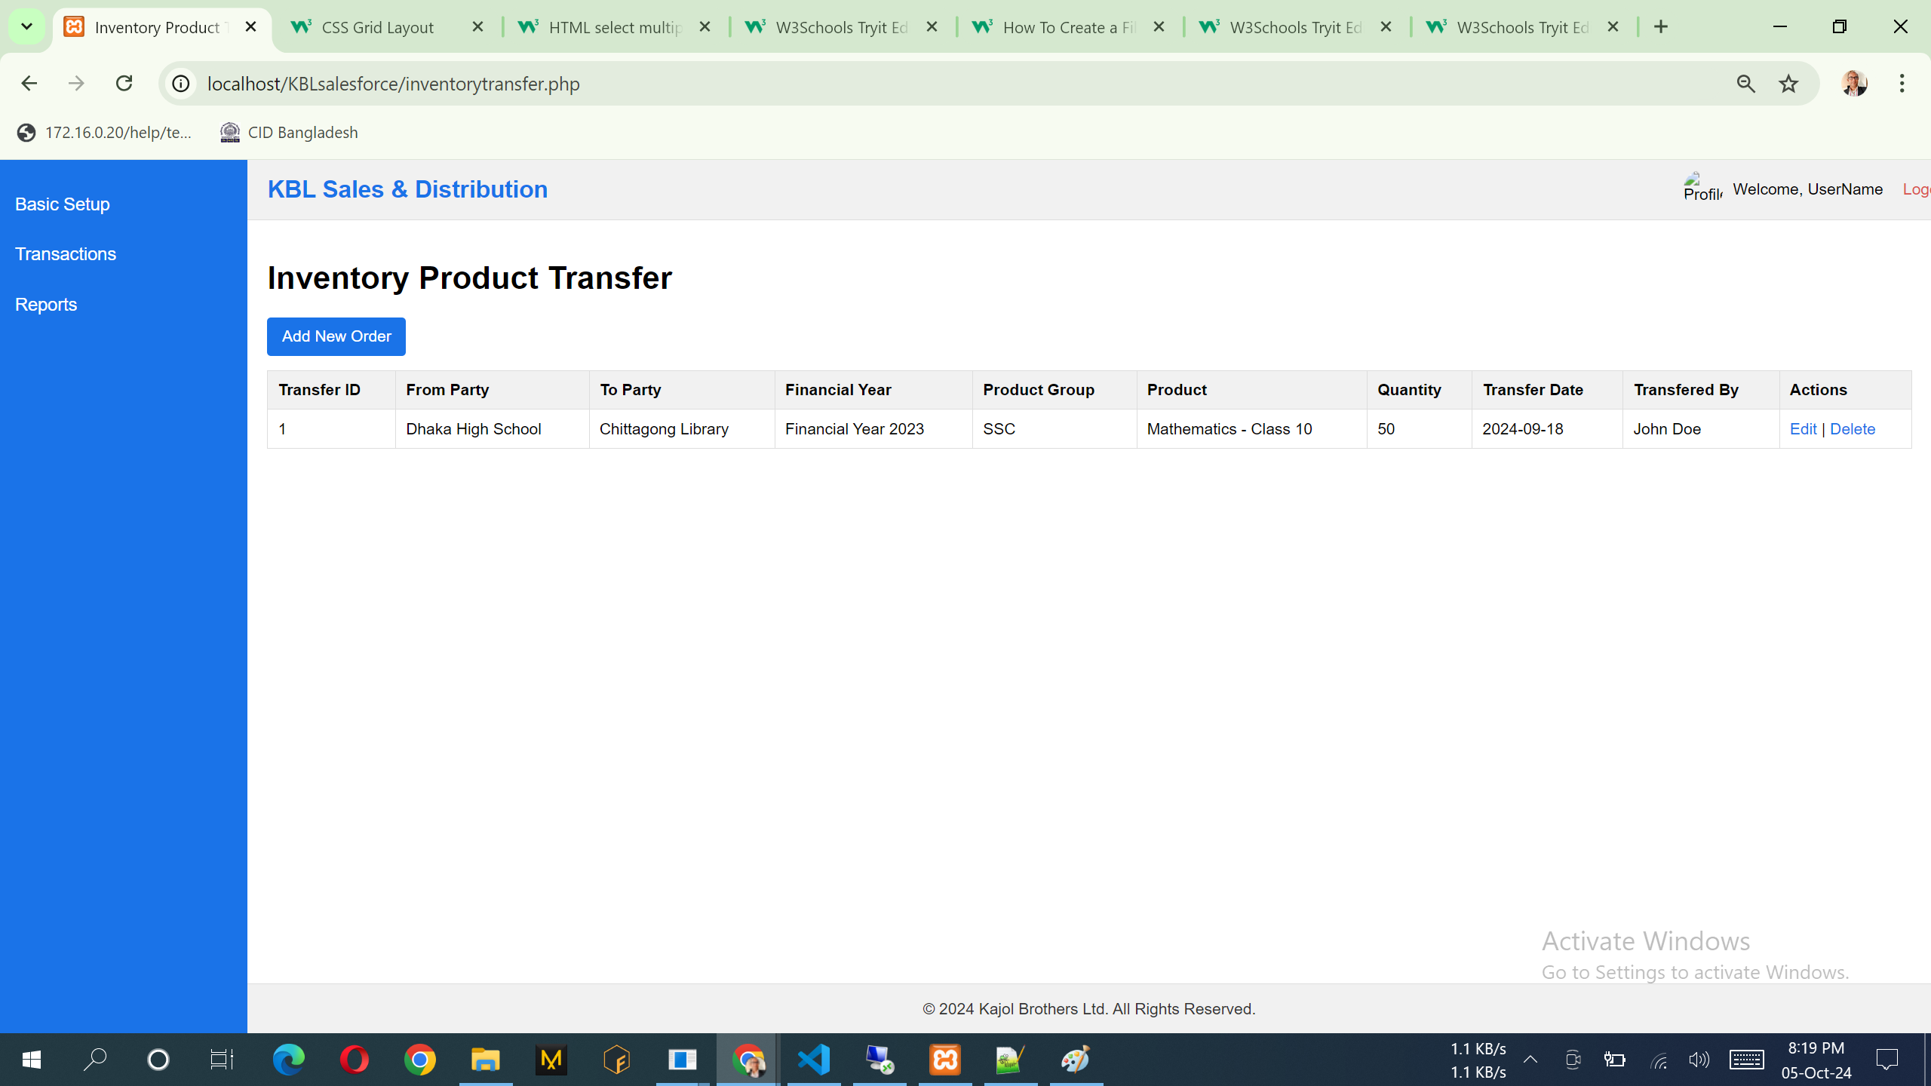

Notes:

1. List of the data can add, view & edit. No delete option.

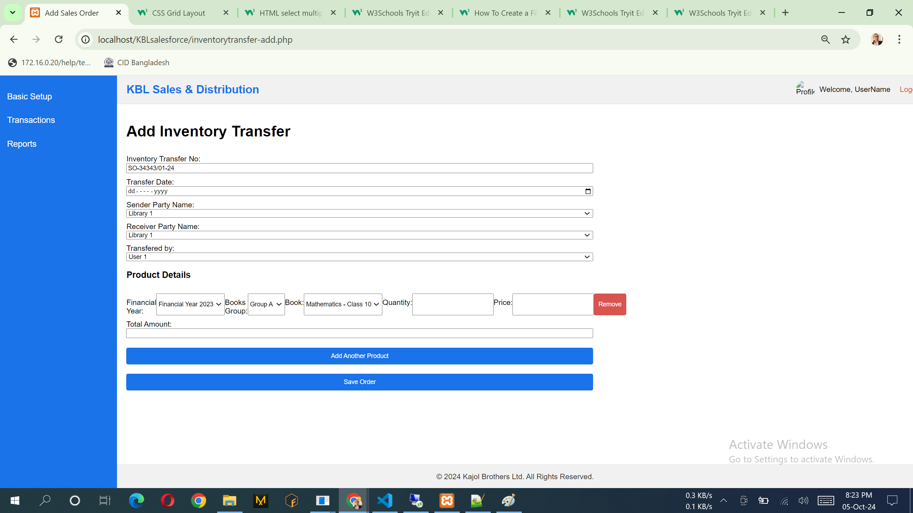

Notes:

1. Please follow the following design, This one is as like previous design… please try to understand business requirements
2. From Party – Party api, To Party – Party api, Financial Year – Financial Year api, Product Category - Product Category api, Product – product api, performed by: user api already discussed

## **Sales Orders Approval Process**

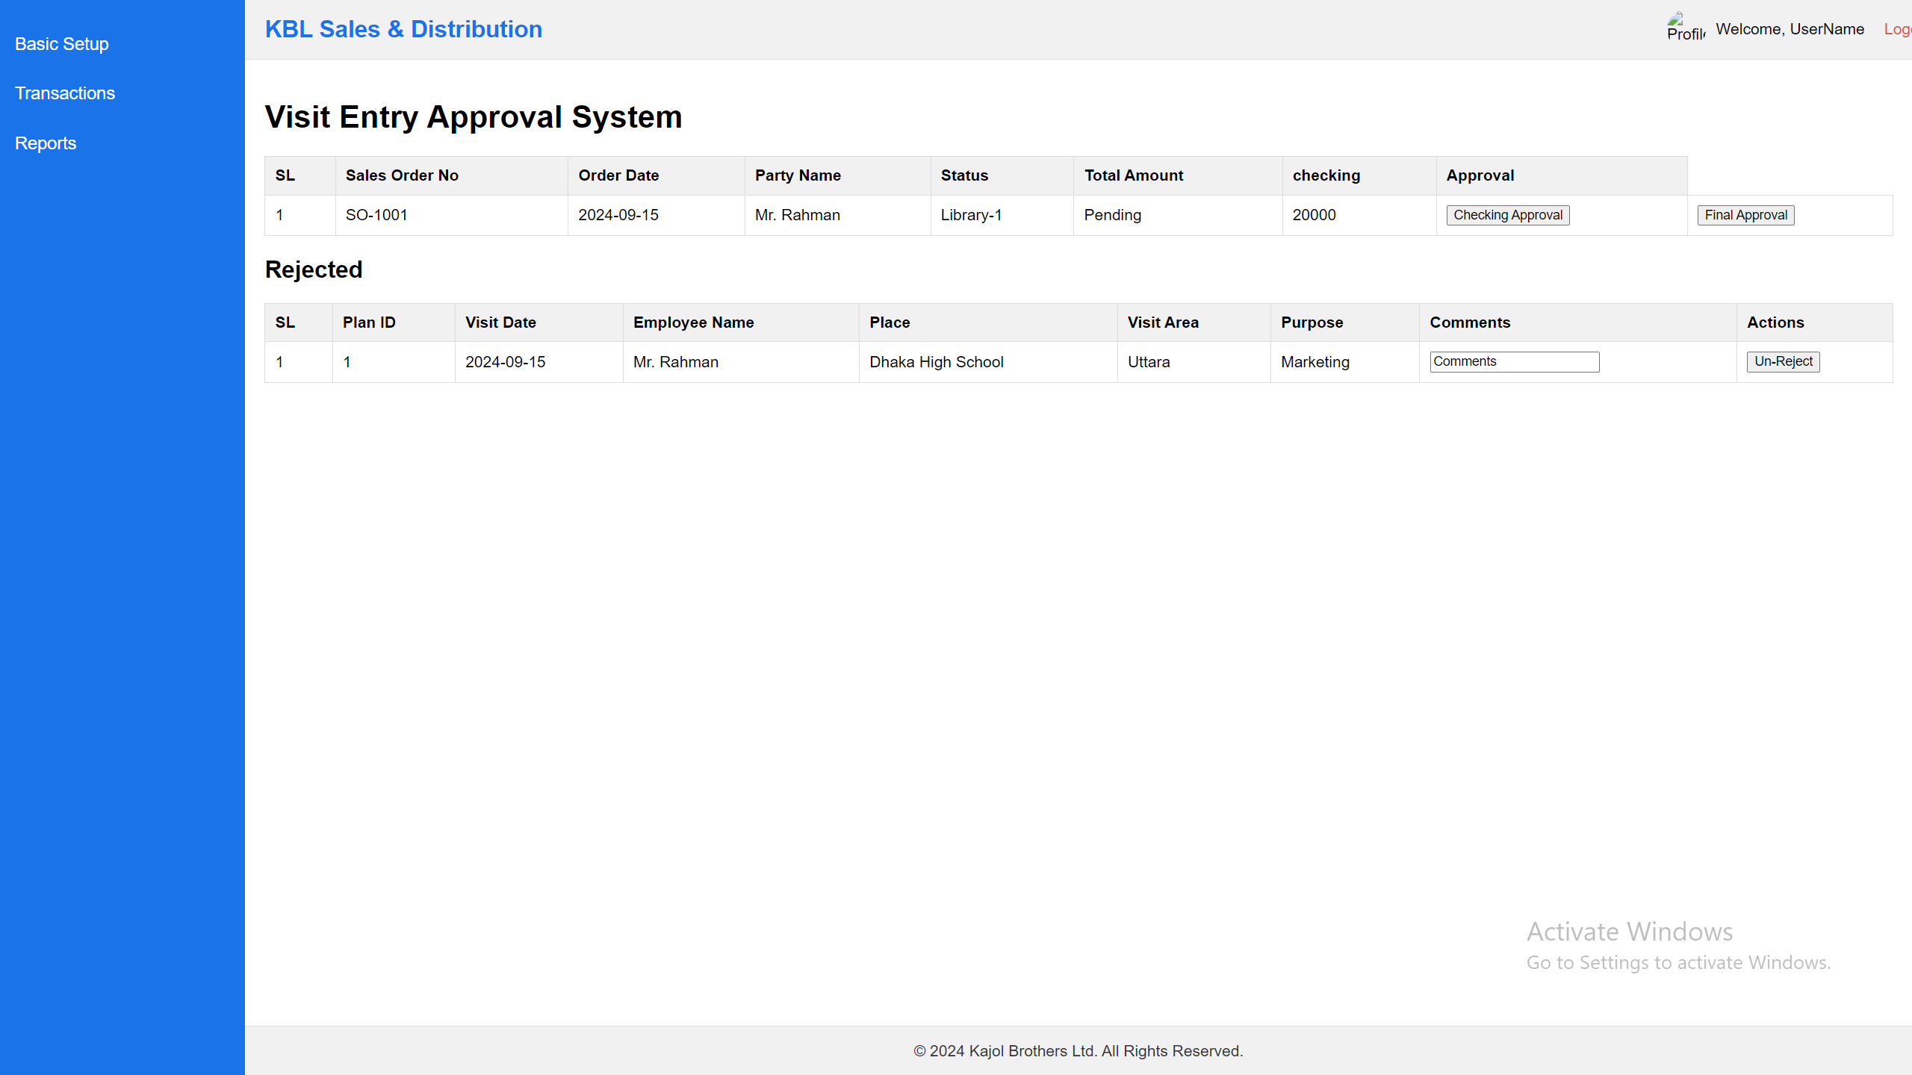

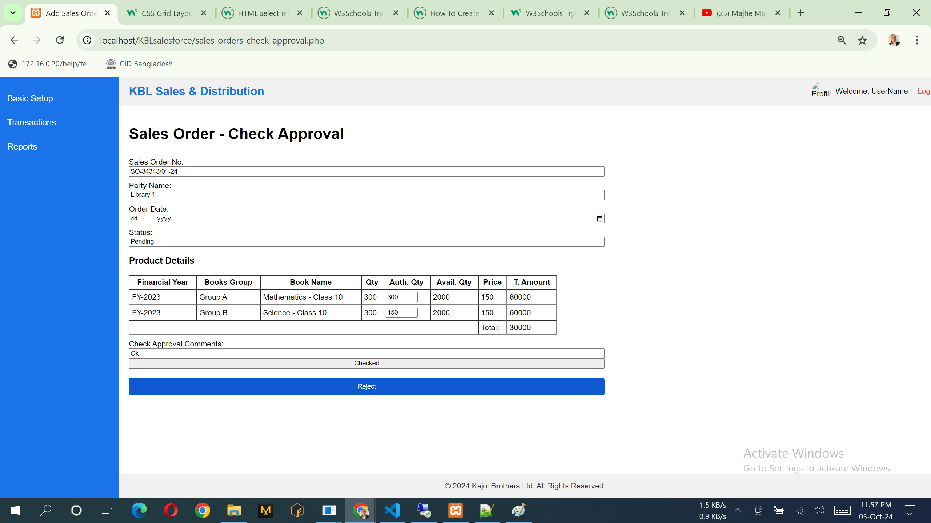

Notes: Here user can put Auth Qty and also see the avatilable stock in the design.

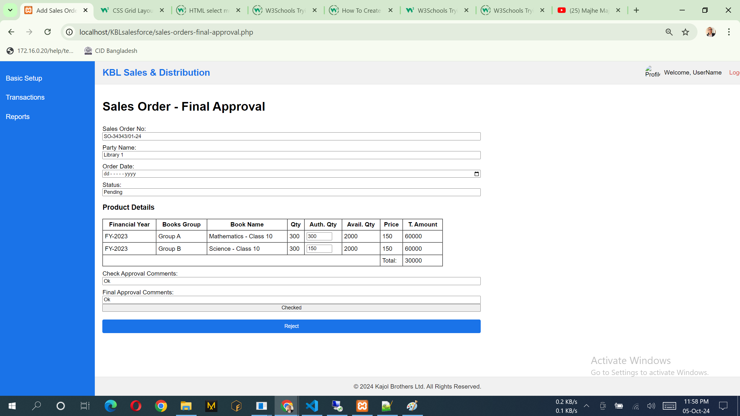

Notes: Here user can edit Auth Qty and also see the avatilable stock in the design.

## **Delivery Challan**

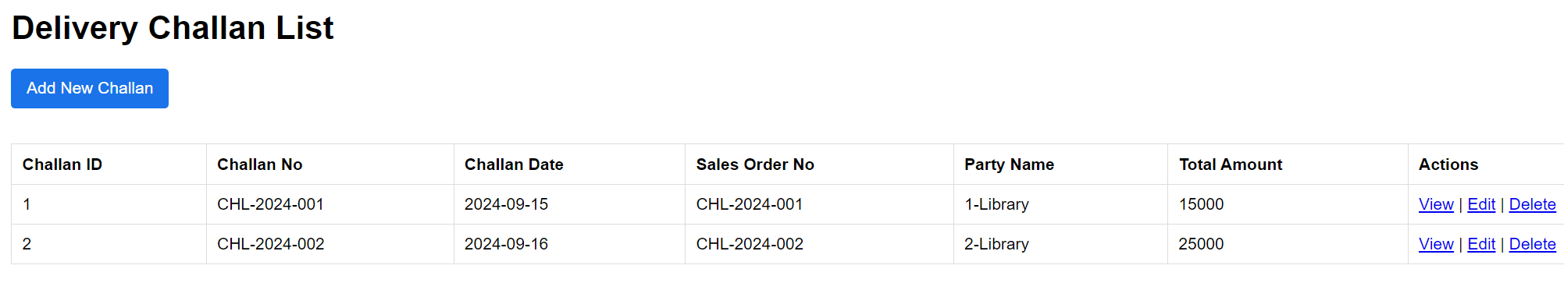

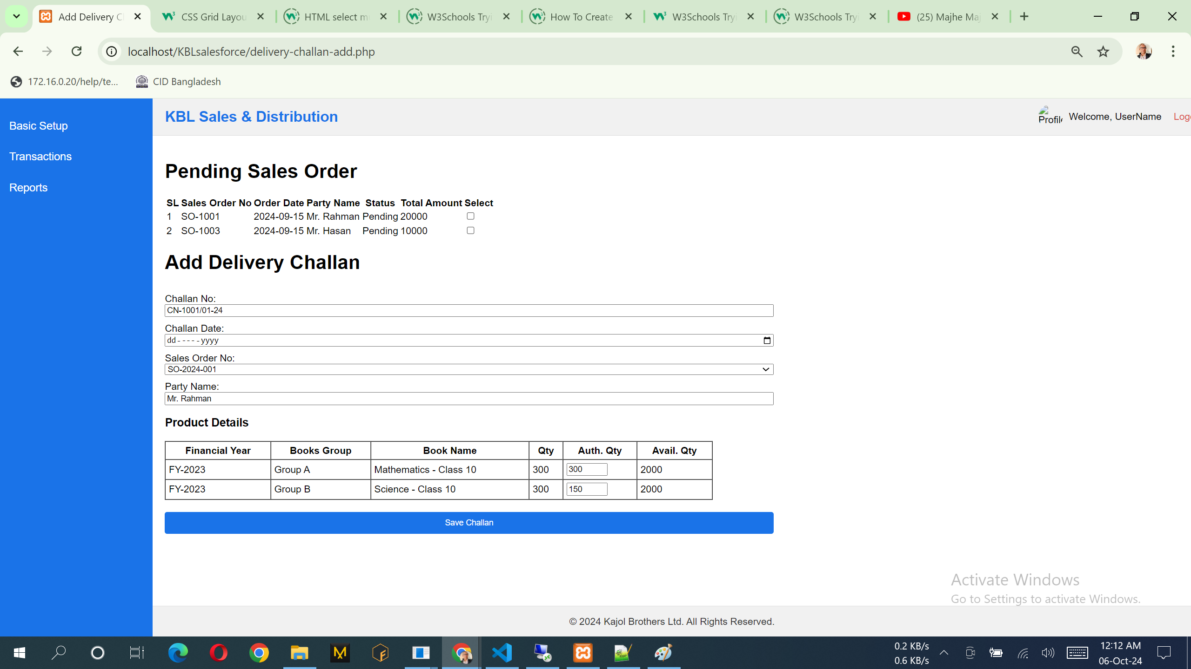

## **Invoice/Bill**

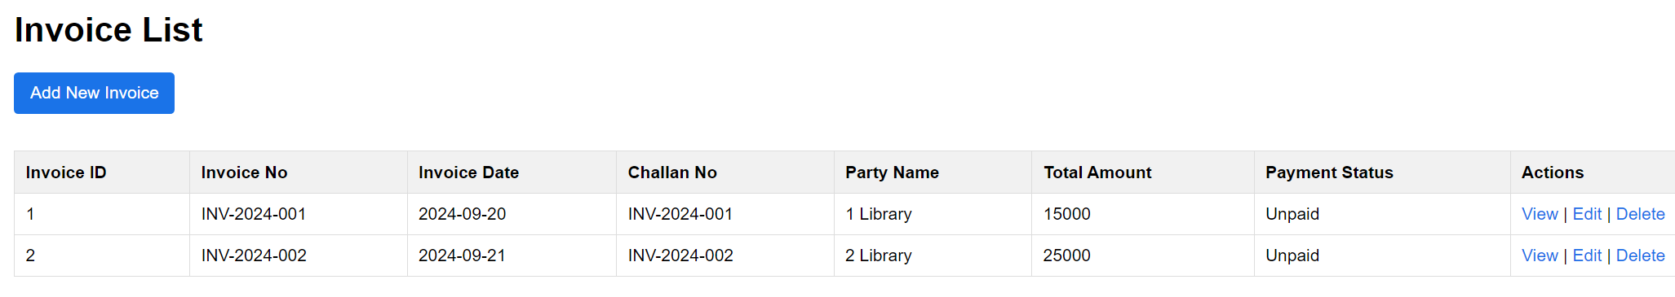

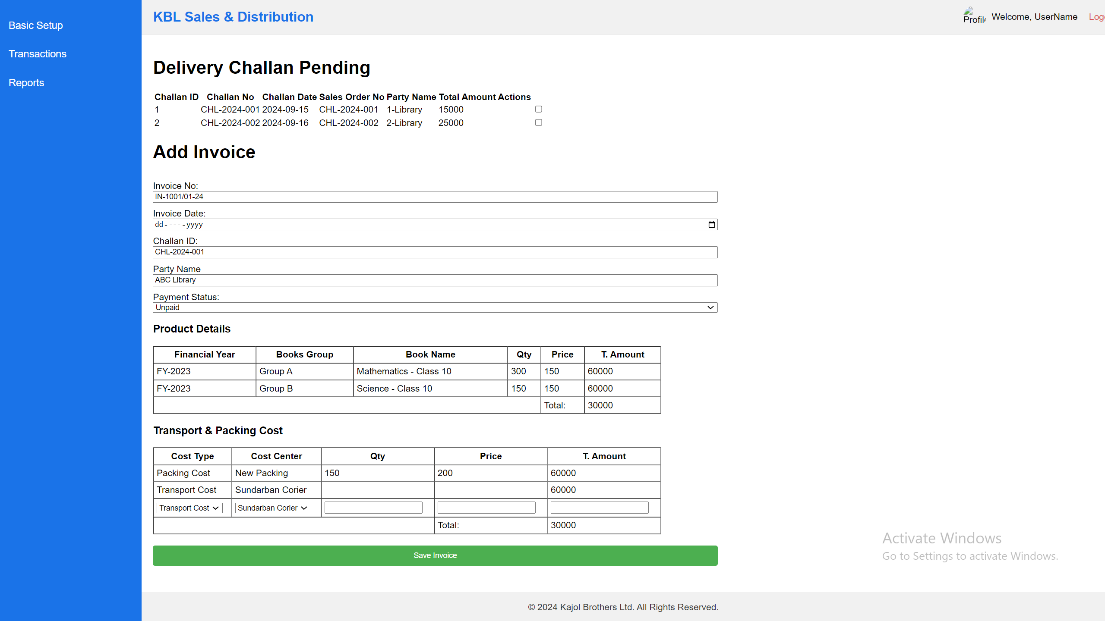

## **Specimen Requisition**

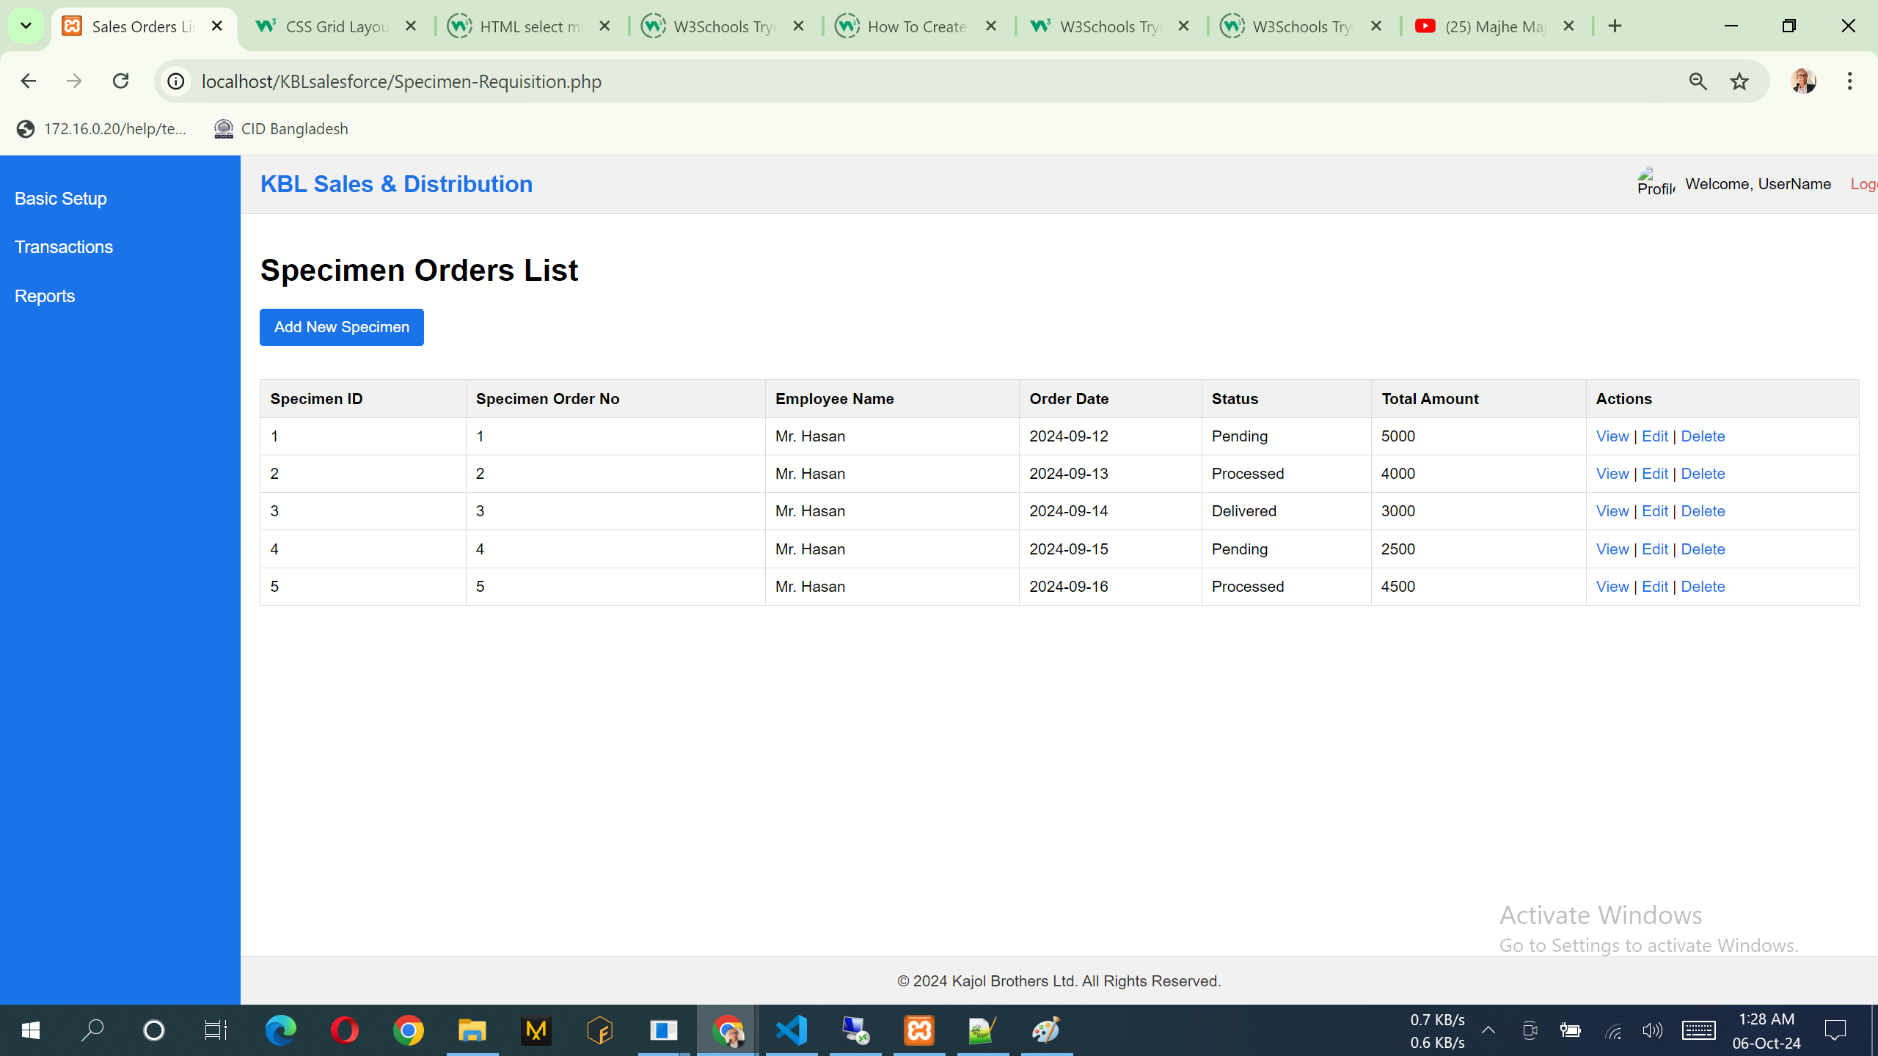

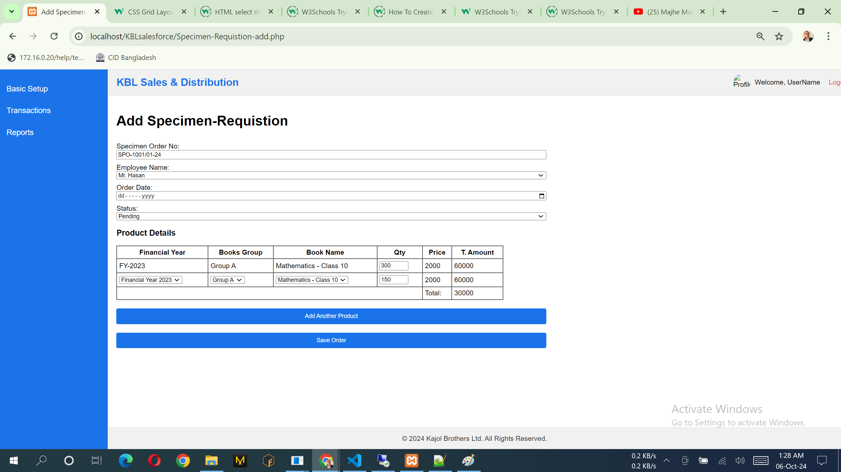

## **Specimen Approval**

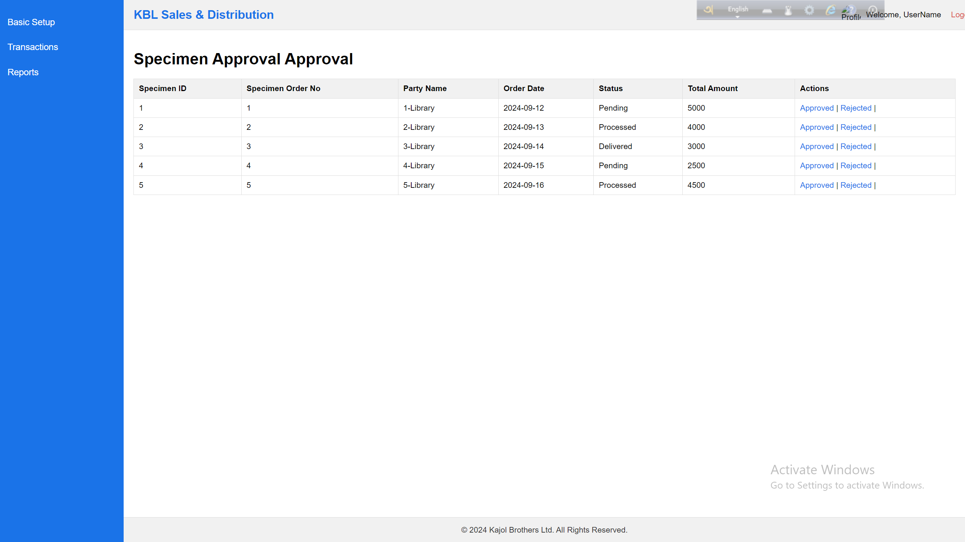

## **Reporting System**

Client will provide reporting system very soon.